# Education InPlace

# School Based Mentor Guide

### September 2023

### Faculty of Education

### Edge Hill University

# Contents

| Topic | Page Number |
| --- | --- |
| Introduction and How to access InPlace | Page 3 |
| Troubleshooting | Page 4 |
| Navigation | Page 5 |
| Mentor Activity   * Attendance Records | Page 5-7 |
| Mentor Activity   * Mentor Feedback | Page 8-10 |

# Introduction

## InPlace

InPlace is a placement management system. The system is an on-line web based solution for allocating and managing students in work placements. School-based mentors can login to InPlace to view the placements that they are supporting, sign off timesheets and access mentor feedback.

## Support

For access related issues please contact [educationpartnership@edgehill.ac.uk](mailto:educationpartnership@edgehill.ac.uk) or call 01695 584399 or 01695 654337

## Access

InPlace can be accessed via any device connected to the internet including your phone.

To access InPlace follow the link <https://www.edgehill.ac.uk/services/education-placements/>

Click on the button that says: ‘Other Accounts’

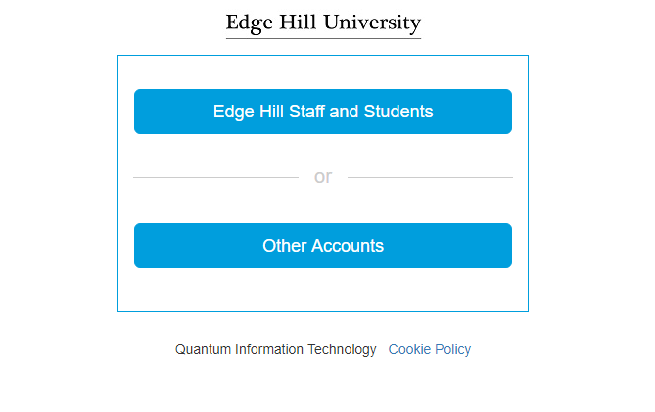

The first time you are invited to login, you will be sent an email to your school/setting email address, there will be a link to click that will prompt you to set up a password. If you forget your password, there is a forgotten password link which will help you to reset.

## Troubleshooting

If you are logging in to InPlace from a school computer, it is worth checking that the InPlace website address is not on a blocked list. Contact your administrator if this is the case.

If, when you login, there is an error telling you that there are no user roles associated with your account, please contact the faculty on the email or phone numbers above to resolve.

If you are struggling to logon, check if your access works on a different device, even your phone, this will narrow down the likely issues to the device you are using.

If it has been sometime between logging into InPlace, there may be a cached version of the website on your browser. Clear the history on your browser, the below instructions are for google chrome.

Step 1: Open Google Chrome, you go to the three dots at the top right and from the drop down select More Tools and then from the further drop down select Clear Browsing Data.

Step 2:From the box that appears, select the ALL TIME option as below and then Clear Data on the blue box.

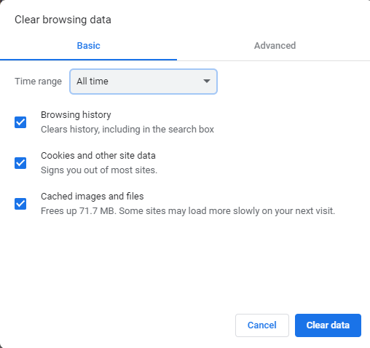

Step 3: Close your browser and relaunch. Try InPlace again.

# Navigation

When mentors log in, the students you are supporting will appear on the left and any timesheets you need to complete will appear on the right. *Please note:* *Student names will only appear here when the placement has been confirmed to the student, which is approximately two weeks before the placement start date.*

# Mentor Activity

There are two main purposes for mentors to access InPlace, to sign off placement attendance records and to access mentor feedback.

## Attendance Records

When a student has completed their placement, they will fill in their attendance record. Once submitted, the mentor will see an action in their to do list to the right of the home screen. Click on the action in the To Do list.

This is the attendance summary that mentors are asked to submit for every placement they are supporting.

Click on the drop-down box that says Stage 2 – Mentor Confirmation. This gives you the option to view the student’s attendance submission and calculated number of days on placement. Click on Stage 1 – Trainee.

A summary of the student’s attendance record is below. When in this screen, check the total number of days your student has submitted.

Switch back to stage 2, to see the mentor view again. Input the number of days the student has attended on placement. If it is different to the student’s submission, enter a comment in the comments box. Click on Submit.

## Mentor Feedback

To view your mentor feedback for each placement, click on a student name on the home screen. This placement record page will appear.

A summary of the student appears on the left and the placement detail, including the mentor feedback fields appear on the right. Once you have completed an attendance survey, an assessment report appears in the third tab.

Scroll down to read the Link Tutor’s responses to all the prompts, including the student’s progress on placement and the bespoke mentor feedback fields which can be found at the end of quality assurance 2 and 3 sections.

Quality Assurance 2

Quality Assurance 3

