

Welcome to the weekly mentor, trainee and link tutor briefing from the Department of Primary and Childhood Education

Course:  PGCE Primary 5-11 | Phase:  Developmental | Week: 1

Welcome Mentors to the PGCE 5-11 Primary Developmental phase, thank you for supporting our trainees in their professional practice, we hope you are having a good first week.
This Developmental phase will be an opportunity for students to build up to teaching and planning for 40-50% of the class timetable and be based in one class with opportunities to visit other classes in other key stages
for specific purposes. Please follow the weekly development summaries and our subject component tracker that reflects how our university-based practice aligns with the school-based experiences. These are flexible
and can be used compatibly with the your school timetable and found along with all resources you may need for the placement here. Your link tutor will contact you regarding to arrange a meeting with you and your
trainee and discuss any potential training needs. If you need mentor training, please follow the link here.

Weekly intended curriculum expectations linked to CCF:
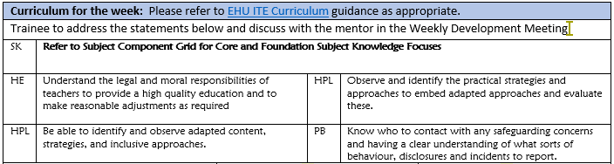

Mentor focus:
During this placement, we would expect our trainees to be settling in and getting to know the school routines and expectations. We would like our students to observe the class at work and to work with groups of children under the direction of the class teacher, across all timetabled lessons in order to get to know the children and their age, range of attainment, as well as the units of work being planned.

Mentor Space: PGCE 5-11 Developmental Archives - Mentor Space (edgehill.ac.uk)
Here you will find all the information needed to support the professional practice, including the Handbook ,
the EHU ITE Curriculum component trackers, lesson observation formats and the pre-populated weekly development summary (WDS) forms.

Link tutors:
Thank you for supporting our students through their Developmental phase of their professional practice, we know that you will have contacted the trainees to say hello and to let them know that you will be their go to person during professional practice. Please make sure you contact your mentor and arrange the initial visit
and ensure mentors have received mentor training and phase-specific training, this can be found here.
During your QA1 meeting, please also ensure mentor information is up to date on our system and that they have access to InPlace.

Observation of experts to support training suggestions:
During this phase, students should have the opportunity to observe or discuss with the subject leader or recommend colleague to understand how children learn in the foundation subjects. Please see the
component tracker here.

Research and resources:

Core Content Framework defines in detail the minimum entitlement of all trainee teachers. Drawing on the best available evidence, it sets out the content that we draw upon and go beyond in our integrated curriculum for trainees.
Initial teacher training (ITT): core content framework - GOV.UK (www.gov.uk)

