

Welcome to the weekly mentor, trainee and link tutor briefing from the Department of Primary and Childhood Education

Course:  PGCE Primary 5-11 | Phase:  Developmental | Week: 2

Welcome mentors to the PGCE 5-11 Primary Developmental phase, thank you for supporting our trainees in their professional practice, we hope that your students have settled in well.
Your link tutor should have contacted you and signposted to any training applicable. If you need mentor training, please follow the link here.
In week 2, we would like you to share your weekly development summary with your link tutor during your meeting as part of our quality assurance. This is also an opportunity to include target setting, check the placement specific expectations and awareness with your students. You can find your weekly development summaries on the mentor space here. in addition to a mentor and student checklist. There is a requirement to complete a Systematic Synthetic Phonics observation this placement and you can also find a blank SSP observation form and the standard lesson observation form here.

Weekly intended curriculum expectations linked to CCF: EHU ITE Curriculum
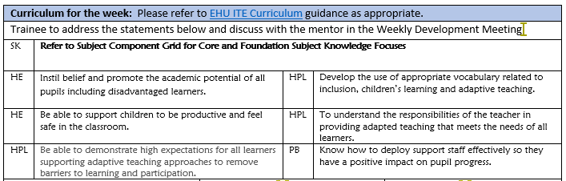
Mentor focus:
During this placement, we would expect our trainees to be settling in and getting to know the school routines and expectations. We would like our students to observe the class at work and to work with groups of children under the direction of the class teacher, across all timetabled lessons in order to get to know the children and their age, range of attainment, as well as the units of work being planned.

Mentor Space: PGCE 5-11 Developmental Archives - Mentor Space (edgehill.ac.uk)
Here you will find all the information needed to support the professional practice, including the Handbook,
the EHU ITE Curriculum component trackers, lesson observation formats and the pre-populated weekly development summary (WDS) forms.

Link tutors:
Thank you for supporting our students through their Developmental phase of their professional practice, we know that you will have contacted the trainees to say hello and to let them know that you will be their ‘go to’ person during professional practice. Please make sure you contact your mentor and arrange the QA1 and
QA2 visit, and ensure they have received core mentor training and phase-specific training. This can be found here.
Please also ensure the mentor information is up to date on our system and that they have access to InPlace.
All students must have their safeguarding documents uploaded prior to placement so if you have noted this
as ‘No’ on InPlace you must follow this up accordingly and notify me immediately if these details are not held. Safeguarding and Prevent training certificates can be seen on the ‘details’ area on InPlace.

Observation of experts to support training suggestions:
During this phase, students should have the opportunity to observe or discuss with the subject leader or recommend colleague to understand how children learn in the foundation subjects. Please see the
component tracker here.

Research and resources:

Core Content Framework defines in detail the minimum entitlement of all trainee teachers. Drawing on the best available evidence, it sets out the content that we draw upon and go beyond in our integrated curriculum for trainees.
Initial teacher training (ITT): core content framework - GOV.UK (www.gov.uk)

