

Online AT Claims

Associate Tutor claims can now be submitted using the Selenity online expenses system. The AT hours to be paid, along with costings, work order reference and grade information will need to be input. The claim will then be authorised using the same functionality as the expense approval.

The system captures the hours to be paid only, all cash values are calculated once the hours are approved and have been transferred into the payroll system for payment.

To access the system, select Employee Expenses from the Edge Hill Staff page. Select Login to Employee Expenses. If accessing from off-site you will need to enter your normal Edge Hill username and password.

The link takes you to the expenses page. Click the blue arrow to access the system.

If this does not take you to the Expenses home page, please email [payroll-expenses@edgehill.ac.uk](mailto:payroll-expenses@edgehill.ac.uk). The team will be able to check your account details.

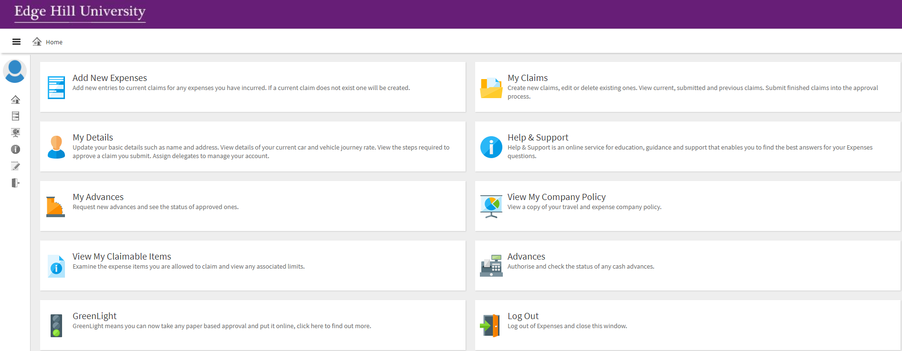

There is a 20-minute timeout on the system, if at any point your session times out, you will be taken to this screen. Simply close the window and access expenses through the Edge Hill wiki page again.

If you are claiming expenses on the system, you will need to input your bank details for payment.

If claiming for AT hours only, then zeros can be used for account number and sort code. Please note if at later date you need to claim expenses, you will need to ensure you update the system with your correct bank details.



All AT claims will be paid via the payroll system, in line with the normal month end payroll run deadlines.



The links you will need to access are the ‘Add New Expense’ and the ‘My Claims’ area where you can view and submit your current claim and view and track any previous claims.

It is preferable, if you are claiming both expenses and AT hours that you input them on separate claims as they will have different deadlines for submission and may also require different approvers. If your work orders are for different line managers these also will need to be on separate claims. Please ensure you build your claim over the month and submit in line with the faculty deadlines.

You are also able to input your AT hours via your phone. You will need to download the Selenity expenses app from the app store. (Please see the mobile app user guide available on the Finance - Expenses wiki page)

To access your account on the app

The company ID - is **EHU**

Username - this is your **Edge Hill email address**. (If unsure which format, this can be checked on the ‘My Details’ screen)

The password is the password you set on the Selenity system. The link to change the password is also under ‘My Details’. Please note you will be prompted to change this password every 30 days, whether you use the mobile app or not.

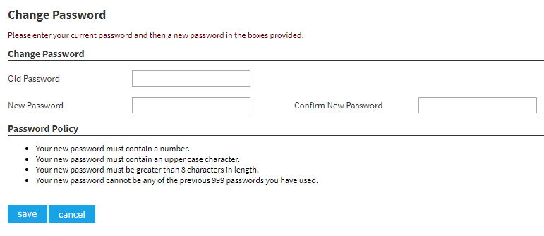

**Inputting a claim.**

1. To start a new claim, select ‘Add New Expenses’. To add hours throughout the month and submit your current claim please use the ‘My Claims’ tab and select ‘Current Claims’.



Add new Claim claimCaExpense

Current / ongoing claims. Submit current claim.

Along with Claim history

1. To start a claim, select ‘Add New Expenses’ from the side bar.

Begin by selecting the date when the hours were worked. Leave the country and currency as default UK pound sterling. The default cost centre will display, this can be amended along with adding, Job Code and Activity Code that applies to the claim hours in that order.

NB: If unsure of your Job/Activity Code please contact your faculty for information.

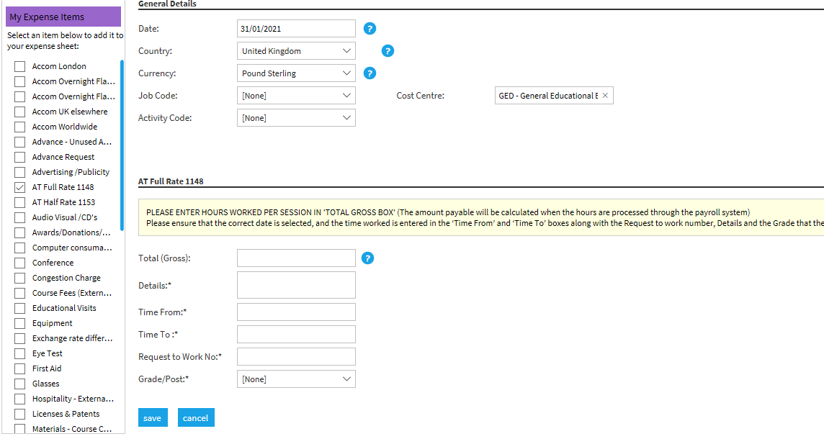

1. Select the expense items on the left so that it appears on your claim page. You are able to tailor your ‘Claim View’ to include items you frequently claim.

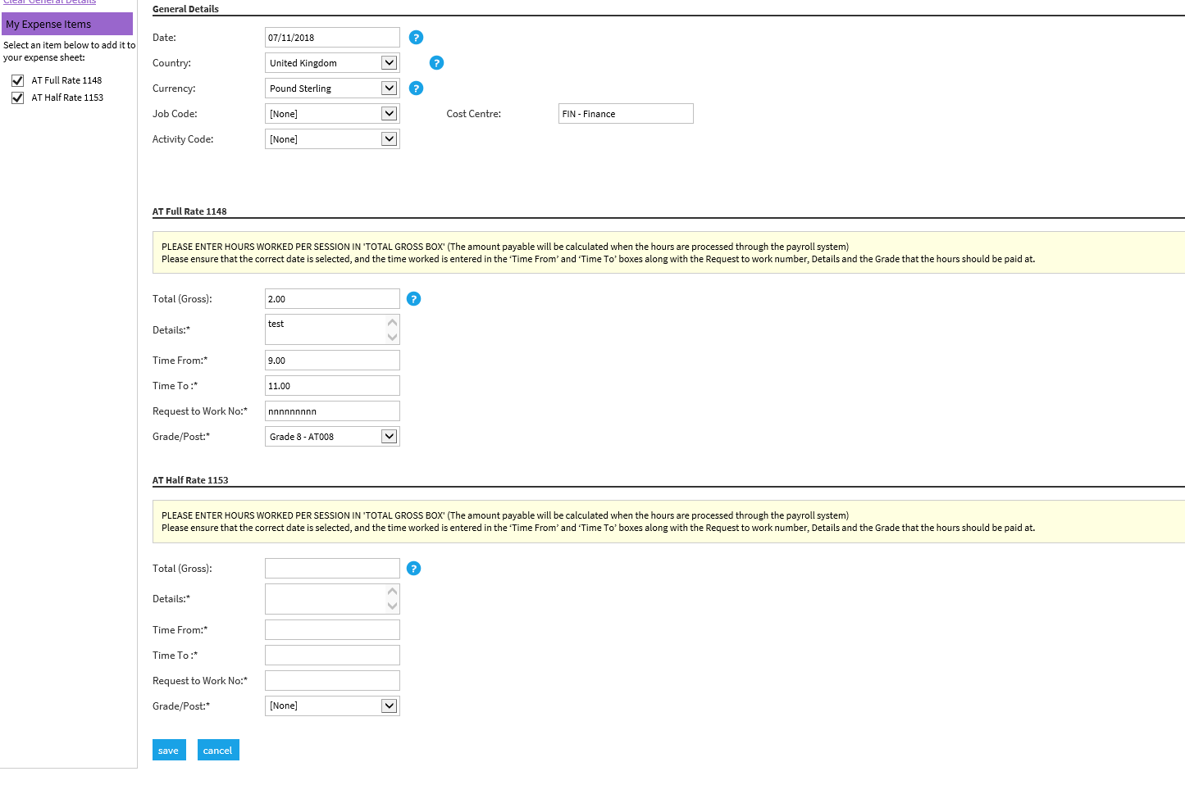

Complete the fields as directed.

1. The total gross field should be the hours to be paid per session. (Don’t worry that it will show a £ sign. **The actual payment will be calculated against the grade selected/rates of pay held on the Payroll system).**
2. The details box should be details of the work undertaken including students visited if appropiate.
3. The ‘time from’ should be the start time, as you would enter on the pink paper claim form.
4. The ‘time to’ is the finish time.
5. The request for work number will be the reference number issued on your work agreement, which you will have received from the faculty. Please be aware that this is a mandatory field and should be quoted on all claims relating to the hours claimed for each agreement. If you have multiple agreements please ensure that the correct number is quoted.
6. Select the grade that is applicable to the work undertaken. This is provided on the agreement confirmation received from the faculty.

If you have muliple work orders, please ensure hours for each indivdual work orders are bulit up on separate claims as now, so they can be apporoved by the appropiate manager. You are able to have multiple cliams ‘in progress’ under the current claim link.

Please claim each session as a separate line on the single claim. A warning flag will show if you have multiple claims on a single day as the system highlights the possibility of duplication. If a flag appears you will just need to provide a brief justification, click ‘Show further details and justify’. Please add an explanation for your manager in the text box provided. Then click save. Please note the maximum hours per session is set at 9.00.

1. Once the item has been entered, you will be taken to the ‘Claim Details’ page, at this stage you can add further items to your claim, if you wish.

As you build up your claim over the month, you will access the claim via the ‘Current Claim’ link within the ‘My Claims’ section.

* + To add further lines to your claim, click ‘New Expense’
  + If you wish, you can copy a claim if the details are similar. **(See notes below).**
  + To add receipts to an item, click on the yellow folder. (This is not required for AT claims).

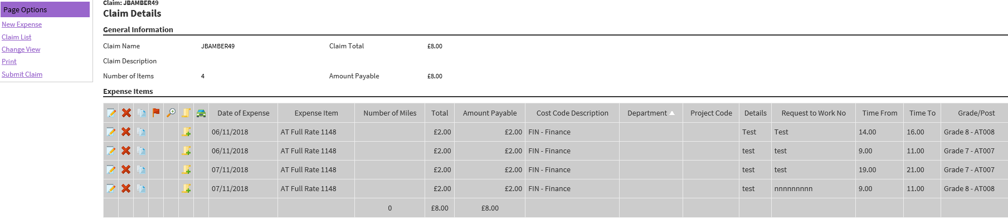

* + Once complete click on ‘Submit Claim’.
  + The red X deletes a claim line
  + Please note the hours worked will be shown with a £. Please ignore this as the actual payment value will be calculated by the payroll system.

1. If you choose to ‘Copy expense line’ the item selected will become a new line on the claim with all the details of the previous claim. Please ensure you **change** **the date of the claim to match when the hours were worked**, along with any other details that need to be amended and click ‘Save’.

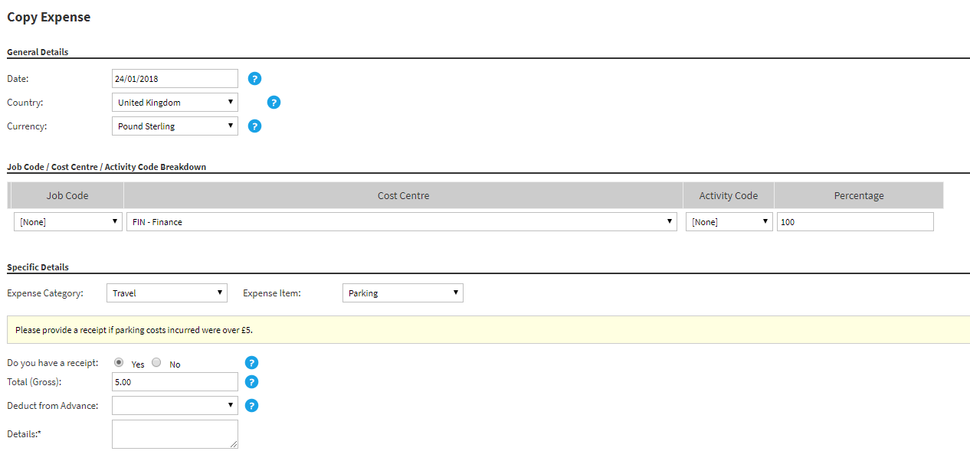

After clicking ‘Submit Claim’, depending on your approval route, you will be required to choose the manager who issued the ‘work order’ as the approver in the first instance. If the claim is for hours worked for Research (GRS) please select a member of the Research admin team from the list provided, rather than your line manager; click Save. Once approved by your line manager/research admin team it will automatically go to your faculty admin team and your budget holder for approval.

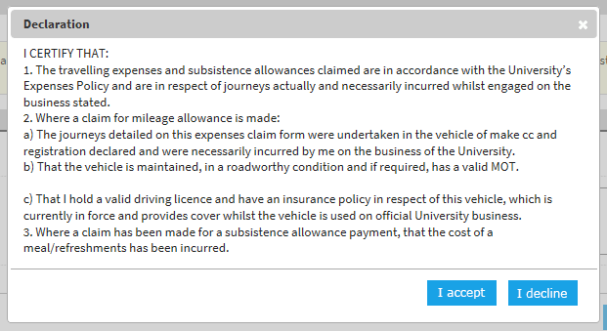You must accept the declaration to allow your expenses/claims to be submitted and approved.**

Select the name of the person who issued your work order as approver here.

1. To check the progress of your claim, on the home page select ‘My claims’ and then click on ‘Submitted Claims’. Here you can track the progress of your claim along the approval process.



If submitted in line with the faculty deadlines, your claim, will be paid at month end as normal with the hours and rate of pay displaying on your payslip.