# Trainee and Mentor Handbook for Contrasting Placement

# PGDiT in Further Education and Skills

# AY 2024-2025

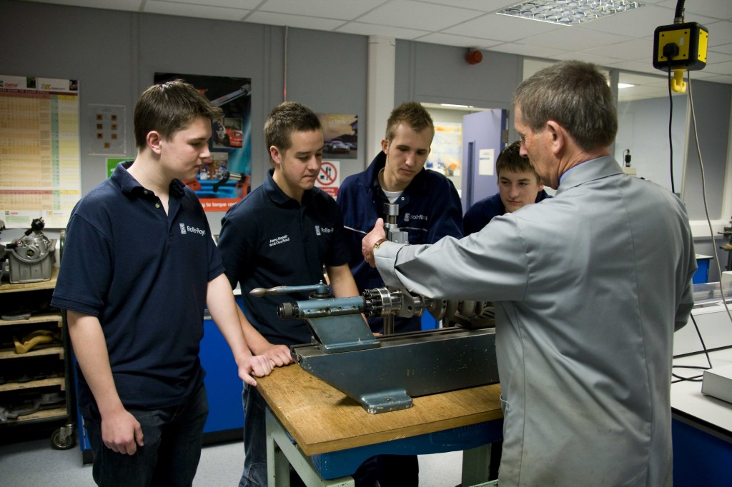

# Why have a contrasting placement?

Whilst trainees will mostly be in one placement during their teaching practice, the FE sector is a wide and varied education setting, with students studying entry level, up to level 7 courses. Students in FE also have a wide range of specific needs, behavioural and pastoral issues. The purpose of this placement is to give our trainees experience of as a wide range of teaching styles and skills as possible. This also enables us to make sure our trainees meet the requirements of the Diploma in Teaching (Further Education and Skills) framework, in which they need experience of two different settings.

How does this fit with the Occupational Duties?

The Occupational Duties state:

*Duty 1 Promote a passion for learning and set high expectations of all students and support their personal and skills development,*

*Duty 2 Maintain a focus on outcomes, for all students, so that they recognise the value of their learning and the future opportunities available to them.*

*(*[https://www.instituteforapprenticeships.org/media/5061/learning-and-skills-teacher-2021-05-06.pdf)](https://www.instituteforapprenticeships.org/media/5061/learning-and-skills-teacher-2021-05-06.pdf#:~:text=Skills%20Teacher%20typically%20has%20significant)

By observing in other areas of FE trainees are provided with opportunities to see a wider variety of teaching to enable them to develop their own style.

During the college-based element of the Contrasting Placement, trainees will need to have:

* **Opportunities to observe and reflect upon expert practice**. **They should be** **supported to understand exactly what it is that makes such practice effective and to think about how it could be embedded in their own teaching and subject**.
* **Opportunity to apply what they have learned, deconstruct practice, and receive feedback from their expert colleagues in their subject area**.
* **Opportunity to expand their knowledge, deepen their understanding of theory and practice and increase their confidence to teach using a given aspect of pivotal practice.**

## The role of the mentor and other expert colleagues during the contrasting placement.

The mentor and expert colleagues have two very different roles, and both are referred to within our curriculum. To clarify, a Mentor is the college-based specialist within that subject who is assigned to a specific trainee and who has undertaken their Edge Hill mentor training. An Expert Colleague is any colleague (college or centre-based) who has expertise within a specific subject and/or area of practice.

During the contrasting placement, trainees should be given the opportunity to intensify the focus on these foundational and key aspects of the ITE curriculum that may vary from their main placement; benefit from immediate and targeted feedback focused on improvement in relation to their own practice; and access appropriate expert support. As a mentor, you will have responsibility in ensuring that trainees receive the broad range of experiences required during the contrasting placement days and that purposeful feedback is provided to enable trainees to develop knowledge, skills and confidence in this area.

Throughout this manual we have referred to ‘expert colleague(s)’. This can be anyone who has expertise and does not have to be the Edge Hill trained mentor. This has been done to assist with mentor workload but also to ensure trainees are able to benefit from expert advice from a range of colleagues.

Our curriculum is spiralised in its approach. Trainees will return to their learning about inclusive and adaptive practice at key points throughout their ITE curriculum. For full coverage of our ITE curriculum, please see the PGDiT Further Education and Skills ITE Curriculum available on our mentor site.

## Intended learning & outcomes for the Contrasting Placement

**To make progress through the curriculum during their Contrasting Placement trainees should know:**

* It is a misconception that FE does not present any behaviour management challenges, and, in some instances, the nature of FE can compound some of these challenges
* How to respond consistently and decisively to student behaviour (including the use of rewards, praise, and sanctions).
* How to motivate learners by engagement of challenging content, building towards the students’ long-term goals and aspirations.
* Working alongside and learning from new expert colleagues as part of a wider system of behaviour management can help to manage the behaviour of learners.

**Trainees should also be provided with the opportunity to:**

* Complete training in relation to Safeguarding Training within the setting, knowing who to contact with any safeguarding concerns within this setting.
* Distinguish and have a clear understanding of what sorts of behaviour, disclosures and incidents to report within the setting.
* Utilise the range of theoretical approaches to help with behaviour management and assessment
* Observe a wide range of examples of reward and sanction in the classroom.
* Observe the use of consistent language and non-verbal signals for common classroom directions which allow for early and least-intrusive interventions as an initial response to low level disruption.

What opportunities should trainees be provided with during their Contrasting Placement?

|  |  |
| --- | --- |
| Trainees will need to be provided with an opportunity to: | Trainees would benefit from an opportunity to: |
| Meet with the Designated Safeguarding Lead to find out about the safeguarding processes in that setting and how that setting ensures its learners are safeguarded. | Shadow a learner who is working at Level 1 or Level 2. |
| Meeting with the SENCO to discuss how they, and expert colleagues, support colleagues to meet the needs of learners. | Meet with the colleague who has oversight of the behaviour policy within the college so the trainee can discuss how the policy has been designed and any challenges/opportunities with its implementation. |
| Observe at least 2 sessions which show learners working at Level 1 and Level 2 in a contrasting subject and have an opportunity to meet with the relevant tutor(s) to discuss their observations and reflections on what they have observed. | Meet with a colleague who has responsibility for pastoral support in the college to discuss how they, and expert colleagues, support colleagues to meet the needs of learners. |
| Observe at least 2 sessions which provide trainees with an opportunity to see how behaviour is managed within FE and to address the misconception that FE learners do not present with any challenging behaviour. | Observe a colleague who is able to demonstrate the college policy/use of sanctions and rewards. |
| Observe a range of vocational sessions/learners to see the breadth and range of Further Education. | Observe at least two sessions in which either Maths or English is the focus of the session. |
| Become familiar with policies and resources related to: Safeguarding, behaviour, pastoral support etc. |  |
| Observe at least 2 sessions which show effective adaptive teaching strategies and be given an opportunity to meet with the relevant tutor(s) to discuss their observations and reflections on what they have observed. |  |

What should happen before the placement commences?

Trainees should be provided with an appropriate name at the Contrasting Placement to act as a key contact. If the Contrasting Placement is happening at the main setting, this should be someone within the department the trainee is spending their Contrasting Placement. Trainees should be given information on where to go on the first day, what time to arrive, when they will finish and lunch arrangements.

# Exemplar Timetable – week 1

|  |  |  |  |  |
| --- | --- | --- | --- | --- |
|  | Session 1 | Session 2 | Session 3 | Session 4 |
| Monday | Familiarisation with safeguarding process and completion of safeguarding training (if relevant) | Observation of expert colleague within a L2 lesson. | Meeting with expert colleague to discuss the observations from the morning and consider implications for practice. | Trainee to review and become familiar with the system of rewards and sanctions in the college |
| Tuesday | Shadowing a level 1 or 2 learner | | | |
| Wednesday | Meeting with college pastoral lead | Meeting with college SENCO: | Observation of expert colleague in a lesson with a clear SEND focus | Meeting with expert colleague to discuss the afternoon’s observation. |
| Thursday | Meet with pastoral team to discuss wellbeing and pastoral support in the setting | Observation of expert colleague in a pastoral support session. | Observation of expert colleague demonstrating effective stretch and challenge in the classroom. | Meeting with expert colleague to discuss the observations from the afternoon and consider implications for practice. |
| Friday | Trainee to be given time to consider the weeks engaged reading. | Observation of expert colleague in a session which embeds maths and/or english alongside the students’ main course. | Trainees join online teaching session delivered by EHU tutors.  They will need to be provided with a space to join online via their laptop. | |

# Exemplar Timetable – week 2

|  |  |  |  |  |
| --- | --- | --- | --- | --- |
|  | Session 1 | Session 2 | Session 3 | Session 4 |
| Monday | Meet with careers/progression advisors to discuss next steps within the setting and in the wider area. | Observation of expert colleague in a Maths/or English GCSE resit class. | Meeting with expert colleague to discuss the observations from the morning and the challenges of students having to resit subjects not necessarily related to their main course. | Meet with exams officer to discuss the process for entering students into exams and the role teachers play in ensuring smooth practice. |
| Tuesday | Shadowing an adult or level 3 learner | | | |
| Wednesday | Observation of expert colleague in an adult or commercial class (if available) | Meeting with expert colleague to discuss the observations from the morning and the difference between pedagogical and andragogical teaching. | Observation of an expert colleague in an academic (L3) subject, different from their own. | Meeting with expert colleague to discuss the observations from the afternoon with a focus on how they manage cognitive load in their subject. |
| Thursday | Opportunities for trainee led task – trainee to take a lesson they have observed over last 2 weeks and adapt lesson for a different level. | | Opportunity for trainee to meet with students to discuss what they consider to be ‘effective teaching’. | |
| Friday | Trainee to be given time to consider the weeks engaged reading. | Meeting with expert colleague to discuss trainee adaption of lesson plan/activity. | Trainees join online teaching session delivered by EHU tutors.  They will need to be provided with a space to join online via their laptop. | |

Questions for trainees to consider when observing and meeting expert colleagues

|  |
| --- |
| **Observation of expert colleague in a level 2 class** |
| **Questions for trainees to consider during their observation:**   1. As you observe the class, how does the teacher ensure that everyone is included? 2. How does the teacher adapt their exposition or explanation of key learning? How do they adapt their language or use of key terminology? 3. How does the teacher make use of any resource(s) to support those who need it but also to stretch those who may be more independent in their learning? 4. What do you notice about the teacher’s use of questioning? Does this vary depending on the student? |
| **Points for discussion when meeting expert colleagues around level 2 teaching**   1. What information or data does the teacher use to plan their teaching for this class? How does this help them to plan their lesson? 2. How did the teacher ensure they were measuring the progress of every student in the class. 3. How does the teacher balance the need to work through the curriculum, with ensuring all students are able to make progress? 4. Can they suggest any strategies which might make this easier when teaching level 2 learners? |

|  |
| --- |
| **Observation of expert colleagues in SEND provision** |
| **Questions for trainees to consider during their observation:**   1. How does the teacher make use of the support colleague within the classroom (if there is one)? 2. How does the teacher (and support colleague) support the students throughout the lesson? Does the support vary at key points for example. 3. If there is a support colleague, what responsibilities do they appear to have? Are there moments when they support more than 1 student? Why is this the case? 4. What impact does it have on the students to have this level of tailored support? 5. How does the teacher/support colleague contribute to the classroom being an inclusive environment? |
| **Points for discussion when meeting expert colleagues around SEND teaching**   1. What information or data does the teacher/support colleague have access to? How do they use this in their practice? 2. Are they provided with extra CPD to support them when working with SEND students? 3. How do the teacher and the support colleague work together to ensure pupil(s) are best supported? For example, does the teacher share their planning with the support colleague in advance? What impact does this have? 4. How much access do teachers have to additional resources? What impact does this have on their teaching? |

|  |
| --- |
| **Observation of expert colleagues in pastoral sessions** |
| **Questions for trainees to consider during their observation:**   1. How is a pastoral/tutorial session different from other lessons you’ve observed? 2. How is the room set out? Do students sit in friendship groups or in a seating plan? Does this make a difference? 3. How is informal learning (discussion/groupwork) used as opposed to formal? 4. How do students seem to respond to these sessions? 5. How does the teacher contribute to the classroom being an inclusive environment? Do students seem to enjoy the sessions? |
| **Points for discussion when meeting expert colleagues around pastoral teaching**   1. How are pastoral/tutorial sessions structured? Is there a curriculum or is it teacher driven? 2. How well do students respond to the sessions? 3. How does the teacher prepare for these sessions? 4. How does the teacher feel covering subjects which may be controversial, or not their subject specialism? |

|  |
| --- |
| **Observation of expert colleagues in academic lessons/lessons with high expectations of challenge** |
| **Questions for trainees to consider during their observation:**   1. How is the lesson structured, compared to the level 2 class you observed? 2. How is the room set out? Do students seem to sit in friendship groups or in a seating plan? Does this make a difference? 3. What type of formative assessment can you observe in the session? 4. How does the teacher ensure all students are making progress? 5. What evidence can you see of higher order thinking (metacognition) or stretch within the activities? |
| **Points for discussion when meeting expert colleagues around pastoral teaching**   1. What information or data does the teacher when planning sessions? How do they use this in their practice? 2. Are they provided with extra CPD to support them with stretch and challenge? 3. To what extent do they consciously embed theory or research into their practice? Or is it tried and tested approaches? 4. What are the challenges with working with higher level classes? |

|  |
| --- |
| **Observation of expert colleagues in a Maths/English resit class** |
| **Questions for trainees to consider during their observation:**   1. How is the lesson structured, compared to other classes you have observed? 2. What type of formative assessment can you observe in the session? 3. How does the teacher ensure all students are making progress? 4. What evidence can you see of positive reinforcement in this session? 5. How does the teacher encourage reluctant learners? |
| **Points for discussion when meeting expert colleagues around Maths/English resits.**   1. What information or data does the teacher when planning sessions? How do they use this in their practice? 2. How do they work to overcome negative feelings towards the subject? 3. To what extent do they consciously embed theory or research into their practice? Or is it tried and tested approaches? 4. What support is available to both students and teachers to help them with their Maths/English outside the classroom? 5. What are the main challenges to working with resit students? |

|  |
| --- |
| **Observation of expert colleagues in adult classes** |
| **Questions for trainees to consider during their observation:**   1. How is the lesson structured, compared to the other level 2 classes you have observed? 2. How does the teacher address the students? Is this different to in a class of younger students? 3. What type of formative assessment can you observe in the session? 4. How does the teacher ensure all students are making progress? 5. What behaviour or potential support needs can you observe? |
| **Points for discussion when meeting expert colleagues around teaching adults**   1. What information or data does the teacher when planning sessions? How do they use this in their practice? 2. How is teaching adults different to teaching younger students? 3. To what extent do they consciously embed theory or research into their practice? Or is it tried and tested approaches? 4. What kind of challenges does working with adults present? |

|  |
| --- |
| **Points to consider when meeting department heads/programme leads.** |
| **Questions to discuss with Pastoral Lead**   * + - 1. To what extent is pastoral support in college driven by Ofsted/government policy?       2. What are the biggest issues facing students in regard to pastoral issues?       3. How can the college/setting support teachers when faced with these issues?       4. How has covid impacted on the issues facing students today? Has it changed?       5. To what extent is mental health a factor in students’ performance in colleges? What can teachers and settings do to try and mitigate against this? |
| **Questions to discuss with SENCO**  What is the process for supporting a student who potentially may have special educational needs?  How difficult is it for colleges/settings to receive support for students with SEND?  How much is the college responsible for that support and do they get help from outside agencies?  Are most students with SEND able to get support?  What CPD are teachers provided with when they have a student with SEND in their classroom?  What can teachers do to help in these instances?  What more could be done to support students with SEND? |
| **Questions to discuss with careers/progression leads**   * + - 1. How much support do students get from careers/progression teams?       2. Is this done through tutorials or specific times in the year?       3. How does a student access support outside of those times?       4. What time of support do students ask for?       5. How many of your students go to higher education? Is this about average for this area/town/region?       6. What misconceptions do students have about higher education or employment? |
| **Questions to discuss with exams officer.**  What involvement do teachers have in exam administration?  How do you manage access arrangements in this college/setting?  What challenges can this bring?  Are teachers involved with invigilation, or do you bring in extra staff?  Are teachers given CPD on helping to organise or supervise exams? |

Frequently Asked Questions

Who is the expert colleague?

This term applies to anyone who is an expert in their subject. This includes tutors at Edge Hill, mentors during placement, and other expert colleagues in the placement setting. this may be the mentor. However, another expert colleague from within the college/setting may also be more appropriate for that task. Where the term ‘mentor’ is used, this is the subject mentor.

What if the trainee is absent during the week?

We expect our trainees to attend placement every day as per the expectations of the teaching profession. Any absences from placement can have a detrimental impact on their progression throughout the curriculum. If the trainee is absent at any point during the Contrasting Placement, they will miss out on opportunities to observe, discuss, co-plan and/or receive feedback. This may impact on their progression which would be managed via the usual process such as a Progress Support Plan or sourcing further contingency opportunities on placement.

Further support and resources

Policies

Prevent Duty Safeguarding Learners (2022) - https://www.gov.uk/government/publications/the-prevent-duty-safeguarding-learners-vulnerable-to-radicalisation

Keeping Children Safe in Education (2024) - Keeping children safe in education 2024 (publishing.service.gov.uk)

Occupational Duties for Teachers - [Learning and skills teacher / Institute for Apprenticeships and Technical Education](https://www.instituteforapprenticeships.org/apprenticeship-standards/learning-and-skills-teacher/)

Texts

Ball, D. L., Thames, M. H., & Phelps, G. (2008) Content knowledge for teachers: What makes it special? Journal of Teacher Education, 2008 59: 389 DOI: 10.1177/0022487108324554 [Online] Accessible from: <https://www.math.ksu.edu/~bennett/onlinehw/qcenter/ballmkt.pdf>

Duckworth, V., Flanagan, K., McCormack, K. & Tummons, J. (2012) Understanding Behaviour 14+, Open University Press. Chapter 4: Understanding Behaviour, pp. 25-54. [Kortext Reader (cla.co.uk)](https://contentstore.cla.co.uk/EReader/Index?guid=f9b365ec-0980-ef11-9c35-d5fd3d126a5e&pcid=3215035&t=eyJhbGciOiJIUzI1NiIsInR5cCI6IkpXVCJ9.eyJqdGkiOiIwOTZhMWM3NS03YTc5LTRjNzgtODhkOS03YWE1Y2FkNTdiNjIiLCJuYmYiOjE3Mjc3OTc1MjMsImV4cCI6MTcyNzc5NzgyMywiaWF0IjoxNzI3Nzk3NTIzLCJpc3MiOiJEQ1MiLCJhdWQiOiJSZWFkZXIifQ.LJWUDdVc2Ag3iO_riul4tZjravf8mz4EzUIMbl4waLI&b=False)

Kirschner, P.A & Hendrick, C. (2024) How Learning Happens: Seminal Works in Educational Psychology and What They Mean in Practice, Routledge, pp. 115-126.

Lovell, J. (2020) Sweller's Cognitive Load Theory in Action (In Action Series), pp 17-34.

Midwinter, D. & Whatmore, T. (2011) Positive placements: making the most of your educational placement. Continuum, pp. 51-65.

Miles, A & White, P (2024) [Safeguarding in FE – what more needs to be done? | NCFE](https://www.ncfe.org.uk/all-articles/safeguarding-in-fe-what-more-needs-to-be-done/)

Rosenshine, B. (2012) Principles of Instruction: Research-based strategies that all teachers should know. American Educator, 12–20.

<https://www.aft.org/sites/default/files/periodicals/Rosenshine.pdf>

Thompson, C. & Wolstencroft, P. (2021) Being a Teacher: The trainee teacher’s guide to developing the personal and professional skills you need, Learning Matters, pp. 37-62.