

Welcome to the Weekly Mentor, Trainee and Link Tutor Briefing from the
Department of Early Years.

Course:  Primary 3-7 PGCE with QTS | Phase:  Developmental | Week:  1

Welcome to the first week of DEVELOPMENTAL Professional Practice Placement (PPP) for the Primary 3-7 (Early Years)
PGCE trainees. Please note the Intended Curriculum (Strand) for week one below, and this forms part of the EHU curriculum that the trainees will be focusing on during this placement. Please also refer to the Primary 3-7
(Early Years) PGCE Handbook where you will find the SUBJECT Intended Curriculum. The Subject and Strand
Component Trackers, are also available from the Mentor Space (please access via this link)
Primary 3-7 PG Developmental - Mentor Space

Mentor training is essential to ensure that the right level of support is offered to our trainees. We would ask that all mentors, who did not complete this training last academic year, book onto one of the training events scheduled for this placement pattern. These live links can be accessed via the Mentor Space link above, but please see the dates for training below, please follow this link Mentor Development - Mentor Space

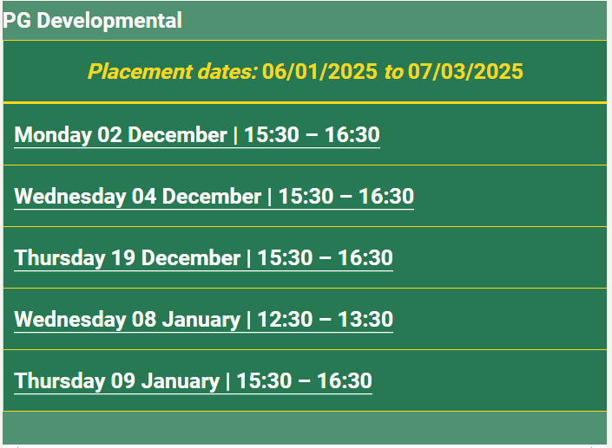

The Core Mentor Training link can be found here: OMNIS

The Phase Specific Training link can be found here Mentor Development - Mentor Space

The trainees will be starting their eight-week placement on Monday 6th January 2025. This professional practice experience lasts for 40 days and has an additional 2-day (Intensive Training and Practice) ITaP focus. The trainees
will be able to discuss this ITaP focus with you whilst on Professional Practice Placement (PPP). Their first job this
week is to identify with you, which 2 days this focus will be undertaken on (this needs to be BEFORE 31st January 2025). The focus for the ITaP is – Questioning for Assessment (QfA). Your support with this task would be greatly appreciated. More information regarding this QfA ITaP can be found at the end of this newsletter.

We ask that Mentors complete the (Weekly Development Summary) WDS, each and every week with the trainee
at their Weekly Development Meeting and identify clear and robust targets which the trainees will work on. Additionally, it is really important that trainee performance, related to progress through the curriculum, is identified clearly within each Weekly Development Summary.

Thank you, Mentors for your support, advice and help with our trainees. Please stay in touch with Link Tutors
who will be able to expertly guide you through this Professional Practice Placement successfully.

Weekly intended curriculum expectations:

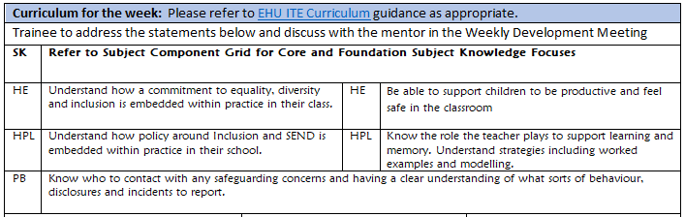

Links to CCF or centre-based training:
As part of the university-based teaching sessions, both prior to starting their Developmental Phase PPP and after the completion of this current placement, the trainees will have further opportunities to gain experience about, and reflect upon, the teaching of Systematic Synthetic Phonic strategies. We would therefore ask that before trainees complete this current placement, that they have had opportunities to both observe and teach a sequence of SSP lessons. There is a lesson observation template available on the Mentor Space to support the feedback.

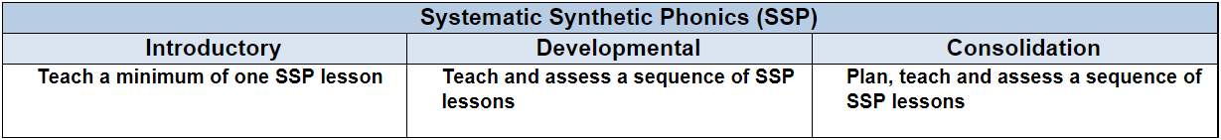

Link Tutors:
Thank you link tutors for agreeing to support mentors in providing a positive and effective experience on PPP for trainees.

Link Tutors please note that I have added you to a TEAMs chat group called, EYPGCE LT Chat Group Developmental
PPP, which is where anything related to this placement will be shared. It also offers you the opportunity to ask
and have questions/queries answered swiftly.
Mentor focus:
We would ask that Mentors focus their Weekly Development Meeting (WDM) upon the Intended Curriculum, as identified above. Furthermore, to engage trainees in professional dialogue related to what they have been learning
and how they can use this new knowledge and understanding to help them in planning and delivering effective
learning opportunities for the children. In relation to Future Targets within the WDS forms, please could you set
targets that relate to the Intended Curriculum for that week, and also, be very mindful of how
trainees can action and complete these targets within the timeframe they have on Developmental PPP. If you
require further support with target setting, please do contact your trainee’s Link Tutor in the first instance.

PLEASE NOTE - Weekly Development Summaries (WDS) are now completed, fully electronically on Abyasa, there is
no need to download, complete and upload these documents onto InPlace anymore. The EHU system for completing and recording WDS and Lesson Observation forms can be accessed and completed via Abyasa.

Observation of experts to support training suggestions:
This week sees the trainees Intended Curriculum relating to Safeguarding, SEND and EDI. With this in mind mentors,
we would ask that you talk with trainees about the SEND Code of Practice and how all schools and settings follow
this for the provision of pupils requiring an EHCP (Educational & Health Care Plan). This will help to support the
trainees developing knowledge and understanding of such a key and pivotal school process upon their return to campus in early-March 2025.

Research and resources:
Send Code of Practice: 0 to 25 Years: Dept for Education; Dept of Health & Social Care, 2014
Equality Act by Equality and Human Rights Commission 2010

SEND Review: Right support, right place, right time.
https://www.gov.uk/government/consultations/send-review-right-support-right-place-right-time

SEND: Old Issues, New Issues, Next Steps
Ofsted, 6/06/2021

Supporting SEND
Ofsted, 13/05/2021

Inclusion in the Early Years, Cathy Nutbrown; Peter Clough; Frances Atherton, 2013

If you require any further support or guidance, then please email the Primary 3-7 PGCE Professional Practice Quality Lead – Amanda Casey at Caseya@edgehill.ac.uk

Mentor Guidance for ITaP days.

During the Developmental phase of Professional Practice, trainees will complete two days of the Questioning for Assessment Intensive Teaching and Practice (ITaP).

Mentors will be able to set the ITaP days between 13th January – 31st January.

Please see guidance below for ITaP content. Trainees will share further information with their Mentors about the ITaP during the Developmental Professional Practice induction week.

Day One | Day Two
AM  Instructional coaching  Trainee observes a section of a whole class adult led input/lesson lead by the mentor.  The expert mentor uses an instructional coaching approach to support the identification of effective QfA strategies that are used.  AM/PM  Deliberate practice: working towards specific goals.  Trainees work with children during independent practice.  Mentor supports the trainee in a coaching role to engage in professional dialogue.  Deliberate practice: Receive and respond to feedback.  PM  The mentor and trainee engage in professional discussion about Day 1.  Trainees in collaboration with the mentor plan for QfA) which the mentor records on an (IDS) for Day 1.  Using this mentor and trainee co-plan tomorrow’s lesson using an existing lesson plan and carefully layer QfA into the existing lesson plan. | Please arrange the timings of this day according to what works best in your school setting.  Assessing practice: Recording a taught extract of teaching  Having planned with the mentor, the trainee teaches and records approximately 10 minutes of a directed teaching input where QfA is evident for example 10 minutes of a mathematics lesson.  Self-reflection and feedback  The trainee independently self-reflects on the 10-minute recorded video by analysing their practice.  Following this, the mentor and trainee engage in professional discussion which the mentor records on the IDS for Day 2.  The mentor supports the trainee’s self-reflection and analysis and engages in purposeful dialogue to give effective feedback. The mentor and trainee set a SMART development target that will become a focus for the following week.  Trainee Independent Final Reflections  Independent time needed: 1.5 hrs.  Trainees record how they have developed their knowledge, skills and understanding and add this to their Pebblepad Portfolio.

