

Welcome to the Weekly Mentor, Trainee and Link Tutor Briefing from the
Department of Early Years.

Course:  Primary 3-7 PGCE with QTS | Phase:  Developmental | Week:  2

Welcome to the DEVELOPMENTAL professional practice placement for the Primary 3-7 (Early Years)
PGCE trainees. Please note the Intended Curriculum (Strand) for this week below, and this forms part of the EHU curriculum that the trainees will be focusing on during this placement. Please also refer to the Primary 3-7
(Early Years) PGCE Handbook where you will find the SUBJECT Intended Curriculum. The Subject and Strand
Component Trackers, are also available from the Mentor Space (please access via this link)
https://sites.edgehill.ac.uk/mentorspace/

Mentor training is essential to ensure that the right level of support is offered to our trainees. We would ask that all Mentors complete the ONLINE MENTOR TRAINING, if not already completed last academic year. There is also PHASE SPECIFIC MENTOR TRAINING that has been conducted centrally by the EHU team. If you missed this, then the PowerPoint slides and recording can be accessed through the Mentor Space link.

This week, the trainees will be starting week 2 of an eight-week placement. This professional practice experience
lasts for 40 days and has an additional 2-day (Intensive Training and Practice) ITaP focus. The trainees
will be able to discuss this ITaP focus with you whilst on Professional Practice Placement (PPP). Their first job this
week is to identify with you, which 2 days this focus will be undertaken on (this needs to be BEFORE 31st January 2025). The focus for the ITaP is – Questioning for Assessment (QfA). Your support with this task would be greatly appreciated.

We ask that Mentors complete the (Weekly Development Summary) WDS, each and every week with the trainee,
at their Weekly Development Meeting and identify clear and robust targets which the trainees will work on. Additionally, it is important that trainee performance, related to progress through the curriculum, is identified clearly within each Weekly Development Summary. This weekly WDS will be fully accessible using the Abyasa platform.

Weekly intended curriculum expectations:

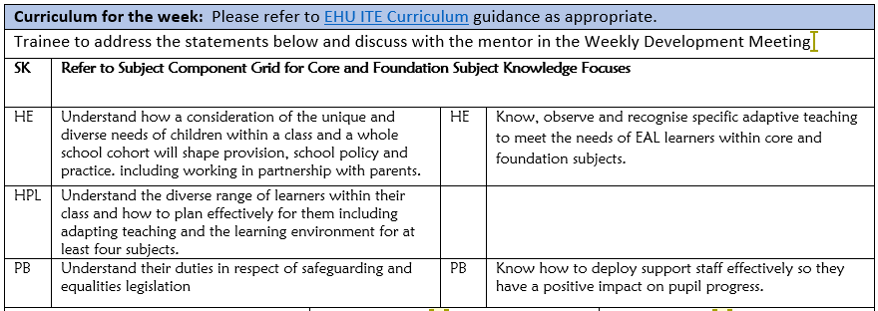

Links to CCF or centre-based training:
As part of the university-based teaching sessions, both prior to starting their Developmental Phase PPP and after the completion of this current placement, the trainees will have further opportunities to gain experience about, and reflect upon, the teaching of Systematic Synthetic Phonic strategies. We would therefore ask that before trainees complete this current placement, that they have had opportunities to both observe and teach a sequence of SSP lessons. There is a lesson observation template available on the Mentor Space to support the feedback.

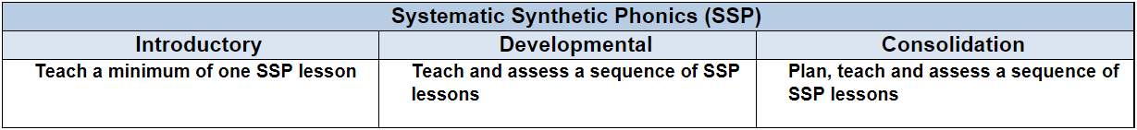

Link Tutors:
Thank you link tutors for agreeing to support Mentors in providing a positive and effective experience on PPP for trainees. We would ask that Abyasa is updated as soon as ‘visits’ are undertaken with Mentors and trainees. If you require any further support with this, then please do get in touch, or contact the wider team at FOEMentoring@edgehill.ac.uk

Link Tutors please note that I have added you to a TEAMs chat group called, EYPGCE LT Chat Group Developmental
PPP, which is where anything related to this placement will be shared. It also offers you the opportunity to ask
and have questions/queries answered swiftly.

Mentor focus:
We would ask that Mentors focus their Weekly Development Meeting (WDM) upon the Intended Curriculum, as identified above. Furthermore, to engage trainees in professional dialogue related to what they have been learning
and how they can use this new knowledge and understanding to help them in planning and delivering effective
learning opportunities for the children. The trainees will be able to clearly articulate the Edge Hill Curriculum
that drives their learning, which also features the Core Content Framework and Edge Hill Pillars, at its core.

In relation to Future Targets within the WDS forms, please could you set targets that relate to the Intended
Curriculum for that week, and be very mindful of how you can support trainees in actioning and completing
these targets within the timeframe they have on Developmental PPP.
If you require further support with target setting, please do contact your trainee’s Link Tutor in the first instance.

Observation of experts to support training suggestions:
Please see below, the intended curriculum for trainees whilst learning about SSP in taught sessions on campus. We would ask that during the first half of this Developmental Phase Placement, that the trainees have opportunities to observe SSP teaching, to talk with key members of staff regarding the planning, teaching, and assessment of SSP
and finally, that the trainees have an opportunity to jointly plan a sequence of lessons focused upon SSP, either within their allocated class/year group or in another class/phase.

To continue to develop subject and curriculum knowledge of key SSP terminology.

To develop further knowledge and understanding of adaptive teaching in SSP to provide the necessary amount of scaffolding for learners such as children with SEND, children who have English as an additional language (EAL) and consider stretch and challenge.

To develop knowledge and understanding of longer-term sequencing learning and progression in SSP.

To further explore the structure and components of an SSP lesson and a weekly sequence of lessons through
examining planning including opportunities for formative assessment to support progress.

Research and resources:
DfE (2023) The Reading Framework

Ehri, L. C. (2022) “What Teachers Need to Know and Do to Teach Letter-Sounds, Phonemic Awareness, Word Reading, and Phonics,” Reading Teacher, 76(1), pp. 53–61.

GLAZZARD, J. and STOKOE, J. (2017) Teaching Systematic Synthetic Phonics and Early English (2nd Edition) St Albans: Critical Publishing

Machin, S., McNally, S., & Viarengo, M. (2018) Changing how literacy is taught: Evidence on synthetic phonics.
American Economic Journal: Economic Policy, 10(2), 217–241.

Milankov, V., Golubović, S., Krstić, T. and Golubović, Š. (2021). Phonological Awareness as the Foundation of
Reading Acquisition in Students Reading in Transparent Orthography. International Journal of Environmental Research and Public Health, 18(10), p.5440.

If you require any further support or guidance, then please email the Primary 3-7 PGCE Professional Practice Quality Lead – Amanda Casey at Caseya@edgehill.ac.uk

