

Welcome to the Weekly Mentor, Trainee and Link Tutor Briefing from the
Department of Early Years.

Course:  Primary 3-7 PGCE with QTS | Phase:  Developmental | Week:  4

Well done trainees for getting through the cold month of January, the children will be very settled back into routines and schedules now, post-Christmas. Thank you, Mentors, for continuing to support our PG trainees, again at such a busy time. We, and the trainees, are grateful for your expert and positive mentoring and in helping them to shape and hone their own practices. This experience will stand them in good stead for when they are fully qualified class teachers in September. And finally, thank you Link Tutors for the wonderful work that you do in liaising with the trainee and the Mentor to ensure that this PP Placement is a positive and encouraging time for all. As always, if you require any further training needs, support, advice, or guidance regarding any aspect of this placement, then please do get in touch using my details at the end of this newsletter.

Mentor Training (reminders!) this occurs in 3 stages: STAGE 1 which is the ONLINE Training package
which can be accessed in the Mentor’s own time and space (this will only need to be undertaken if not completed last academic year). This is an essential part of the training package for Mentors as it will help to strengthen the knowledge of their role and the expectations of providing support to EHU trainees. STAGE 2 is the PHASE SPECIFIC MENTOR TRAINING that has been conducted centrally by the EHU team. If you missed this, then the PowerPoint slides and recording can be accessed through the Mentor Space link. Alternatively, the Link Tutor can deliver this training, individually, to school mentors upon request. And finally,
STAGE 3 is the informative and comprehensive MENTOR SPACE that can be accessed via this link, - Mentor Space which will help Mentors and Link Tutors understand more about the processes and paperwork attached to this placement, in a one-stop-shop platform.

If you have any questions or require any further support with the Mentor Training expectations, then please contact me or the allocated Link Tutor.

By the end of this week, in the main, the trainees will have completed their additional 2-day (Intensive Training and Practice) ITaP focus. The trainees have been asked to discuss this ITaP focus with you whilst on Professional Practice Placement (PPP). They have already identified with us the 2 days to focus upon Questioning for Assessment. This ITaP process has required trainees to observe the Mentor, as the expert colleague, in modelling how questions are used for assessing learning and then follow this with a professional dialogue about what made the questioning successful.

We ask that Mentors complete the (Weekly Development Summary) WDS, each and every week with the trainee,
at their Weekly Development Meeting and identify clear and robust targets which the trainees will work on using Abyasa. Additionally, it is important that trainee performance, related to progress through the curriculum, is identified clearly within each Weekly Development Summary. This weekly WDS will be a reduced/more simplified form
during the week of the focused ITaP WDS, this is to ensure that teacher/trainee workload is addressed more robustly.

Trainees, it is important that you and the Mentor complete the WDS forms, each Friday before you finish placement
for the weekend. This means that we can track your progress regularly and put support in place more quickly,
should it be needed.

Weekly intended curriculum expectations:

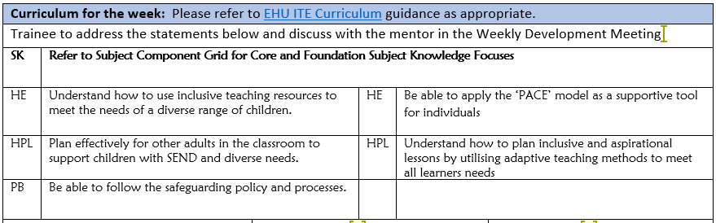

Links to CCF or centre-based training:
As the teaching of Systematic Synthetic Phonic strategies is a Government and National priority, we would ask that before trainees complete this current placement, that they have had opportunities to both observe and teach a sequence of SSP lessons. There is a lesson observation template available on the Mentor Space to support the feedback. Another really important strategy that schools can support trainees with, is to allow them to observe SSP teaching in a range of classes, with opportunities to talk with expert colleagues both before and after the lesson, to ensure there is a robust understanding of how and why SSP is planned so successfully in each school and class.

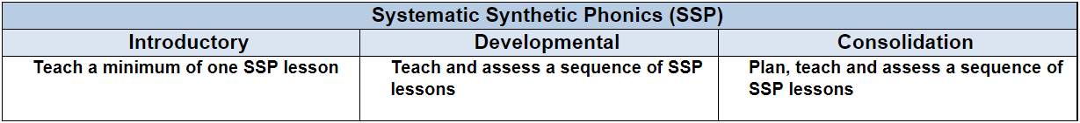

Link Tutors:
Thank you for undertaking 2 online ‘visits’ to schools, meeting with Mentors and trainees, so far. Please could I ask
that you update Abyasa as soon after each ‘visit’ as possible. Abyasa allows me to see which trainees are meeting the placement expectations, and which trainees, if any, may require further support. Please do let me know as soon as possible, if there any matters that you wish to discuss.

Mentor focus:
We would ask that Mentors focus their Weekly Development Meeting (WDM) upon the Intended Curriculum, as identified above. Furthermore, to engage trainees in professional dialogue related to what they have been learning
and how they can use this new knowledge and understanding to help them in planning and delivering effective
learning opportunities for the children. The trainees will be able to clearly articulate the Edge Hill Curriculum
that drives their learning, which also features the Core Content Framework and Edge Hill Pillars, at its core.

In relation to Future Targets within the WDS forms, please could you set targets that relate to the Intended
Curriculum for that week, and be very mindful of how you can support trainees in actioning and completing
these targets within the timeframe they have on Developmental PPP.
If you require further support with target setting, please do contact your trainee’s Link Tutor in the first instance.

Observation of experts to support training suggestions:
Please see below, the intended curriculum for trainees whilst planning for, delivering lessons, and learning focused
on PSED/PSHE. During this time of year there may be a requirement to think about children’s personal and social emotional wellbeing and how this can be addressed in lessons.

To plan and assess a range of social and emotional skills in learning environments beyond the classroom.

To consider ways to incorporate a range of opportunities to promote overall emotional well-being.
The importance of PSHE and RE education to children’s holistic development.
Inclusive active learning and teaching strategies for PSHE lessons
The new DfE 2019 statutory requirements for Health and Relationships Education

Research and resources:
BLANCO-BAYO, A., 2020. ‘It doesn’t matter because I love you.” A case study examining the interpretation of Behaviour Classification Tables and Positive Behaviour Support models. Emotional and Behavioural Difficulties. 25 (2), pp. 155–168.
ELFER, P., GOLDSCHMIED, E. & SELLECKE, D.Y. 2012; 2011, Key persons in the early years: building relationships for quality provision in early years settings and primary schools, 2ndedn, Routledge, London.
GARVEY, D. and ZEEDYK, M.S., 2018. Nurturing personal, social, and emotional development in early childhood: a practical guide to understanding brain development and young children’s behaviour. London: Jessica Kingsley Publishers.
RUCINSKI, C.L., BROWN, J.L., and DOWNER, J.T., 2018. Teacher–child relationships, classroom climate, and children’s social-emotional and academic development. Journal of Educational Psychology. 110 (7), pp. 992–1004.

SKUSE, D., BRUCE, H., and DOWDNEY, L., eds., 2017. Child psychology and psychiatry: frameworks for clinical training and practice. Third edition. Hoboken, NJ: John Wiley & Sons, Inc.

THEODOTOU, E., 2019. Supporting personal and social development through child-led art projects in the early year’s settings. Early Child Development and Care. 189 (11), pp. 1889–1900.

If you require any further support or guidance, then please email the Primary 3-7 PGCE Professional Practice Quality Lead – Amanda Casey at Caseya@edgehill.ac.uk

