

Welcome to the Weekly Mentor, Trainee and Link Tutor Briefing from the
Department of Early Years.

Course:  Primary 3-7 PGCE with QTS | Phase:  Developmental | Week:  6

Throughout the next 3 weeks we would ask that Mentors continue to complete the (Weekly Development Summary) WDS, each and every week with the trainee, at their Weekly Development Meeting. Please identify clear and robust targets, which the trainees will work on, and talk with them about how they will achieve these most effectively.

Trainees will require the expert colleagues within settings, to clearly articulate their thoughts and feedback, so that
they know very clearly what is expected of them.

Trainees, in the main you will be building up the time that you are planning, teaching, and assessing children’s learning across the week. Please use this time well to undertake professional conversations with mentors and class teachers about how best to develop your teaching practice.

Please also ensure that you agree times with your mentor when you can take responsibility for transition periods throughout the day, as this will certainly help to instil professional behaviours which will support you in your full-time teaching capacity when the Consolidation Phase PP Placement begins.

Weekly intended curriculum expectations:

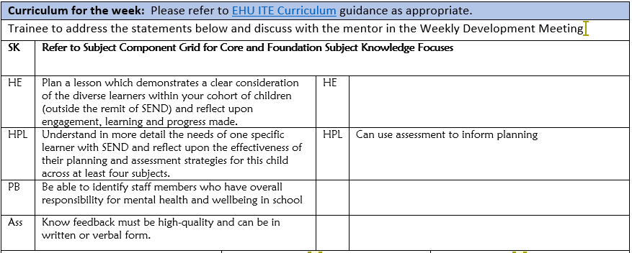

Trainees remember to use your WDM time to discuss thoroughly what you intend to plan and how you expect lessons to be delivered each week. Your mentor/expert colleague will be able to direct and support your thoughts and ideas to ensure that teaching is successful, and that children’s outcomes are positive.

Links to CCF or centre-based training:
As the teaching of Systematic Synthetic Phonic strategies is a Government and National priority, we would ask that before trainees complete this current placement, that they have had opportunities to both observe and teach a sequence of SSP lessons. There is a lesson observation template available on the Mentor Space to support the feedback. Another really important strategy that schools can support trainees with, is to allow them to observe SSP teaching in a range of classes, with opportunities to talk with expert colleagues both before and after the lesson, to ensure there is a robust understanding of how and why SSP is planned so deliberately in each school and class.

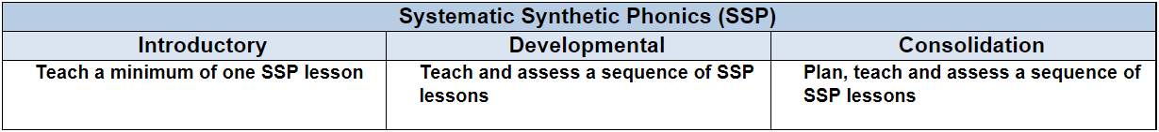

Link Tutors:
Please communicate with trainees and Mentors about when you will undertake an in person visit at school for QA3. This will most likely happen either this week or next (if it has not already been undertaken.)

Trainees learn so much and gather lots of information regarding their practice and pedagogy following a professional discussion with colleagues after a lesson observation has taken place. Good luck with this trainee and please let
us know how this goes.

Mentor focus:
We would ask that Mentors focus their Weekly Development Meeting (WDM) upon the Intended Curriculum, as identified above. Furthermore, to engage trainees in professional dialogue related to what they have been learning
and how they can use this new knowledge and understanding to help them in planning and delivering effective
learning opportunities for the children. The trainees will be able to clearly articulate the Edge Hill Curriculum
that drives their learning, which also features the Core Content Framework and Edge Hill Pillars, at its core.

In relation to Future Targets within the WDS forms, please could you set targets that relate to the Intended
Curriculum for that week, and be very mindful of how you can support trainees in actioning and completing
these targets within the timeframe they have on Developmental PPP.

If you require further support with target setting, please do contact your trainee’s Link Tutor in the first instance.

Observation of experts to support training suggestions:
MATHEMATICS is a focus that trainees will be reflecting more upon, in the next part of their PP Placement.
This is as a direct consequence of their teaching responsibility and expectations increasing over the next 4 weeks.
We would ask that as Mentors and Link Tutors, you hold professional dialogues with trainees focusing on
the following:

To know how to collaborate with colleagues to create learning that is inspirational and challenging that helps pupils to be extrinsically motivated in their mathematics lessons.

To know how to plan and deliver a well-sequenced mathematics curriculum that is representative of the school's values and ethos.

To understand how to encourage resilience and perseverance in pupils’ mathematical learning and normalise the making of mistakes.

To understand how to model new content effectively, using a blend of discussion, questioning and examples to develop understanding in mathematics lessons.

To be an effective role model, including how to model a positive attitude towards mathematics.

Research and resources:

Haylock, D., and Manning (2019) Mathematics Explained for Primary Teachers. Los Angeles: SAGE.

Montague-Smith, A, Cotton, T, Hanson, A. and Price, A. (2018) Mathematics in Early Years Education. Oxon: Routledge.

NCETM Progression Maps for EYFS.
Available at:
https://www.ncetm.org.uk/in-the-classroom/early-years/

OFSTED. 2021. Research Review Series: Mathematics. Available at: https://www.gov.uk/government/publications/research-review-series-mathematics

Pound, L. (2022) Teaching Mathematics Creatively. Oxon: Routledge

If you require any further support or guidance, then please email the Primary 3-7 PGCE Professional Practice Quality Lead – Amanda Casey at Caseya@edgehill.ac.uk

