7


Welcome to the Weekly Mentor, Trainee and Link Tutor Briefing from the
Department of Early Years.

Course:  Primary 3-7 PGCE with QTS | Phase:  Developmental | Week:  7

The next 2 weeks we see a focus on the trainees completing their placement successfully and with clear and specific targets which they will be able to work on once their Consolidation Placement begins. Thank you to Mentors and Link Tutors for supporting trainees throughout this placement; it certainly has been a positive and productive placement
for many. Please do remember that if there are any questions, queries, or concerns about the placement, its
processes or paperwork, then please do get in touch as soon as possible.

Mentors, please remember that the WDS can be used to identify and note the conversations that you are having
with trainees each and every day, regarding the progress being made against all areas of the curriculum. This
document can be used as a ‘weekly check in form’ to capture all the wonderful professional conversations and
teaching, that may arise throughout the whole week between you both.

Trainees, it is important that you and the Mentor complete the WDS forms, each Friday before you finish placement
for the weekend. This means that we can track your progress regularly and put support in place more quickly,
should it be needed. We have undertaken a QA check of InPlace this week and can see that some records are missing WDS/LO forms, so please complete these on Abyasa as soon as possible.

Trainees, in the main you will be increasing your planning, teaching, and assessing of the children’s learning each week, for the final 2 weeks. Please use this time well to undertake professional conversations with mentors and class teachers about how best to develop your teaching practice.

Please also ensure that you agree times with your mentor when you can take responsibility for transition periods throughout the day, as this will certainly help to instil professional behaviours which will support you in your full-
time teaching capacity when the Consolidation Phase PP Placement begins.

Weekly intended curriculum expectations:
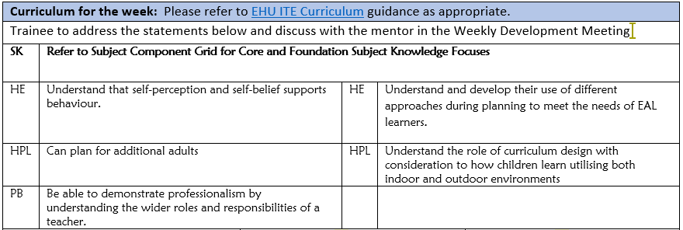

Trainees remember to use your WDM time to discuss thoroughly what you intend to plan and how you expect lessons to be delivered each week. Your mentor/expert colleague will be able to direct and support your thoughts
and ideas to ensure that teaching is successful, and that children’s outcomes are positive.

Links to CCF or centre-based training:
As the teaching of Systematic Synthetic Phonic strategies is a Government and National priority, we would ask that before trainees complete this current placement, that they have had opportunities to both observe and teach a sequence of SSP lessons. There is a lesson observation template available on the Mentor Space to support the feedback. Another really important strategy that schools can support trainees with, is to allow them to observe SSP teaching in a range of classes, with opportunities to talk with expert colleagues both before and after the lesson, to ensure there is a robust understanding of how and why SSP is planned so deliberately in each school and class.

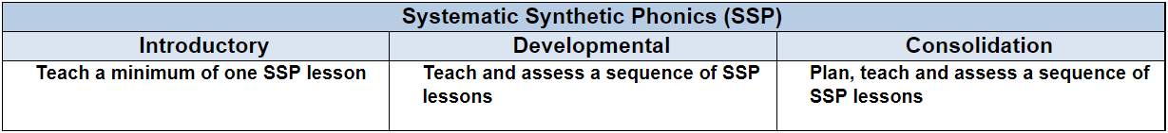

Link Tutors:
Please communicate with trainees and Mentors about when you will undertake an in person visit at school for QA3. This will most likely happen this week if it has not already been undertaken.

Trainees learn so much and gather lots of information regarding their practice and pedagogy following a professional discussion with colleagues after a lesson observation has taken place. Good luck with this trainee and please let
us know how this goes.

Mentor focus:
We would ask that Mentors focus their Weekly Development Meeting (WDM) upon the Intended Curriculum, as identified above. Furthermore, to engage trainees in professional dialogue related to what they have been learning
and how they can use this new knowledge and understanding to help them in planning and delivering effective
learning opportunities for the children. The trainees will be able to clearly articulate the Edge Hill Curriculum
that drives their learning, which also features the Core Content Framework and Edge Hill Pillars, at its core.

In relation to Future Targets within the WDS forms, please could you set targets that relate to the Intended
Curriculum for that week, and be very mindful of how you can support trainees in actioning and completing
these targets within the timeframe they have on Developmental PPP.

If you require further support with target setting, please do contact your trainee’s Link Tutor in the first instance.

Observation of experts to support training suggestions:
PLANNING is a focus that trainees will be reflecting more upon, in the next part of their PP Placement.
This is as a direct consequence of their teaching responsibility and expectations increasing over the next 2 weeks.
We would ask that as Mentors and Link Tutors, you hold professional dialogues with trainees focusing on
the following:

That trainees use assessment to inform planning.

That trainees evaluate the effectiveness of lessons they have planned/taught to inform future planning.

That trainees know how to manage workload and wellbeing by planning efficiently and sharing the workload (where appropriate.)

That trainee can plan for additional adults (where appropriate.)

That trainees understand how to plan inclusive and aspirational lessons by utilising adaptive teaching methods
to meet all learners needs.

That trainees know and understand that teachers break down the national curriculum/EYFS end points into
component knowledge in their Short-Term Planning.

Research and resources:

Ephgrave, A. (2013) The reception year in action. 2nd edn. Hoboken: Taylor and Francis.

Ephgrave, A. (2015) The nursery year in action: following children's interests through the year. London: Routledge,
Taylor & Francis Group.

Ephgrave, A. (2018) Planning in the moment with young children: a practical guide for early years practitioners and parents. Milton Park, Abingdon, Oxon: Routledge.

Fisher, J. (2016) Interacting or interfering?: improving interactions in the early years. Maidenhead: Open University Press.
Rosenshine, B. (2010). Principles of instruction; Educational practices series; Vol.:21; 2010. The International Academy of Education, 21(2010).
Rosenshine, B. (2012) Principles of Instruction: Research-Based Strategies That All Teachers Should Know. American Educator, 36(1), p12-39.

If you require any further support or guidance, then please email the Primary 3-7 PGCE Professional Practice Quality Lead – Amanda Casey at Caseya@edgehill.ac.uk

