7


Welcome to the Weekly Mentor, Trainee and Link Tutor Briefing from the
Department of Early Years.

Course:  Primary 3-7 PGCE with QTS | Phase:  Developmental | Week:  8

Welcome to the final week of this EYPGCE Developmental Phase Professional Practice Placement. As the
trainees are nearing the end of this phase of their training, I would ask that they be encouraged to ensure that all paperwork elements of this PPP are complete, near completion and/or ready to be uploaded onto InPlace. If there
are missing documents then this may hinder a smooth transition in the Consolidation Phase of PPP.

Please do remember that if there are any questions, queries, or concerns about the placement, that as a trainee,
Mentor or Link Tutor you may have, then please do get in touch as soon as possible.

Link Tutors please remember to schedule in the QA 4 ‘check point’ with trainees and Mentors as the last professional conversation to be had, regarding the final WDS and the outcome for the trainee before they progress onto the next phase of their training, the Consolidation PPP.

Weekly intended curriculum expectations:
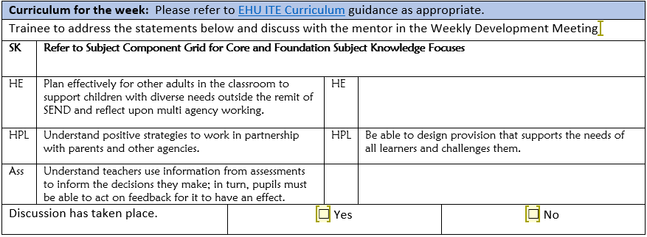

Trainees remember to use your WDM time to discuss thoroughly what you intend to plan and how you expect lessons to be delivered each week. Your mentor/expert colleague will be able to direct and support your thoughts
and ideas to ensure that teaching is successful, and that children’s outcomes are positive.

Links to CCF or centre-based training:
As the teaching of Systematic Synthetic Phonic strategies is a Government and National priority, we would ask that before trainees complete this current placement, that they have had opportunities to both observe and teach a sequence of SSP lessons. There is a lesson observation template available on the Mentor Space to support the feedback. Another important strategy that schools can support trainees with, is to allow them to observe SSP
teaching in a range of classes, with opportunities to talk with expert colleagues both before and after the lesson, to ensure there is a robust understanding of how and why SSP is planned so deliberately in each school and class.

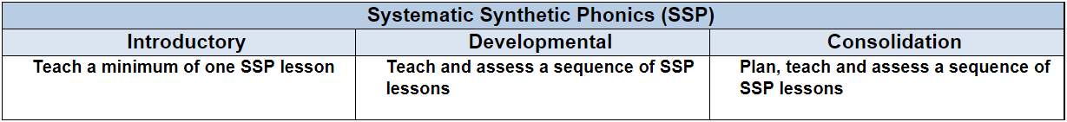

Link Tutors:
Please remember to update Abyasa as soon as you possibly can, following the QA 4 visit/check point, as this is the information we use to ‘conclude or close off’ the Developmental PPP, before the trainee can progress to the Consolidation Phase Placement. Many thanks for your support with this.

Mentor focus:
We would ask that Mentors focus their Weekly Development Meeting (WDM) upon the Intended Curriculum, as identified above. Furthermore, to engage trainees in professional dialogue related to what they have been learning
and how they can use this new knowledge and understanding to help them in planning and delivering effective
learning opportunities for the children. The trainees will be able to clearly articulate the Edge Hill Curriculum
that drives their learning, which also features the Core Content Framework and Edge Hill Pillars, at its core.

In relation to Future Targets within the WDS forms, please could you set targets that relate to the Intended
Curriculum for that week, and be very mindful of how you can support trainees in actioning and completing
these targets within the timeframe they have on Developmental PPP.

If you require further support with target setting, please do contact your trainee’s Link Tutor in the first instance.

SEND focus:
Could I please ask that trainees talk with the teacher during the WDM about how they may support the self esteem
of children with SEND. In particular those children who are aware that they have different provision or require further
intervention to support learning or even those learners who find aspects of learning difficult. This will certainly
help the trainees begin to develop a deeper understanding of how to meet the needs of all learners.

Observation of experts to support training suggestions:
ENGLISH/LITERACY is a focus that trainees will be reflecting more upon in the next part of their training, and in
particular the teaching of SSP. This Developmental Phase PPP expected trainees to plan, teach and assess a sequence
of SSP lessons aimed at a group of children, in preparation for their Consolidation Phase PPP, whereby full-time class teaching will be a priority and planning for all areas of the curriculum will be essential.

This is as a direct consequence of their teaching responsibility and expectations increasing over the phase of their training. Therefore, we would ask that as Mentors and Link Tutors, you hold professional dialogues with trainees
focusing on the following:

To know how to collaborate with colleagues to create learning that is inspirational and challenging that helps pupils
to be extrinsically motivated in their reading and writing lessons.

To know how to plan and deliver a well-sequenced English curriculum that is representative of the school's values
and ethos.

To understand how to encourage resilience and perseverance in pupils reading and writing learning and normalise
the making of mistakes.

To understand how to model new content effectively, using a blend of discussion, questioning and examples to
develop understanding in English lessons.

To know how to be an effective role model, including how to model good standards of written and oral English.

To adjust planning in English lessons, according to formative assessment information of children’s reading and
writing skills.

Research and resources:

HOLMES, R. M. et al. 2019. The relationship between young children’s language abilities, creativity, play, and storytelling.
Early Child Development and Care.

HOLMES, R. M. et al. 2022. Is there a connection between children’s language skills, creativity, and play? Early Child
Development and Care.

The Education Endowment Foundation, 2021. Improving Literacy in Key Stage 1: Guidance Report.

If you require any further support or guidance, then please email the Primary 3-7 PGCE Professional Practice Quality Lead – Amanda Casey at Caseya@edgehill.ac.uk

