

BA (Hons) Primary Education with QTS

Year 3
Intensive Training and Practice (ITAP)
Questioning for Assessment

Mentor Information and Overview





What is an ITAP?

ITAP stands for Intensive Training and Practice and differs from other weeks of training due to the ‘intense focus on specific pivotal areas’ (Department for Education (DfE), 2022:26). An ITAP offers an opportunity to have intensive focus on a specific and fundamental aspect of practice to ‘give trainees feedback on foundational aspects of the curriculum where close attention to and control of content, critical analysis, application and feedback are required’ (DfE, 2022:26).

Our ITAPs are aligned with the philosophy of the 2024 Initial Teacher Education (ITE) accreditation and the National Institute of Teaching (NIOT) with a key aim to ‘strengthen the link between evidence and classroom practice’ (DfE, 2022:26).The ITAPs are built on principles of approximation of practice (Reich, 2022: Grossman 2018) which enable trainees to put theory into practice and receive feedback outside of a classroom environment (NIOT, 2023:1). This includes elements of intense training at the university with expert theoretical input by university tutors, partnership experts, lead mentors or lead practitioners. They all identify the specific pivotal practice that will be developed and crucially how this is linked to the overall intended curriculum and sequence of learning. This is combined with time in the classroom to enact practice and further support development of knowledge, skills and understanding.

ITAP Structure

ITAP Structure This ITAP is designed using a framework adapted from the 2023 NIOT pilot and combine centre and school-based activities which include the following elements:

- Critical analysis of teaching and materials linked to theory and the evidence base
- Expert modelling and deconstruction of pivotal practice and components
- Deliberate practice by trainees with multiple opportunities for expert feedback
- Implementation of the component in simulation, digital or real scenarios
- Assessment and target setting for further development

They follow a clear sequential structure using the NIOT 2023 pilot:

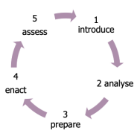

- Introduce: support trainees’ learning about the theory of teaching and learning around a given aspect of pivotal practice

- Analyse: support trainees to analyse and deconstruct expert teaching.

- Prepare: provide opportunities for trainees to use approximations to practice and get expert feedback

- Enact: support trainees to apply their learning in the classroom in different scenarios and contexts

- Assess: monitor trainees’ knowledge and skills

Questioning for Assessment ITAP
(Year 3)

Effective questioning is a key part of high-quality instruction which is one of the six key components of effective teaching (Coe et al., 2014:2-3) with strong evidence of impact on student outcomes. Coe et al. (2020:34-35) identify that teachers use questioning for two main and distinct purposes: to promote students’ thinking and to assess it. Therefore, as a pivotal aspect of practice this ITAP will focus on the use of questioning to effectively monitor and assess the progress of the class and individual pupils. The key curriculum components of this ITAP are underpinned by the Initial Teacher Training and Early Career Framework (DfE, 2024) as follows:

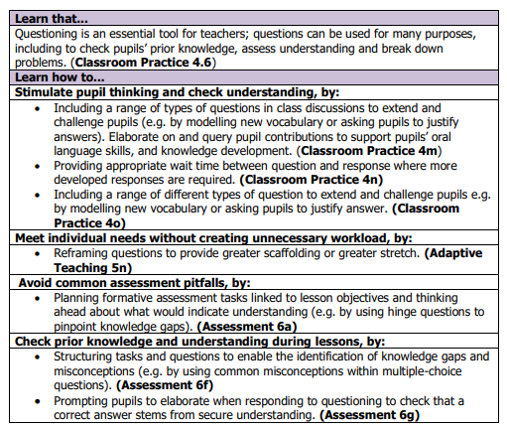

What did trainees do?

The model below was explored through the ITAP to explore key elements of questioning for assessment, alongside questioning resources from the Walkthrus platform: https://walkthrus.co.uk/members-area

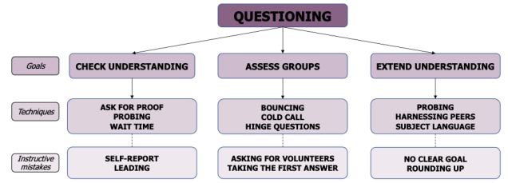

During the ITAP, the overarching intention was to consolidate understanding of how the research evidence base underpinning the Initial Teacher Education (ITE) curriculum shapes teaching practice. This approach to teacher education offers opportunities to expand knowledge, deepen understanding of theory and practice and increase trainees’ confidence to teach using this pivotal aspect of practice.

Trainees learned about questioning from experienced tutors, teachers and mentors and had the opportunity to observe and reflect on expert practice. They considered how this can be embedded into their own teaching. Trainees developed knowledge and skills to apply what they had learnt, deconstructed practice and received feedback and coaching from peers and expert practitioners. By focusing on questioning for assessment, trainees gained insights into many aspects of practice and this supports their knowledge, skills and understanding of:

• School assessment policy and procedures

• Curriculum expectations including statutory reporting and assessment

• Planning – focusing on assessing learning and overall learning outcomes

How can mentors support trainees on professional practice?

As part of the campus-based ITAP sessions, trainees completed a reflective journal and engaged in professional dialogue with their Personal Academic Tutors. We now expect trainees to put their learning into action! In your capacity as a school-based mentor, you can support trainees in the following ways:

- Facilitating opportunities for trainees to observe effective questioning for assessment
- Discussing and deconstructing questioning approaches
- Supporting trainees with planning of effective questioning in a range of subjects
- Allowing trainees time to reflect on their use of questioning for assessment in observed lessons
- Providing constructive feedback on questioning for assessment in WDS meetings and in lesson observations

Thank you for supporting our trainees – we appreciate it!

References

COE, R., ALOISI, C., HIGGINS, S. and MAJOR, L. E., 2014. What makes great teaching? Review of the underpinning research. Durham University: UK. Available from: https://www.suttontrust.com/wp-content/uploads/2014/10/What-Makes-Great-Teaching-REPORT.pdf

COE, R, RAUCH C.J., KIME, S. and SINGLETON, D., (2020) Great Teaching Toolkit: Evidence Review. Available from: https://www.cambridgeinternational.org/Images/584543-great-teaching-toolkit-evidence-review.pdf

DEPARTMENT FOR EDUCATION., 2022. Initial teacher training (ITT): provider guidance on stage 2. Available from: https://www.gov.uk/government/publications/initial-teacher-training-itt-provider-guidance-on-stage-2

GROSSMAN, P., 2018 (ed). Teaching core practices in teacher education. Cambridge, MA: Harvard Education Press.

NATIONAL INSTITUTE OF TEACHING., 2023. Intensive Training and Practice Pilot: Pilot Evaluation Report. Available from: https://niot.s3.amazonaws.com/documents/ITP_NIoT_Cover.pdf

REICH, J., 2022. Teaching Drills: Advancing Practice-Based Teacher Education. Available from: https://eric.ed.gov/?id=EJ1358628

