
Welcome to the weekly mentor, trainee and link tutor briefing from the Primary Education Department.
Course | BA (Hons) Primary Education with QTS
Phase: | Consolidation | Week: | 2 (3rd – 7th March 2025)

Weekly intended curriculum expectations linked to ITTECF:
High Expectations: Collaborate in multi-agency working with internal and external colleagues. Know that they have professional responsibilities in relations to inclusion (e.g. The Equality Act, 2010).

How Pupils Learn / Classroom Practice / Adaptive Teaching: Understand the importance of working collaboratively and co-operatively with other professionals and agencies. Know that sequences of learning must break down learning into small steps to take account of all learners (including those with SEND) from the outset.

Professional Behaviours: Know the importance of parental engagement

Assessment: N/A

Mentor Focus:
Training: It is a requirement that all mentors complete the Core and Phase-Specific Mentor Training. Thank you to those of you who have already completed it. There are still a couple of dates available for the Phase Specific Mentor Training:

- Core Mentor Training (Contact FoEMentoring@edgehill.ac.uk for technical support)
- Phase Specific Mentor Training
  - Tuesday 4th March 15:30 – 16:30
  - Thursday 6th March 15:30 – 16:30

Abyasa: There is a training guide available to support with any technical or operational issues that you may be experiencing with Abyasa. You can access the Abyasa mentor training guide here. If your query cannot be resolved, please contact foementoring@edgehill.ac.uk

QA2: Your link tutor will be in touch, if they have not already done so, to arrange a brief meeting on Teams. This is a three-way meeting between you, the trainee and the link tutor. Some of the themes covered in the meeting include:
- Does the trainee know who the DSL/DSO is?
- Has the trainee shared their targets from their developmental practice?
- Are you aware of the mentoring requirements and EHU ITE curriculum for this placement?
- Are trainees receiving their 20% PPA entitlement, WDS meeting and weekly observation?
- Are you confident with the WDS and information that is required?

If you have any issues, queries or concerns, please do not hesitate to contact your assigned link tutor at the earliest opportunity. They will be able to offer guidance, support and answer many of your questions (or find a colleague who can). If your query is about your link tutor, please email the Professional Practice and Quality Lead, Ben Thomas ben.thomas@edgehill.ac.uk.

Observation of experts to support training suggestions: | Research and Resources:
In preparation for the second Weekly Development Summary meeting, it may be beneficial for trainees to speak to the following colleagues/experts in school:  - SEND Coordinator  - Inclusion Lead  It would also be beneficial for trainees to observe any interactions with parents at drop-off, collection and arranged meetings. | Department for Education, 2018. Equality Act 2010: advice for schools. Available from: https://www.gov.uk/government/publications/equality-act-2010-advice-for-schools  Education Endowment Foundation, 2021. Effective parental engagement for pupils with SEND. Available from: https://d2tic4wvo1iusb.cloudfront.net/production/eef-guidance-reports/send/EEF_Effective_parental_engagement_for_pupils_with_SEND.pdf?v=1740576697
Link Tutor: | Trainee:
Thank you for supporting your trainee(s) through their Consolidation Professional Practice.  QA1: All link tutors should have now met with their mentor. Could I kindly ask that the QA1 information under the ‘Quality Assurance’ tab is completed on Abyasa at your earliest convenience.  QA2: Please arrange to meet with your trainee(s) and mentor(s) at the end of week 2 or beginning of week 3.  If any of mentors cannot make the training dates (see Mentor Focus box), there is a video recording on MentorSpace. Please ensure that the following box is updated on InPlace, if your mentor has watched the recording.  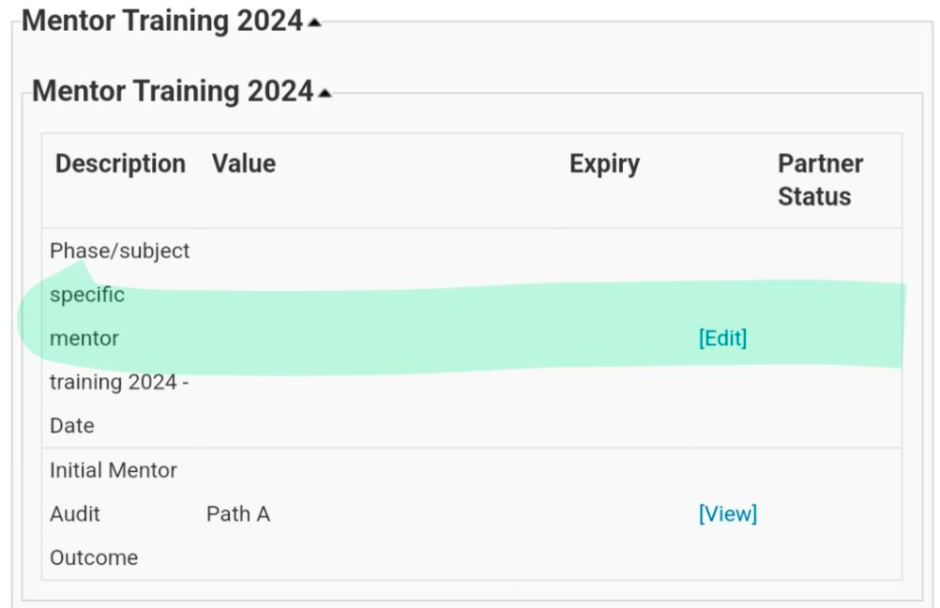  If you have any questions, queries or issues, please use the MS Teams chat function. A member of the team will aim to respond as soon as possible. However, trainee-specific issues should be emailed directly to ben.thomas@edgehill.ac.uk | Hopefully you have had a positive first couple of days in your placement school!  Roadmap: If you have not already done so, please ensure that you have a rough ‘roadmap’ of your journey through your Professional Practice; both in terms of teaching and additional opportunities. Make sure you are pro-active and get involved in the wider life of the school (extra-curricular clubs, break duties, staff meetings, trips, parents evening etc.)  QA2: Your link tutor will arrange to speak to you and your mentor on Teams at the end of week 2 or beginning of week 3. If you have not heard from your link tutor by Friday 28th February, please email primarysupervision@edgehill.ac.uk and cc ben.thomas@edgehill.ac.uk  Mentor details: If your mentor has changed, please inform your link tutor and cc ben.thomas@edgehill.ac.uk  Abyasa: You can access the Abyasa trainee training guide here.

