Guidance for Link tutors:

How to check if a mentor has completed core mentor training via InPlace

Contents
Links: 1
Core training via Agency Personnel record: 1
Core and phase training via the students’ placement record: 3

Links:
- InPlace link: https://www.edgehill.ac.uk/service/education-placements/go/

- Link to Core Mentor Training guidance for mentors: http://sites.edgehill.ac.uk/mentorspace/files/2025/03/Core-Mentor-Training-OMNIS-Guidance-24-25.docx

- Link to phase training webinar signups: Mentor Development - Mentor Space

*If all dates have passed for webinars, please direct the mentor to the correct phase Mentor Space page to the ‘mentor training resources’ button. Direct the mentor to email foementoring@edgehill.ac.uk when this is completed.

Core training via Agency Personnel record:

- On InPlace, navigate to Manage>Agency Personnel
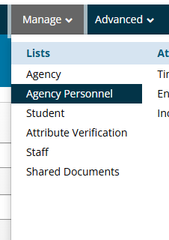

- Type in the mentor’s name or email

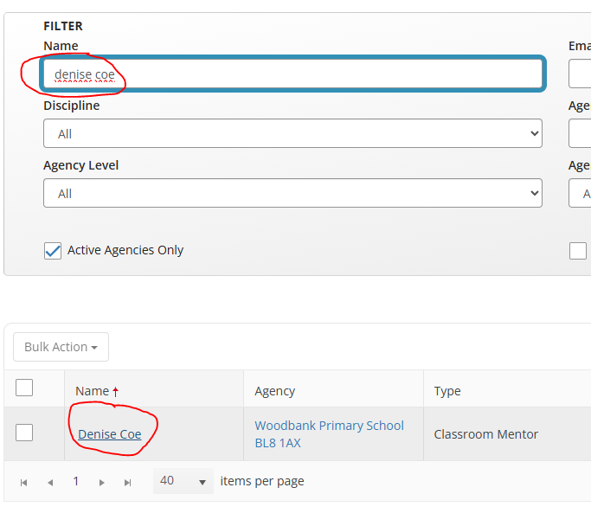

- To the right on the named mentor’s row, is a column with credentials. When a mentor has complete core training, the column will show ‘Online Mentor Training 2023/2024 completed’

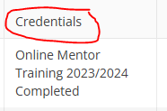

Core and phase training via the students’ placement record:
- On InPlace, navigate to the student’s placement record and scroll to the bottom to Supervisors.

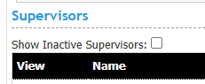

- If the mentor had completed core training it would appear on the right, on their line under Credentials as ‘Online Mentor Training 2023/2024 Completed’
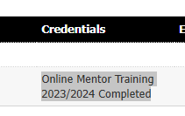
- If credentials is blank this means that core mentor training is outstanding.

For phase and mentor audit completions, the dates and audit outcome will show under the ‘Mentor Training 2024’ section on the student’s placement record on InPlace:

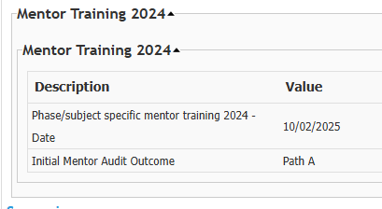

Link to Core Mentor Training guidance for mentors: http://sites.edgehill.ac.uk/mentorspace/files/2025/03/Core-Mentor-Training-OMNIS-Guidance-24-25.docx

