Primary Early Years Education PGCE (with QTS) School Based Section of ITaP Guide
Focus: Scaffolding
ITTECF CORE CONTENT FRAMEWORK LINKS | SCAFFOLDING FRAMEWORK (Proxima ©)  This is the overarching framework that has been used to guide trainees’ knowledge, understanding and skills.
Learn that:  - Guides, scaffolds and worked examples can help pupils apply new ideas but should be gradually removed as pupil expertise increases. (Classroom Practice 4.4)  - Adapting teaching in a responsive way, including by providing targeted support to pupils who are struggling, is likely to increase pupil success. (Adaptive teaching 5.1)  Learn how:  Increase likelihood of material being retained, by:  - Increasing challenge with practice and retrieval as knowledge becomes more secure (e.g. by removing scaffolding, lengthening spacing or introducing interacting elements) (How Pupils Learn 2k)  Plan effective lessons, by:  - Using modelling, explanations and scaffolds, acknowledging that novices need more structure early in a domain. (Classroom Practice 4a)  - Removing scaffolding only when pupils are achieving a high degree of success in applying previously taught material (Classroom Practice 4c)  - Breaking tasks down into constituent components when first setting up independent practice (e.g. using tasks that scaffold pupils through meta-cognitive and procedural processes) (Classroom Practice 4e)  Stimulate pupil thinking and check for understanding, by:  - Providing scaffolds for pupil talk to increase the focus and rigour of dialogue. (Classroom Practice 4p)  Meet individual needs without creating unnecessary workload, by:  - Reframing questions to provide greater scaffolding or greater stretch. (Adaptive Teaching 5n)  Provide high quality feedback, by:  - Scaffolding self-assessment by sharing model work with pupils, highlighting key details. (Assessment 6k) | 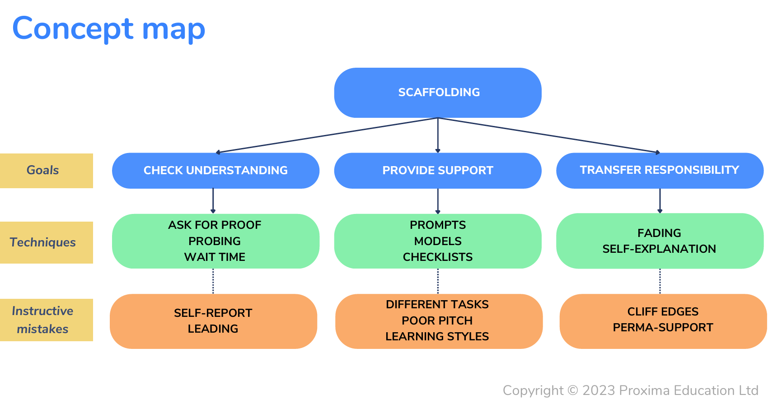  Trainees have explored the scaffolding techniques above and identified what instructive mistakes may be for each technique which they should try to avoid.
 | Check Understanding  Ask for Proof  Teachers ask for proof when using questioning to assess understanding because they are aware that when pupils are asked to self-report their understanding (e.g. “Has everyone got it?”), this information is often misleading (“Yes!”). Questioning that requires pupils to demonstrate their understanding is likely to be a better way to get proof of pupils’ learning, and might be targeted at individuals (e.g. “Can you show me how you would balance the equation?”) or the whole class (e.g. using mini whiteboards)  Probing  Teachers use probing questions when they follow-up on an initial answer with a question that requires pupils to go into more detail. Probing can be used to help teachers assess understanding (e.g. to check the depth of a pupil’s understanding) or extend understanding (e.g. to prompt a pupil to think more deeply about a topic). Probing might focus on process (e.g. “How did you work that out?”), connections between ideas (e.g. “How does that compare to…”), require pupils to generate their own questions, or make predictions (e.g. “What do you think will happen next?”).  Wait Time  Wait time is the amount of time a teacher allows for pupils to think after asking a question. Expert teachers vary the amount of wait time depending on the type of question they ask. Ensuring adequate wait time can help teachers assess understanding because it reduces the risk of ‘false negatives’, i.e. concluding that pupils don’t understand when they actually do. Wait time can also help extend understanding, e.g. by giving pupils the chance to engage with deeper questions. | Provide Support  Prompts  Teachers use prompts – which can be written, verbal or non-verbal – as a simple and powerful form of additional support for pupils. Prompts can be pre-planned, for example based on an analysis of common misconceptions in a particular area or developed responsively. Effective prompts are likely to be specific (e.g. “Watch the ball when it is in the air.”) rather than general (“Try to catch it!”)  Models  Models are a powerful form of scaffolding that can be used to provide temporary additional support to pupils who are struggling or completing a challenging task for the first time. Teachers can use a wide range of models and forms of modelling, including exemplars (model answers), think aloud (also known as 'live modelling'), and physical models, such as manipulatives in mathematics.  Checklists  Checklists are a versatile form of scaffolding that can be used to provide temporary additional support to pupils who are struggling or completing a challenging task for the first time. Checklists can focus on a product (e.g. listing specific features of a high-quality response) or a process (e.g. listing the steps pupils should take to complete a complex task). Teachers can also engage pupils in the creation of checklists (“What should a good answer include?”) or use them to support self- or peer-assessment. | Transfer Responsibility  Fading  Fading occurs when teachers gradually remove support, in order to develop pupil independence and avoid an overreliance on a scaffold that has been put in place to help a pupil take the next step in their learning. Fading is most likely to be effective when it follows an assessment of a pupil's progress, rather than following a predetermined timetable.  Self-explanation  Self-explanation occurs when teachers prompt pupils to explain an aspect of their learning to themselves, for example by recounting the steps they took to solve a problem or explaining how a new idea they have been introduced to links to their prior learning. There is promising evidence that self-explanation is a strategy that teachers can use to support the transfer of responsibility towards pupils, as scaffolded support is being faded.

Day One – in PPP | Day Two – in PPP
AM  Instructional coaching  Trainee observes a section of a whole class adult led input/lesson (10-15 minutes) delivered by the expert mentor.  The expert mentor uses an instructional coaching approach to support the identification of effective scaffolding strategies that are used.  This is based around the 3 key elements:  - check understanding  - provide support  - transfer responsibility  AM/PM  Deliberate practice: working towards specific goals  By using lesson plans completed by the expert mentor, trainees work with children during independent practice (either a focused small group and/or supporting children in provision) to further their knowledge and understanding of scaffolding using the 3 key elements (check understanding, provide support and transfer responsibility).  Whilst the trainee is supporting groups/children within the classroom, the mentor supports the trainee in a coaching role to engage in professional dialogue about the 3 key questioning elements (check understanding, provide support and transfer responsibility) using a proforma.  Deliberate practice: Receive and respond to feedback  PM  After the taught sessions where practice has been observed  Following this, the mentor and trainee engage in professional discussion about Day 1 (the trainee’s observation practice, the trainee’s group practice, trainee’s collaboration with the mentor to plan for scaffolding which the mentor records on an ITaP development summary (IDS) for Day 1. Discuss how questions are reframed questions to provide greater scaffolding or greater stretch and challenge to support SEND/EAL/Pupil Premium/high attainers.  Using this mentor and trainee co-plan tomorrow’s lesson using an existing lesson plan and carefully layer scaffolding into the existing lesson plan aiming to develop the trainee’s practice. For example, identify types of scaffolding and how they are used at different points within the lesson e.g. prior-learning, misconceptions, recall and retrieval. | Please arrange the timings of this day according to what works best in your school setting.  Assessing practice: Recording a taught extract of teaching  Having planned with the mentor, the trainee teaches and records approximately 10 minutes of a directed teaching input where scaffolding is evident for example 10 minutes of a mathematics lesson.  IMPORTANT:  Recording lessons  This must be agreed by the classroom mentor following school policy and safeguarding and using agreed school equipment. You DO NOT need to send this recording to anyone. It is only for in school use.  Self-reflection and feedback  Initially the trainee independently self-reflects on the 10-minute recorded video by analysing their practice using the 3 key elements of scaffolding (check understanding, provide support and transfer responsibility).  Following this, the mentor and trainee engage in professional discussion which the mentor records on the ITaP Development Summary for Day 2.  The focus of this discussion is reflecting on the recorded video and overall knowledge and skills gained whereby the mentor supports the trainee’s self-reflection and analysis and engages in purposeful dialogue to give effective feedback relating to what the trainee knows, understands and is able to do regarding scaffolding and the mentor and trainee set a SMART development target.  Trainee Independent Final Reflections  Independent time needed: 1.5 hrs  Trainees record how they have developed their knowledge, skills and understanding through the process by reviewing and reflecting around the focus of scaffolding by:  - Uploading the completed IDS to Pebblepad  - Uploading reflections to PebblePad porfolio titled ‘School based days’ using mentor feedback and self-reflection and upload documents for all 5 ITaP days (observation forms, lesson plans and IDS).

A SELECTION OF THEORY AND RESEARCH USED

- Coe, R., Aloisi, C., Higgins, S., & Major, L. E. (2014) What makes great teaching. Review of the underpinning research. Durham University: UK.
- Dunlosky, J., Rawson, K. A., Marsh, E. J., Nathan, M. J., & Willingham, D. T. (2013) Improving students’ learning with effective learning techniques: Promising directions from cognitive and educational psychology. Psychological Science in the Public Interest, Supplement, 14(1), 4–58. https://doi.org/10.1177/1529100612453266
- Fisher, D. and Frey, N. (2021) Better learning through structured teaching: a framework for the gradual release of responsibility. 3rd edition. Alexandria, Virginia: ASCD. Available at: http://public.eblib.com/choice/PublicFullRecord.aspx?p=6685619 (Accessed: November 5, 2024).
- Muijs, D., & Reynolds, D. (2017) Effective teaching: Evidence and practice. Thousand Oaks, CA: Sage.
- Parsons, S. et al. (2018) Teachers’ Instructional Adaptations: A Research Synthesis. Available from: https://journals.sagepub.com/doi/full/10.3102/0034654317743198
- Rosenshine, B. (2012) Principles of Instruction: Research-based strategies that all teachers should know. American Educator, 12–20. Available from: https://eric.ed.gov/?id=EJ971753
- Sherrington, T. and Caviglioli, O. (2020) Teaching walkthrus : five-step guides to instructional coaching. Melton, Woodbridge: John Catt Educational.

