
Welcome to the weekly mentor, trainee and link tutor briefing from the Primary Education Department.
Course | PGCE Primary Education 5-11 with QTS
Phase: | Consolidation | Week: | 2  Monday 31st March to Friday 4th April 2025
I hope that the first week of practice has gone well for everyone! The lighter nights are coming and only one week to go until the Easter holidays. I imagine that will bring some much needed rest for us all. Thank you to all mentors and link tutors for supporting our trainees in their new school environment and helping them to get to grips with processes, policies and planning before they start to teach sessions next week!

Please find key contacts below for some of the common queries which arise during placement. We ask that you contact the relevant person for each specific query so that we can answer your questions as quickly as possible.
- If mentors or students have any questions throughout the placement window, please contact the Link Tutor (LT) in the first instance.
- Students, please contact your PAT for any pastoral or academic support, as normal. Please do not contact them for placement-related queries, your LT is your first point of contact.
- For Abyasa related queries, please contact foementoring@edgehill.ac.uk
- If you have not yet had your QA1 meeting, please email me kayv@edeghill.ac.uk

We have a dedicated area of mentor space for this placement on the Edge Hill University website. It is available here https://sites.edgehill.ac.uk/mentorspace/prmpg3/

Have a lovely second week and a restful break when it arrives
Virginia Kay

Weekly intended curriculum expectations linked to ITTECF:
High Expectations:
- Collaborate in multi-agency working with internal and external colleagues .
- To understand the duty of schools in compensating for disadvantage

How Pupils Learn / Classroom Practice / Adaptive Teaching:
- Understand pupils learn at different rates and require different levels of support to ensure their success and to be able to provide and plan to enable their success.
- Be able to incorporate the use of technology, including educational software and assistive technology to support teaching and learning for pupils with SEND. To be able to use the feedback gained to scaffold and ensure progress for all pupils.

Professional Behaviours:
- Know the importance of parental engagement and how it can have a positive impact of pupils’ motivation, behaviour and academic success.

Mentor Focus:
It is a requirement that all mentors complete both the Core and Phase Specific Mentor Training
Contact FoEMentoring@edgehill.ac.uk to arrange Core Mentor Training if you have not already engaged with this.

There are still some times to sign up for in order to complete the Phase Specific Training, please see links below to book onto this:
Phase Specific Mentor Training
Wednesday 26 March | 15:30 – 16:30
Thursday 27 March | 15:30 – 16:30
Wednesday 02 April | 15:30 – 16:30
Thursday 03 April | 15:30 – 16:30

Abyasa: There is a training guide available to support with any technical or operational issues that you may be experiencing with Abyasa. You can access the Abyasa mentor training guide here. If your query cannot be resolved, please contact foementoring@edgehill.ac.uk

QA1 and QA2: Your link tutor should already have been in touch to conduct the QA1 meeting and will shortly be in touch to arrange the QA2 meeting, which will take place on Teams. This is a three-way meeting between you, the trainee and the link tutor. Some of the themes covered in the meeting include:
- Does the trainee know who the DSL/DSO is?
- Has the trainee shared their targets from their developmental practice?
- Are you aware of the mentoring requirements and EHU ITE curriculum for this placement?
- Are trainees receiving their 20% PPA entitlement, WDS meeting and weekly observation?
- Are you confident with the WDS and information that is required?

If you have any issues, queries or concerns, please do not hesitate to contact your assigned link tutor at the earliest opportunity. They will be able to offer guidance, support and answer many of your questions (or find a colleague who can). If your query is about your link tutor, please email the Professional Practice and Quality Lead, Virginia Kay kayv@edgehill.ac.uk

Observation of experts to support training suggestions: | Research and Resources:
In preparation for the second Weekly Development Summary meeting, it may be beneficial for trainees to speak to the following colleagues/experts in school:  - SEND Coordinator  - Inclusion Lead  - Member of SLT (to discuss the ways in which PP is used to address disadvantage) | EEF, 2024. The EEF Guide to the Pupil Premium  NASEN, 2024. Teacher Handbook: SEND.  EEF, 2021.  Effective parental engagement for pupils with SEND.
Link Tutor: | Trainee:
Thank you for supporting your trainee(s) through their Consolidation Professional Practice.  QA1: All link tutors should have now met with their mentor. Could I kindly ask that the QA1 information under the ‘Quality Assurance’ tab is completed on Abyasa at your earliest convenience.  QA2: Please arrange to meet with your trainee(s) and mentor(s) at the end of week 2 or beginning of week 3.  If any of mentors cannot make the training dates (see Mentor Focus box), there is a video recording on MentorSpace. Please ensure that the following box is updated on InPlace, if your mentor has watched the recording.  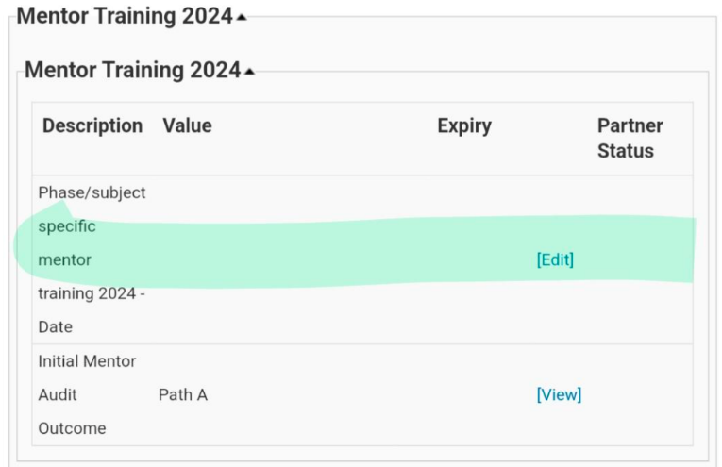  If you have any questions, queries or issues, please use the MS Teams chat function. A member of the team will aim to respond as soon as possible. However, trainee-specific issues should be emailed directly to  kayv@edgehill.ac.uk | Your Consolidation Professional Practice is finally here; make the most of the experience!  Discuss with your mentor what you will be expected to plan/teach over the coming weeks and ensure that you are organised and prepared. Please make sure that you have familiarised yourself with the expectations of the placement by reading the placement handbook, accessed the Subject and Strand trackers and logged in to Abyasa.  If your mentor has changed, please inform your Link Tutor and cc kayv@edgehill.ac.uk  QA2: Your link tutor will arrange to speak to you and your mentor on Teams at the end of week 2 or beginning of week 3 (first week back after Easter for most of you).  If you have not heard from your link tutor, or the QA1 meeting has not yet taken place please contact primarysupervision@edgehill.ac.uk and cc kayv@edgehill.ac.uk

