
Welcome to the weekly mentor, trainee and link tutor briefing from the Primary Education Department.
Course | BA (Hons) Primary Education with QTS
Phase: | Consolidation | Week: | 6 (31st March – 4th April 2025)

Weekly intended curriculum expectations linked to ITTECF:
High Expectations: Know how to make effective use of teaching assistants and other adults to support effective classroom and behaviour management.

How Pupils Learn / Classroom Practice / Adaptive Teaching: Understand the purpose and value of planning documentation for a range of adults and the importance of being mindful regarding workload.

Professional Behaviours: Understand that the Teachers’ Standards underpin a teacher’s professionalism throughout their career.

Assessment: NA

Mentor Focus:
80% Teaching: Trainees should now be teaching 80% of the class timetable (or be on their way to doing so soon). If they have not yet reached this point, or you are concerned that the trainee is unlikely to do so, please speak to your link tutor at the earliest opportunity. A bespoke pathway forward for the remaining weeks can then be discussed on a case-by-case basis.

Positive News: Please share any positive news about trainees’ progression thus far! It is always good to hear positive stories about the impact our Edge Hill trainees are having on placement.

WDS and Lesson Observations: As the placement moves into week 6, trainees should already have the following documents completed on their Abyasa timeline:

- 5 Weekly Development Summaries
- 5 Lesson Observations

If you have any issues, queries or concerns, please do not hesitate to contact your assigned link tutor at the earliest opportunity. They will be able to offer guidance, support and answer many of your questions (or find a colleague who can). If your query is about your link tutor, please email the Professional Practice and Quality Lead, Ben Thomas ben.thomas@edgehill.ac.uk.

Here is a reminder of the expectations for the Consolidation Professional Practice:
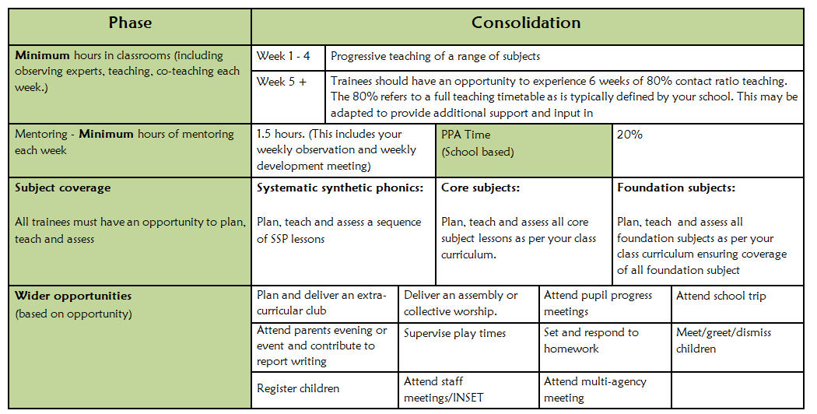

Observation of experts to support training suggestions: | Research and Resources:
In preparation for the sixth Weekly Development Summary meeting, it may be beneficial for trainees to speak to the following colleagues/experts in school:  - Teaching Assistants  - Curriculum Leads | Working with Teaching Assistants: The EEF have produced the following document that outlines the vital role and optimal deployment of Teaching Assistants. Making Best Use of Teaching Assistants | EEF  Teachers’ Standards: These are the standards that teachers are required to adhere to when working as professionals in school. Teachers' standards - GOV.UK
Link Tutor: | Trainee:
Thank you for supporting your trainee(s) through their Consolidation Professional Practice.  Progress Support Plans: If you have any trainees currently working on a Progress Support Plan, or mentors who believe that this may be necessary, please keep me informed. ben.thomas@edgehill.ac.uk  Abyasa: Please check that the trainees are continuing to receive their weekly entitlement to 1 WDS and 1 lesson observation. If not, please could you have a brief chat with the mentors.  QA3: You should have arranged some of your QA3 visits at this point. Encourage mentors to arrange for a TA to be present to cover the final portion of the lesson. This will enable you to have the discussion with the trainee and mentor within the hour.  Mentor Training: FoE Mentoring have been active in emailing all school-based colleagues who are yet to complete the Core and Phase training. Please continue to chase up any training gaps and ensure that the relevant box is updated on InPlace once your mentor has watched the recording.  If you have any questions, queries or issues, please use the MS Teams chat function. A member of the team will aim to respond as soon as possible. However, trainee-specific issues should be emailed directly to ben.thomas@edgehill.ac.uk | Over the half-way mark! Please read the key messages for this week.  Easter: If your setting has a one-week Easter break, please email Education Partnership educationpartnership@edgehill.ac.uk and cc ben.thomas@edgehill.ac.uk. Pnclude a screenshot from the school website, or the ‘term dates’ document. This may mean that your end date will be amended slightly. This will then be checked by Education Partnership and amended on InPlace, if required. You will need to discuss this amendment with your mentor and link tutor.  Teaching Progression: You should now have reached the point where you teach 80% of the class timetable. If you are not quite there yet, please do not worry. If you are only teaching at 60-70%, focus on the quality of those lessons and making sure that you are prepared to move to 80% as soon as possible. It is important that you aim to reach the 80% in order to be adequately prepared for your career as an ECT in September.  Queries: Speak to your mentor or email your link tutor as your first points of contact. For additional enquiries, please email me at ben.thomas@edgehill.ac.uk.

