

Primary Mentor Guidance

Edge Hill Abyasa Pro Portal

https://edgehill.abyasa.net/Pro

Contents

How To Access Your Edge Hill Abyasa Pro Portal

Home Dashboard

Trainee Timeline and Tabs

Weekly Development Summary

Observation Forms – Scheduled and Unscheduled

Progress Support Plans

Professional Practice Forms

Trainee Attendance

Professional Practice Resources

Curriculum and Subject Tracker

Navigation Tabs - Home Dashboard
Personal Details
Professional Practice Forms
Pro Report
Professional Practice Resources

How To Access Your Edge Hill Abyasa Pro Portal
You will have received an email with guidance on how to access your portal. Click the hyperlink in the email to go to your account.

Link to create account
https://edgehill.abyasa.net/Pro/Login/CreateUserAccount/b694dde969b74329ae33501a8f3b21b6

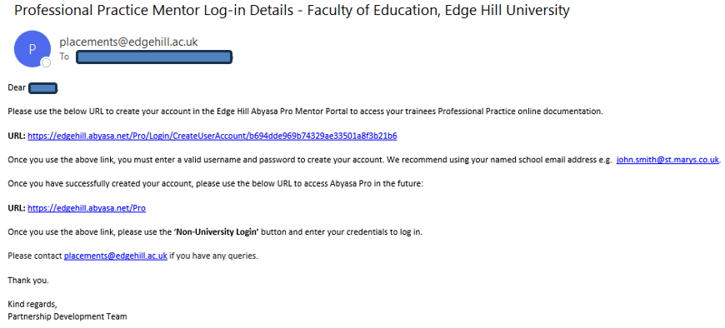

Account creation page

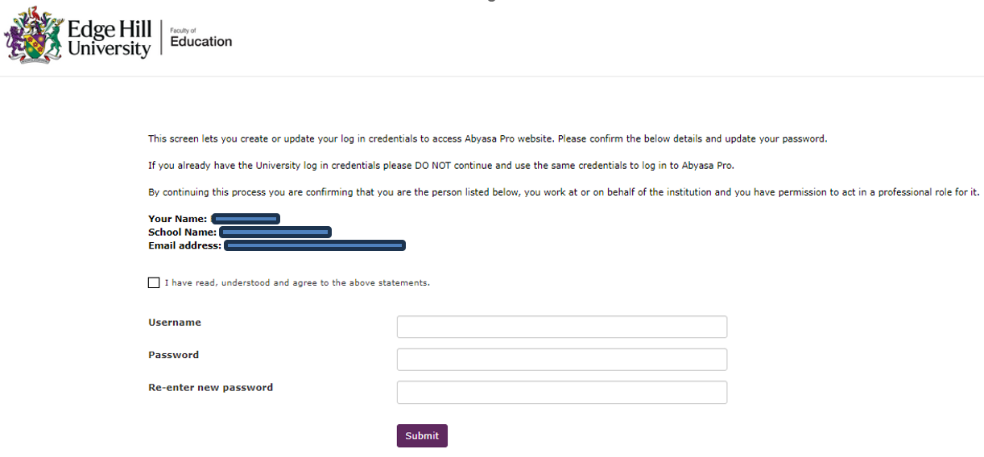

Link to log-in
https://edgehill.abyasa.net/Pro

Log in by clicking the Non-University Login button and entering your username and password.

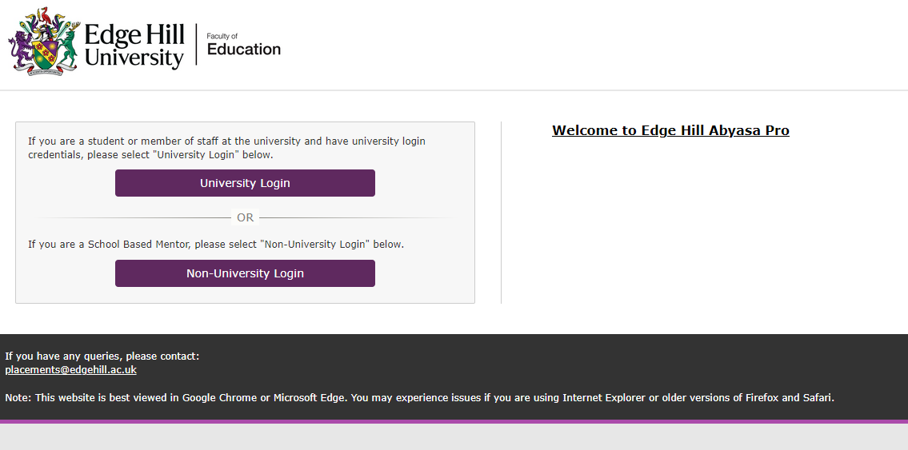

We recommend bookmarking the URL, but you can also use the search function on the top right of our university website homepage. Type ‘Abyasa’ into the search bar.

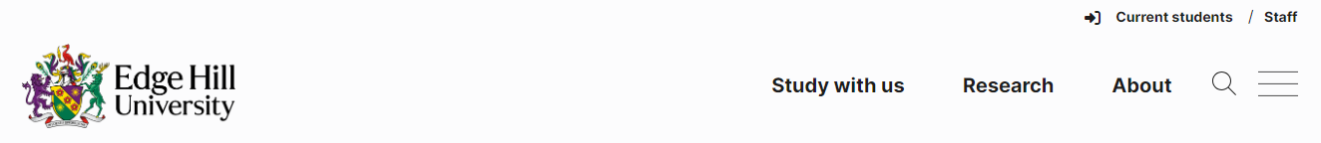

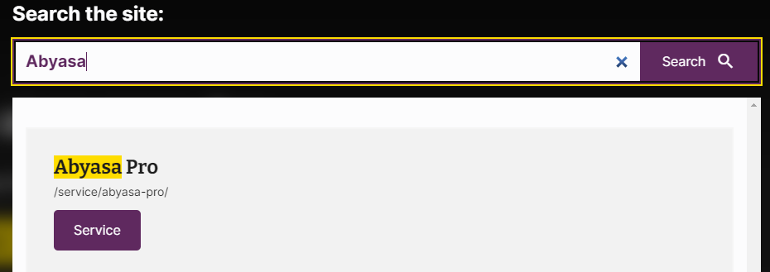

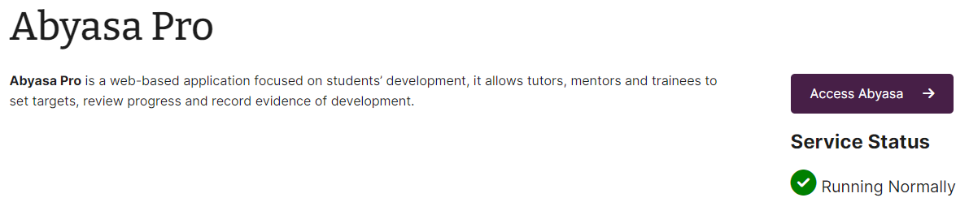
Home Dashboard
When you have logged in you will be taken to your home dashboard. The dashboard consists of several widgets for specific actions and a series of tabs across the top.
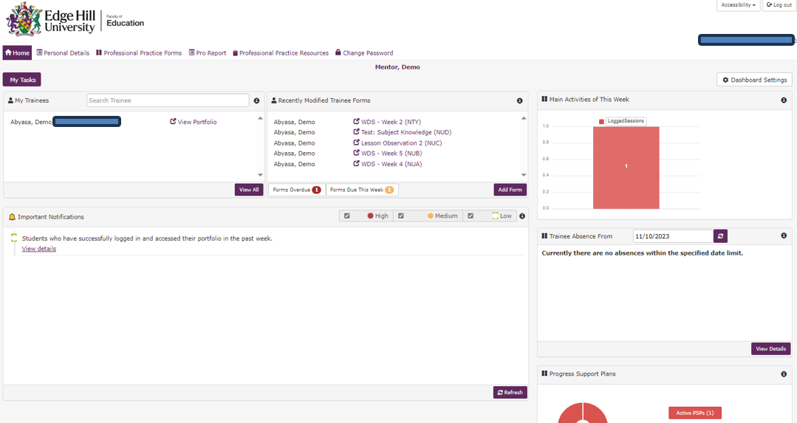
Overview of the dashboard widgets
My Trainees - lists any trainees that you are mentoring. From the View Portfolio hyperlink, you will be taken to the trainee’s timeline and tabs.
Recently Modified Trainee Forms – shows all forms that have recently been edited by you or your trainees. The hyperlinks here will take you directly into the relevant form.
Important Notifications – Notifications are assigned a traffic light system for their level of importance. When you click to view the details of the notification a pop-up box will display the information.
Main Activities of This Week – Is a visual representation of the user access activities for the week.
Trainee Absence – Shows any trainees who have logged absence in their trainee attendance.
Progress Support Plans – Any active or completed plans will appear in this widget. This is also where new plans are created from. See page XX for further guidance.
Trainee Reports – Here you can view any saved trainee reports.

Other Dashboard Functionality
Click the My Tasks button just below the home tab, to see you assigned tasks. The button changes to Dashboard when in this screen. Click this to return to your dashboard.
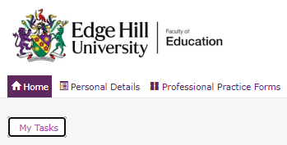
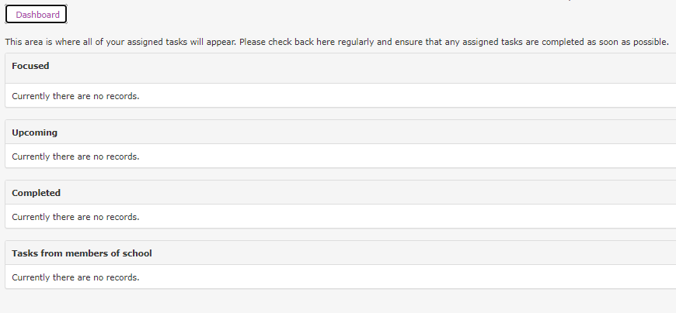
Click the Accessibility button in the top right of the screen to adjust your settings.
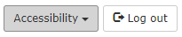
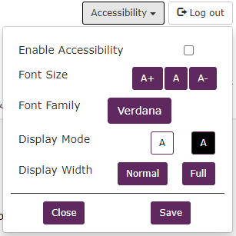
Trainee Timeline and Tabs
The timeline is where you can see your trainees’ professional practice forms, such as Weekly Development Summaries, Observations and Progress Support Plans (if applicable). From this screen you can also access the tabs available to the trainee.
The timeline shows upcoming, focussed, and completed forms.
To access your trainees timeline you click on the View Portfolio hyperlink next to the trainee name on the My Trainees widget of your dashboard.
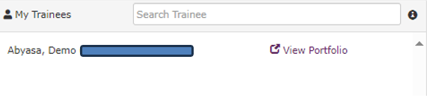
To complete a form, you can either click the Start/Continue link next to the form directly on the timeline or click the Start button near the top of the timeline and select the required form from there.
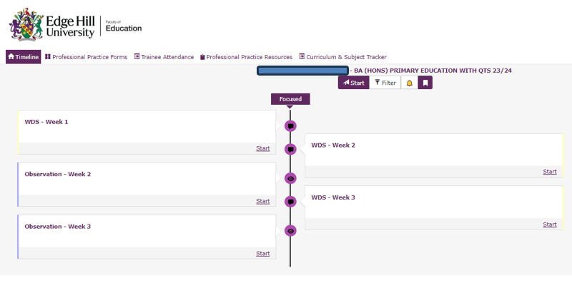
Once a form is completed it will appear towards the bottom of the timeline.
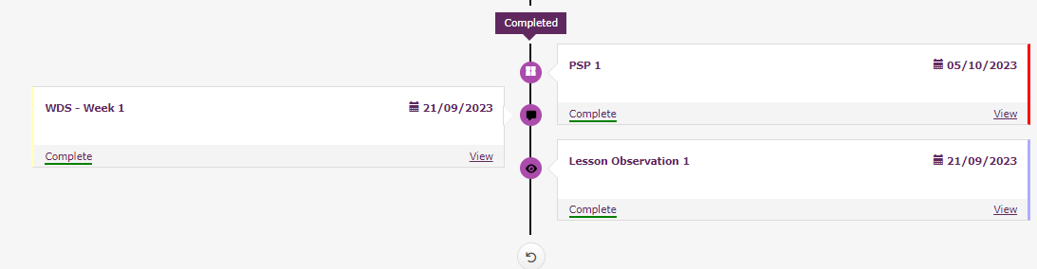
Weekly Development Summary
When you click start or continue on the Weekly Development Summary in the timeline, it will open the form for you to complete with your trainee.
The tabs to the left of the form allow you to navigate through the various sections of the form. Complete the editable sections, the form will autosave and turn green when you click to move to another section.
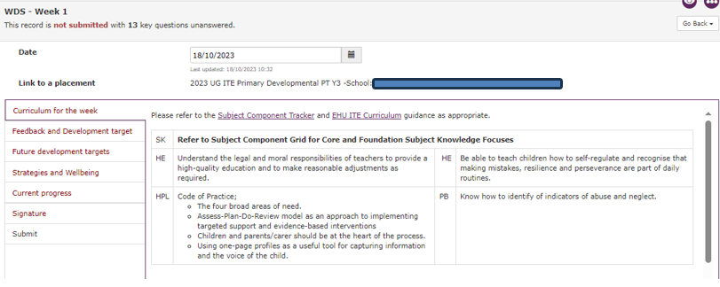
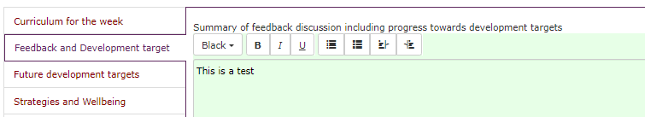
Mentor permissions are set so that you can confirm the form is complete and changes cannot be made by the trainee.
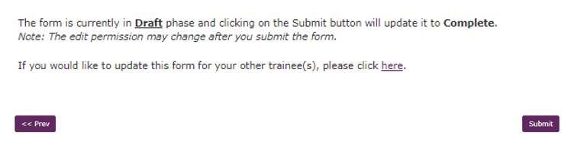

Observation Forms – Scheduled and Unscheduled
There are two types of observation forms. The weekly Observation Form is a scheduled form and appears on the trainee timeline for weeks 2-8. It can also be accessed via the Start button at the top of the timeline.
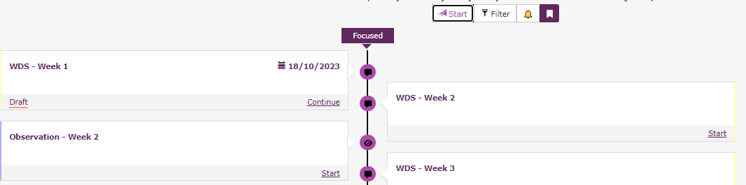
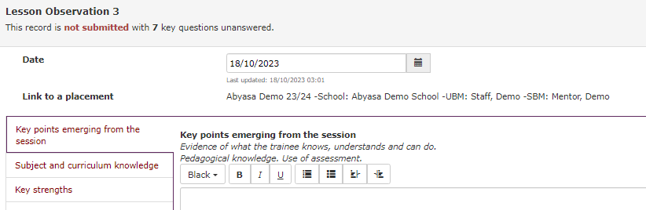
The Systematic Synthetic Phonics (SSP) Observation Form is an unscheduled form. This observation form should be used any time you observe a trainee teaching SSP. This form can only be accessed via the Start button at the top of the timeline.
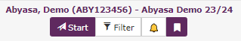
Select Observation from the record type, then SSP Observation Form and Start.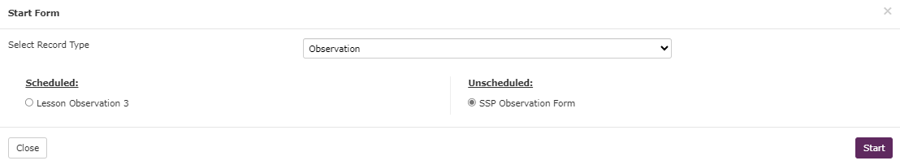
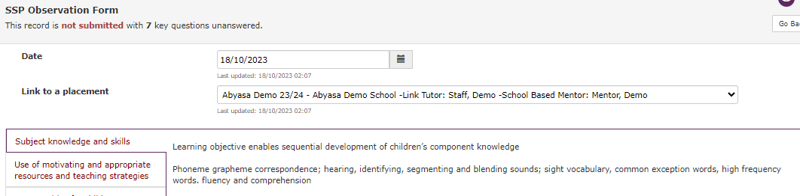
Progress Support Plans
If a trainee requires a Progress Support Plan these can be created on your home dashboard. Once added they will appear on the trainee timeline.
Click the View/Add New button to create a Progress Support Plan.
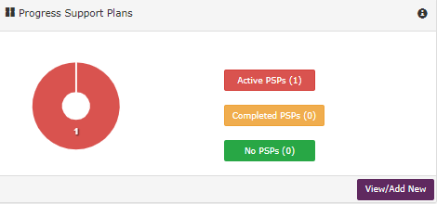

Choose your trainee from the drop-down list, then select Add Progress Support Plan
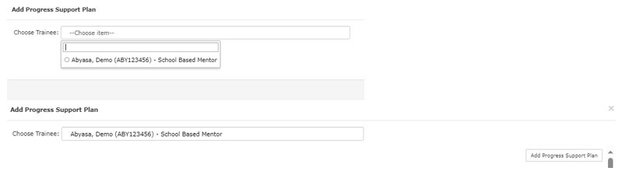
Add the details of Progress Support Plan and save.
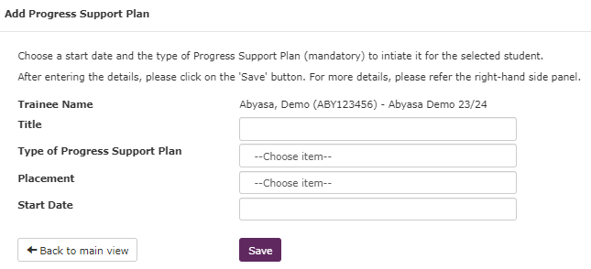
Another box will pop up where you need to add some further details.
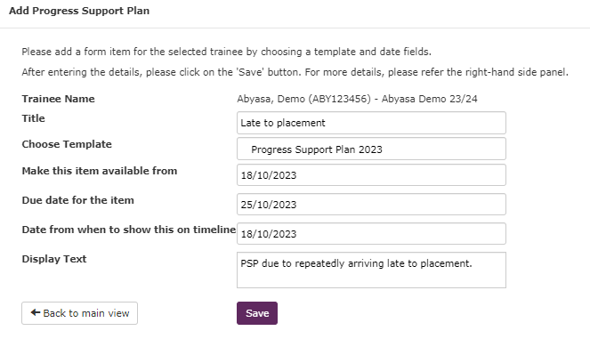
When this is saved, the form will be ready for you to complete. Click the small Add button to open and complete the form. If further plans are required for the same issue. You can click the large Add button to create additional forms.

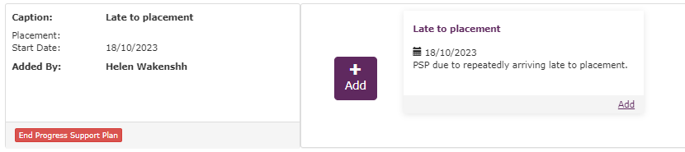

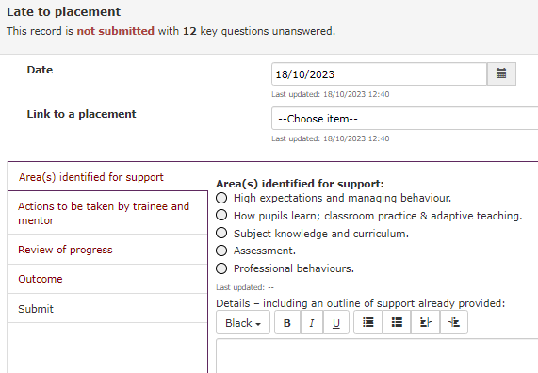
The Progress Support Plan can be viewed by the trainee and other users with specified permissions by clicking the Active Progress Support Plan button on the timeline and then view.
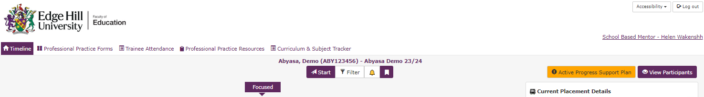

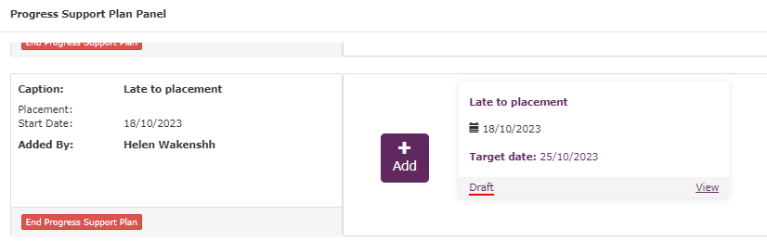
Professional Practice Forms

The Professional Practice Forms tab is where you and your trainee can find the library of all your forms in draft or completed.
Scheduled forms include WDS and Observations, these are forms that you are expected to complete and submit on a weekly basis as the placement pattern requires. Unscheduled forms are forms such as any Progress Support Plans that are created to support you.
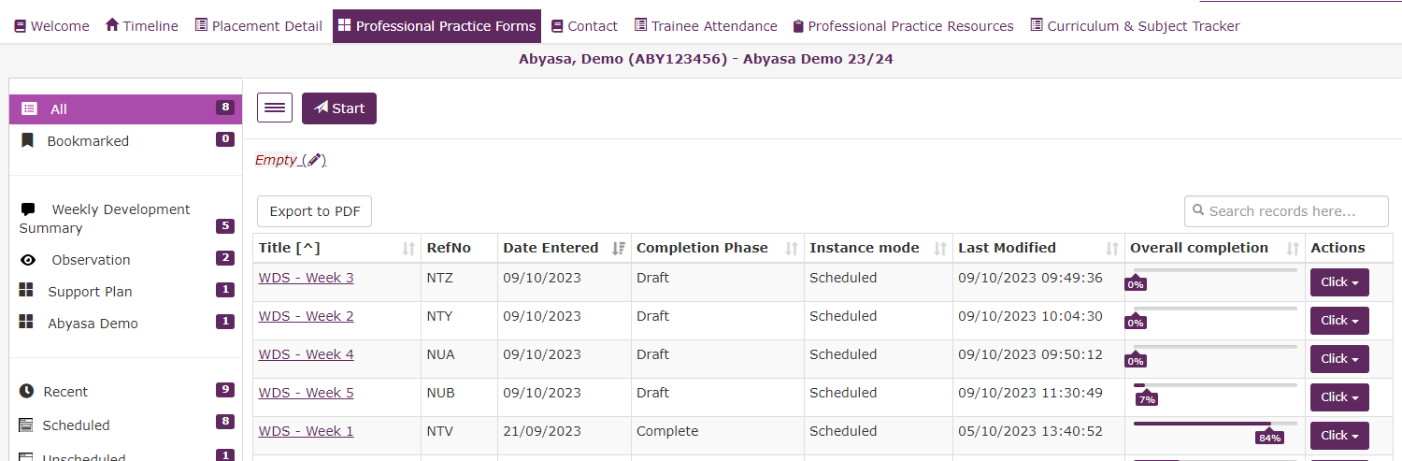
You can access your forms from this tab using the hyperlink in the Title column, this will open the form the same way as if using the timeline.
You can see the overall completion status of your forms and complete actions such as exporting as PDF and deleting forms if needed.
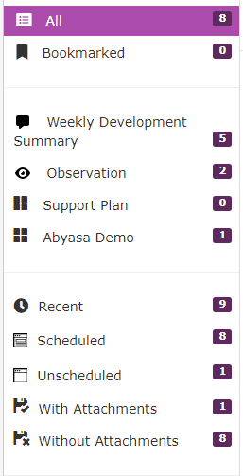
The column to the left of the screen allows you to filter the table by form, schedule, and completion type.

Trainee Attendance

Each week trainees will create a weekly attendance record to monitor and track attendance and absence. You will approve attendance here.
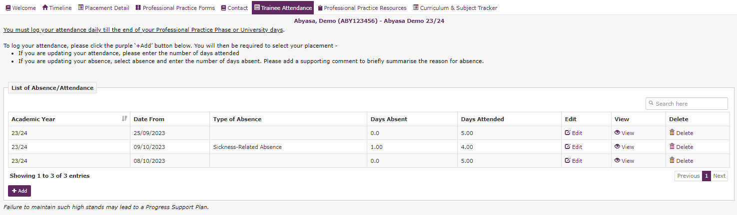
To approve attendance, click Yes/No in the Mentor Approval field.
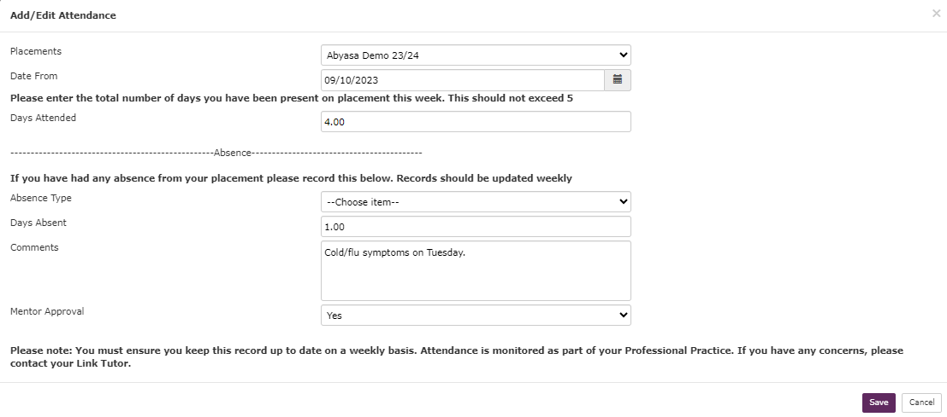
Weekly attendance should only ever add up to a maximum of 5 days. Example: If your trainee is absent for 2 days, please check their Days Attended to confirm they have entered 3.

Professional Practice Resources
This area will contain any hyperlinks and/or documents that you may require to support trainees during professional practice.
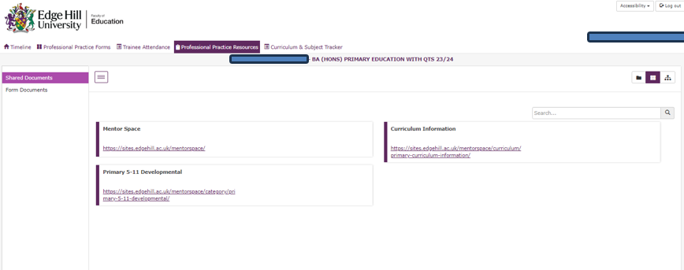

Curriculum and Subject Tracker
The final tab on this section of the trainee portal shows the Curriculum Strand Component Tracker and Subject Specific Component Tracker for professional practice. This is where you can see what the key focus is for the week of professional practice. Click on the hyperlinks to move through the topics.

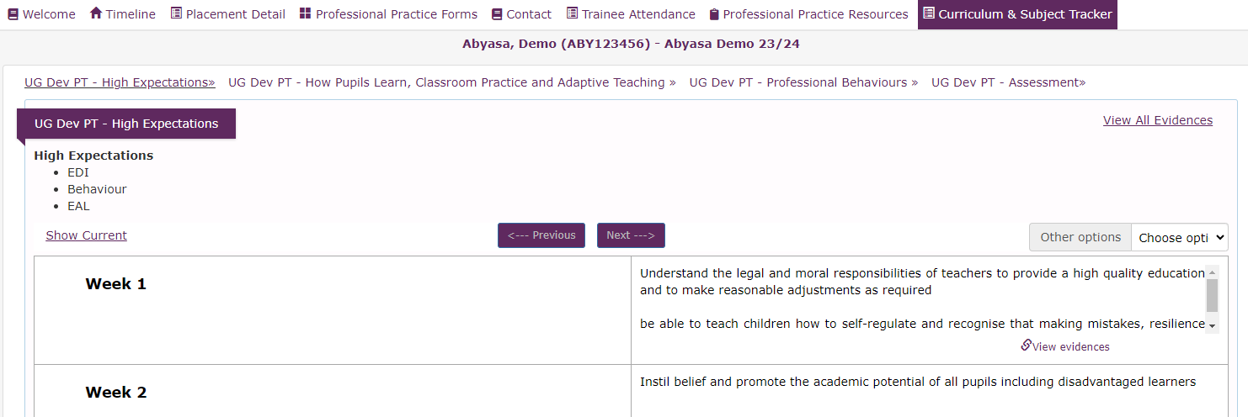

Navigation Tabs - Home Dashboard
Personal Details
Do not input any personal information. If you need to update your name or school email. Please email placements@edgehill.ac.uk
Professional Practice Forms
This tab contains the same library of forms as the Professional Practice Forms tab you can view in the trainee area of the system. The only difference is that colour coding is applied to show the various phases of form completion.
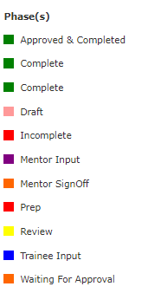
Pro Report
Guidance to follow.
Professional Practice Resources
This tab contains any resources required to support trainees on their professional practice. This tab should contain the same information as the corresponding tab in the trainee area of the system.

