Welcome to the mentor Weekly Development Summary from the
Department of Secondary and Further Education (AY 23/24) Week 13
Course: RE PGCE
‘Working creatively with others to enhance life chances’
Name of trainee |  |  |  | Trainee ID no.
Name of mentor |  |  |  | Professional Practice phase |  |  |  | Introductory (A)
Name of Link Tutor |  |  |  | Name of setting
Programme |  | PGCE History |  | Week beginning |  |  |  | 20/11/23
Days trainee has attended this week |  | Monday | Tuesday |  | Wednesday |  | Thursday |  | Friday
Key reading for the week   | Summary  Wittwer and Renkl's (2010) research on instructional explanations involved 21 studies and 28 pairwise comparisons. The findings revealed minimal benefits overall and variability. Instructional explanations were more effective for imparting substantive knowledge than procedural knowledge and once again the findings were inconsistent across different domains. Surprisingly, the type of explanation and self-explanation prompts did not significantly affect effectiveness. The findings stressed that instructional explanations were complex and to be more impactful a more balanced approach is needed to suit the needs of learners in their particular context.  Limitations  Limitations of the paper include substantial variation in effect sizes across domains. The focus on Maths and Science excludes subject-specific nuances; examining all key stages and subjects is recommended for a holistic analysis.  Wittwer, J., & Renkl, A. (2010) How Effective are Instructional Explanations in Example-Based Learning? A Meta-Analytic Review. Educational Psychology Review, 22(4), 393–409.  How Effective are Instructional Explanations in Example-Based Learning? A Meta-Analytic Review | Educational Psychology Review (springer.com)
Support for mentoring in this subject   | This diagram is taken from the TEEP Cycle (Teacher Effectiveness Enhancement Programme) and demonstrates how effective modelling might take place in the classroom.  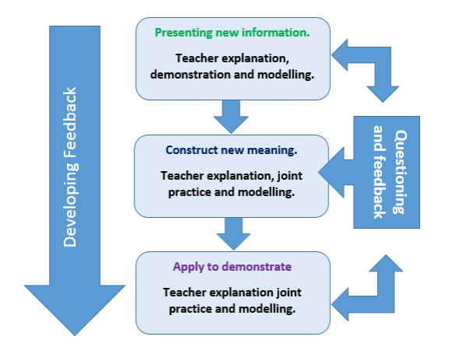  Use the diagram to discuss planning a lesson where modelling takes place or for the trainee to reflect upon a lesson they have observed where this has taken place.  Have a discussion with your trainee about why this process may be an effective method of learning through modelling and also circumstances which may require a different process?
Curriculum for the week   | This week trainees should have demonstrated that they know: |  |  |  |  |  |  |  |  |  | Y/N
 | - Analyse modelling approaches used by your mentor and begin to develop your own approach and incorporate into your classroom.
 | This week trainees should have demonstrated that they know how to: |  |  |  |  |  |  |  |  |  | Y/N
- Practice and receive feedback using modelling, explanations, and scaffolds, acknowledging that novices need more structure early in a domain.

- Discussing and analysing with expert colleagues how to teach different forms of writing by modelling planning, drafting and editing.

Questions for mentor and trainee to discuss in mentor meeting  | - How do you know when it is appropriate to remove scaffolding and allow pupils to apply previously taught material independently?  - Provide an example of how you have used modelling, explanations, and scaffolds to support students in understanding new concepts within history
Additional notes from mentor meeting   | For example, review of subject knowledge, relevant CPD, arrangements for upcoming lesson observation, school/department events etc.
Trainee workload and well-being | Have strategies for workload been discussed? |  |  |  |  |  |  |  |  | Y/N
 | Actions or follow up (if needed)
 | Has the trainee’s wellbeing been discussed? |  |  |  |  |  |  |  |  | Y/N
 | Actions or follow up (if needed)
Opportunities identified for progress | To make progress through the curriculum the trainee needs to: |  |  |  |  | Opportunity agrees for trainee to practise, observe, or receive feedback on this target
 | 1.
 | 2.
 | 3.
Current progress would suggest that the trainee is making sufficient progress through the curriculum to proceed:
☐ Yes, trainee is making sufficient progress through the curriculum.
☐ Yes, trainee is making sufficient progress through the curriculum, but this has required additional support (please list the additional support provided below. For example, a reduction in teaching load, additional meetings, use of team-teaching etc).

☐ No, despite additional support the trainee is not making sufficient progress through the curriculum. A Progress Support Plan should be considered.

Mentor Signature

Trainee Signature

Trainees should ensure this WDS is submitted by the deadline for the purpose of formative assessment. Failure to do prevents the Link Tutor from assessing their progress and may result in the trainee being placed on a Progress Support Plan.

