



Professional Practice Handbook for Trainees and Mentors

2024-2025

Secondary PGCE (11-16) with QTS*
BA/BSc (Hons) Secondary (11-16) with QTS*



Contents
Welcome from the Department of Secondary and Further Education 4
Mentor Site: Your one-stop shop 5
Key Contacts 5
Safeguarding 6
Managing a Safeguarding Concern on Professional Practice 6
The Edge Hill University ITE Curriculum Intent 7
What do I need to know about the Initial Teacher Training and Early Career Framework (ITTECF)? 8
Particular points of interest: ITTECF 8
The Edge Hill University ITE Curriculum Implementation 9
The curriculum as the model of progression 9
Formative Assessment 9
How are ITE students assessed? 9
How is the Weekly Development Summary used as a tool to support formative assessment? 10
Progress Support Plans for trainees not making sufficient progress 10
Roles, Responsibilities, and Expectations 12
Mentor Role and Responsibilities 12
Inducting the Trainee 12
Monitoring the Trainees’ Progress and Achievement 12
Formative Assessment: 12
Supporting the Trainee 12
Supporting trainee workload and well-being 13
Lead Mentor Role and Responsibilities 13
Link Tutor Role and Responsibilities 13
Trainee responsibilities and professional expectations 13
Edge Hill University ITE Code of Conduct 14
Trainee behaviours and attitude 14
Training responsibilities 15
Breaches of Conduct 16
Attendance and punctuality 16
Reporting an absence 16
Absences of longer than 5 consecutive days 17
Frequent absences over a period of several weeks 17
Setting cover work during an absence 17
Making up days absent 17
School closure days, strikes, INSET days etc 17
Days for religious observance 17
Days for interviews and/or visits to potential employers, and induction days 17
Professional Practice Teaching Expectations 19
Professional Practice forms: The Weekly Development Summary (WDS) 22
Professional Practice forms: The Lesson Observation form 26
Exemplar Lesson Observation form 27
Further support, resources, and suggested texts for mentors 30

Welcome from the Department of Secondary and Further Education

I am delighted to welcome you, and all our Initial Teacher Education Trainees, to Edge Hill University!

Whether you have studied or worked with us before, or are joining us for the first time, it is a pleasure and privilege that you have chosen us for Initial Teacher Education. You are joining an institution which has a proud history of teacher training spanning nearly 140 years, and which in March 2024 became the first higher education institution in England to be rated ‘outstanding’ by Ofsted in all three teacher training phases.

As part of their inspection, Ofsted consistently praised the quality of our trainee teachers and all those who support them along their journey, namely, our expert partners and mentors within our partnership. They commented specifically on how our trainees ‘exude the high levels of knowledge, skills and confidence necessary to embark successfully on their teaching careers’, and how those in the secondary age phase ‘acquire a rigorous grounding in the importance of systematic synthetic phonics in developing pupils’ reading fluency’.

Ofsted also rightly recognised the consistently high-quality support our trainees receive from staff at Edge Hill, as well as the unparalleled guidance they receive from the mentors and other expert colleagues in our partner schools and colleges. They remarked how trainees ‘benefit from meticulously designed and seamlessly integrated ITE curriculums…[which] are steeped in pertinent research which keeps trainees’ practice innovative’. They added that our trainees ‘are immensely well supported by knowledgeable and inspirational tutors and by highly skilled, committed mentors.’ I am indebted to all my colleagues and those of you who support as mentors and expert colleagues to ensure our trainees receive the very best possible learning environment and experience at the outset of their career. We look forward to supporting trainees, mentors, and our expert partners during your time with us!

Whether you are a trainee or mentor, please familiarise yourself with the detail and expectations set out in this Professional Practice Handbook. It provides important and valuable information which will help you as part of your Professional Practice experience. I would particularly draw your attention to the three Pillars of Initial Teacher Education at Edge Hill which are listed on Page 7, and which capture the importance of our:

- Personal and professional attitudes, values and beliefs
- Subject and curriculum knowledge
- The craft of teaching and pedagogy

These pillars are closely aligned to the Faculty of Education’s vision of ‘working creatively with others to enhance life chances’. These include your life chances, those whom you encounter whilst in schools and colleges, your fellow trainees, your fellow mentors, as well as the lives of those who will support you along the way.

Teaching is an incredibly rewarding career, and one which will enable you to transform the lives of others. This transformative potential is rightly recognised by the current Secretary of State for Education, The Right Hon Bridget Phillipson, who remarked: ‘I want all children to have the best life chances which means recruiting and keeping great teachers in our classrooms’.

This is a view which we wholeheartedly share, and we look forward to working with you as you become the next generation of teachers, or as you support those at the very start of what will be an immensely rewarding career. This will help ensure all children do indeed have the best start in life and have the best life chances. I have every confidence that you will rise to this challenge given that, as Ofsted also recognised, ‘Trainees at Edge Hill flourish’ and many of them speak ‘proudly about how their ITE programmes have transformed their thinking as new teachers’.

I wish you all the very best of luck as you embark upon your teaching career or work with us to support our trainees, and as you do, please do not hesitate to contact me, or my colleagues, for anything you would like to discuss.

Should you like to contact me, please do so via email (smithand@edgehill.ac.uk) or call by my office which is on the first floor of the Education Piazza building on the Ormskirk Campus, Room FoEP1.21.

Professor Andy Smith
Head of Department, Secondary and Further Education

To hear more about our trainees’ experiences, please visit: https://f.io/2yAcWAWj

Mentor Site: Your one-stop shop

All resources for each professional practice including all relevant links can be found on our dedicated Mentor Site

Key Contacts
For the duration of professional practice, the Link Tutor is the first point of call for all matters. For all other matters, the table below lists key contacts.

Name | Role | Contact
Department Leadership
Professor Andy Smith | Head of Secondary and Further Education Department | Smitha@edgehill.ac.uk
Dr Sjay Patterson-Craven | Associate Head of Department (Initial Teacher Education) | patterss@edgehill.ac.uk
Secondary course leadership
Andy Watkins | Secondary PGCE Geography with QTS* Course Leader | watkinsa@edgehill.ac.uk
Dr Mhairi Birchall | Secondary PGCE Science with QTS* Course Leader | Mirchalm@edgehill.ac.uk
Carl Simmons | Secondary PGCE Computing with QTS* Course Leader | simmonc@edgehill.ac.uk
Dr Felix Obadan | BSc (Hons) Secondary Mathematics with QTS* Course Leader | obadanf@edgehill.ac.uk
Dr Heather Marshall | Secondary PGCE Religious Education with QTS* Course Leader | marshalh@edgehill.ac.uk
Leon Fraser | Secondary PGCE Physical Education with QTS* Course Leader | fraserl@edgehill.ac.uk
Simon Dougherty | Secondary PGCE Physical Education with Ebacc with QTS* Course Leader | doughers@edgehill.ac.uk
Martin Pickett | Secondary PGCE Mathematics with QTS* Course Leader | pickettm@edgehill.ac.uk
Michaela Smith | BA (Hons) Secondary English with QTS* Course Leader | smithm@edgehill.ac.uk
Natalie Reynolds | Secondary PGCE English with QTS* Course Leader | reynoldn@edgehill.ac.uk
Dr Maggie Webster | BA (Hons) Secondary Religious Education with QTS* Course Leader | websterm@edgehill.ac.uk
Dr Rhonwen Bruce-Roberts | Secondary PGCE History with QTS* Course Leader | millingg@edgehill.ac.uk  robertsr@edgehill.ac.uk

you.

Safeguarding

All ITE trainees are expected to be familiar with and adhere to the statutory guidance set out in ‘Keeping children safe in education 2024: Statutory guidance for schools and colleges’ KCSIE. Trainees have all completed ‘Children’s Safeguarding Assurance Partnership’ training and are also expected to be familiar with the specific safeguarding processes and colleagues in their setting during Professional Practice.

All providers of Initial Teacher Training (ITT) have a responsibility to ensure that trainees have the health and physical capacity to teach and will not put children and young people at risk of harm. In addition, statutory guidance, Keeping children safe in education, requires providers to ensure that entrants on all routes, including salaried schemes, have been subject to an enhanced Disclosure and Barring Service (DBS) criminal records check, including a check of the children’s barred list, a check of the Prohibition List; and, for trainees working with children under the age of 8, the Childcare Disqualification Declaration.

A trainee embarking upon a Professional Practice will carry with them their student ID card (Uni Card) and a letter from the University confirming their suitability to train to teach. The enhanced DBS check lasts the length of a
trainee’s programme of study, including where the programme lasts longer than three years. Enhanced DBS apply only to periods of Professional Practice which are organised by Edge Hill for the purpose of completing a named award. They do not cover placement experiences undertaken outside of the structured course, undertaken voluntarily. It is an offence under the 1997 Police Act, and a breach of the DBS Code of Practice, for registered bodies (i.e., Edge Hill University) to share copies of DBS checks or any information contained in a trainee’s disclosure with a third party

Managing a Safeguarding Concern on Professional Practice
It is the responsibility of everyone to safeguard and protect children, young people, and vulnerable adults and to ensure they are kept free from risk of being harmed or exposed to radicalisation.

Recognising safeguarding issues/concerns through:
Direct observation; Disclosure from child, young person or vulnerable adult; Observation by a third party Reporting incidents or disclosed information requires an immediate and professional response.
Reporting when on Professional Practice | Reporting when at university
- Straight away inform the Designated Safeguarding Lead (DSL) in your setting. Do let leave the premises until you have done so.  - Inform the Senior Safeguarding Lead in the Faculty of Education by completing the form found here  Safeguarding Report Form | 1. Inform the Senior Safeguarding Lead in the Faculty of Education by completing the form found here Safeguarding Report Form
Should you wish to contact the Senior Safeguarding Lead for anything other than reporting a disclosure you can email Leon Fraser via foesafeguarding@edgehill.ac.uk.

Remember: You MUST use the Safeguarding Report Form to report a disclosure.

If you need support outside of office hours and the report cannot wait until the next time the office is open, please contact 01695 584227 https://www.edgehill.ac.uk/departments/support/studentservices/critical-incident-support/

Once the information has been reported this will conclude your involvement in the incident. You should not expect to receive any updates, or any further actions which were or may be taken unless explicitly spoken to and you should not seek to involve yourself in such discussions. You must not discuss the disclosure or incident with anyone else unless explicitly requested to do so by the DSL or Safeguarding Lead in the setting/Edge Hill. If you require any support in relation to the disclosure, including any pastoral support, you can contact foesafeguarding@edgehill.ac.uk.

The Edge Hill University ITE Curriculum Intent

Our EHU ambitious curriculum exceeds the full entitlement described in the Initial Teacher Training and Early Career Framework (2024, ITTECF) as a baseline and is designed around the three faculty pillars of:

1. Personal and professional attitudes, values and beliefs.
2. Subject and curriculum knowledge.
3. The craft of teaching and pedagogy.

These faculty pillars are informed by our philosophy of education, created, and enhanced further when our partnership and our students are engaged in an ethos of debate, research and educational curiosity based on reflection and professional enquiry. This ambitious ITE curriculum includes our values of social justice, inclusion, learning outside the classroom and sustainability as key features to support our local and national communities.

Secondary (11-16) Vision
Working creatively with others to enhance life chances for all through a curriculum which enables trainees to develop as subject experts in the subject in which they are training to teach.



What do I need to know about the Initial Teacher Training and Early Career Framework (ITTECF)?

➢ It combines and replaces the previously separate ITT Core Content Framework (CCF) and the Early Career Framework (ECF).
- It sets out the entitlement of every trainee and early career teacher (ECT) to the core body of knowledge, skills and behaviours that the DfE define as great teaching, and to the mentoring and support from expert colleagues they should receive throughout the three or more years at the start of their career.
- It remains neither a curriculum nor an assessment document. It is the minimum content all ITE providers must include as part of their curriculum as set out by the Department for Education (DfE) and assured by Ofsted.
➢ It aligns with our own ambitious ITE curriculum, based on the EHU ITE Pillars (which is a much richer curriculum).
➢ The EHU ITE pillars together with the ITTECF have been key documents used to support the design of the sequencing and progression of our own provision, programme by programme (as outlined within our Curriculum Communication documents).
➢ The ITTECF has been designed to support trainee development in 5 core areas: behaviour management, pedagogy, curriculum, assessment, and professional behaviours.
➢ It is presented within 8 key sections: High Expectations, How Pupils Learn, Subject and Curriculum, Classroom Practice, Adaptive Teaching, Assessment, Managing Behaviour and Professional Behaviours.
➢ Each section of the CCF contains a range of ‘learn that’ and ‘learn how to’ statements or principles, however, this is not an assessment framework and should not be used as such.
➢ The Introductory/Developmental/Consolidation phases of placements should engage with the EHU ITE curriculum and CCF content with levels of detail and complexity commensurate with the stage of the programme.
➢ An evidence base is provided within the framework which should be shared with trainees to support their critical engagement with research. Trainees should be engaging with these materials both whilst at school and at centre-based university training.

Particular points of interest: ITTECF

Trainees should be fully aware of the principles underpinning the ITTECF. There are some areas of particular interest for trainees and mentors to note and some amendments made since the previous CCF:

➢ Consideration of SEND, disadvantaged backgrounds and mental health. The ITTECF includes recognition that learners with SEND may learn in a different way to those who do not have SEND needs.
➢ The principles of adaptive teaching (as opposed to the use of differentiated tasks). This now includes the role that technology can play in supporting adaptive and inclusive practice.
➢ The key role of expert colleagues, including experienced and effective teachers and subject specialists in schools.
➢ Support for Behaviour Management Training.
➢ The importance of subject specific knowledge and training.
➢ Working memory, long-term memory – balancing exposition, repetition, practice and retrieval of critical knowledge and skills.
➢ Trainees themselves need to demonstrate evidence that they know more and remember more of their ITE curriculum and that they can put this into practice.

The Edge Hill University ITE Curriculum Implementation

The curriculum as the model of progression

.
Within the Secondary phase, we have put the curriculum at the centre of our understanding of progression. Each distinct course has its own subject-specific ITE curriculum which ensures trainees meet the relevant learning milestones over the course of their ITE journey. This ensures that, contingent on meeting the milestones in the curriculum, they can be recommended for the award of Qualified Teacher Status (QTS) at the end of the course for the subject in which they are training to teach at the Secondary phase.

You can download the relevant ITE curriculum for your trainee, plus access a wealth of resources via our Mentor Site

The ITE curriculum for each course is purposefully sequenced on a week-by-week basis over the duration of each course so that Secondary trainees cover all aspects of the ITTECF and meet the necessary competencies for the award of QTS, however it also goes far beyond this. At the Secondary phase each course curriculum breaks down the required component knowledge to address the subject-specific pedagogical content knowledge required within each subject, building to the required complex composite understanding at the conclusion of their ITE journey, ready to transition into their Early Career Teacher (ECT) phase. The curriculum is sequenced across 3 years for our undergraduate course and one year for our PGCE.

The week-by-week curriculum for each course states what trainees should be able to know and do each week for the subject in which trainees are training to teach and ensures the necessary progression is made to enable QTS recommendation via a summative Professional Reflective Viva at the end of their ITE. Progress through the curriculum is monitored on a week-by-week basis via the use of ‘Weekly Development Summaries’ which capture what trainees understand and can do in line with their specific course ITE curriculum.

There is no separate curriculum for school-based experience. Instead, the specific ITE curricula for each course encompass all aspects of school-based experience and ensures trainees have opportunity to purposefully integrate their learning at university with the opportunities afforded on Professional Practice when they are mentored through their ITE curriculum by school-based colleagues who are experts in their subject. The content of the curricula is sequenced in line with the faculty approach to progression on Professional Practice; introductory, developmental, and consolidation and builds in opportunities for trainees to revisit key learning via a spiralised approach. During their Professional Practice trainees continue to be monitored on a week-by-week basis via the ‘Weekly Development Summaries’. This approach also enables university-based tutors to QA the mentoring which is taking place during the placement and to provide support/intervention to trainees or school-based mentors as appropriate.

Formative Assessment

How are ITE students assessed?

Edge Hill University adopts a holistic approach to the monitoring and assessment of trainees through the university-based curriculum. This takes place within a variety of contexts:

- Ongoing formative assessment on a weekly basis through their ITE course curriculum via the Weekly Development Summaries (logged on a tracker in addition to any interventions made). This is done from the outset and for the duration of the ITE journey.
- Subject Knowledge Audits
- Trainee reflections and responses to their weekly curriculum during their Weekly Development Meeting (WDM) whilst on Professional Practice.
- WDS progress tutorials (Secondary undergraduate).
- Lesson observations during Professional Practice
- Within taught university sessions (online, present in person (PiP), synchronous and asynchronous), through activities and interactions
- Academic submissions related to the level at which the trainee is studying (L4-L7)
- Progress Support Plans for trainees who are not making sufficient progress despite additional support.
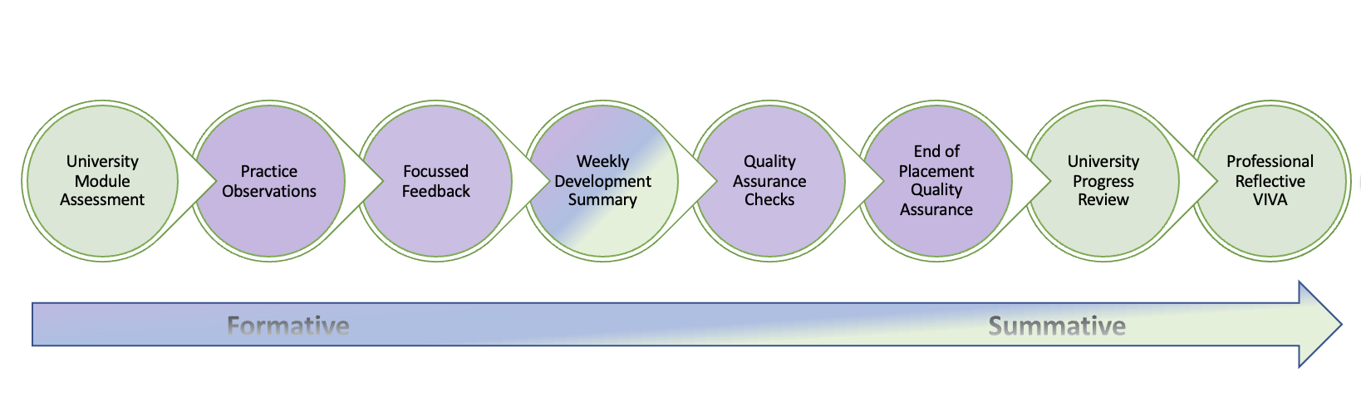

How is the Weekly Development Summary used as a tool to support formative assessment?

We track and monitor progress throughout the ITE curriculum every week for the duration of the ITE course.
Throughout their time at the centre, trainees complete Weekly Development Summaries (WDS) for each week of their curriculum. The WDS’ capture what trainees know and can do in line with the curriculum for that week in the form of their responses to 3 formative assessment questions which are set each week. This is done from the outset of the course and is monitored via the Course Lead when trainees are based on campus.

Once placement commences, the same process is followed however the mentor records the trainee responses to the formative questions based on the discussion had with the trainee in their Weekly Development Meeting (WDM). This is recorded on the WDS via Abyasa, our online platform. The mentor also indicates if the trainee has made sufficient progress through the curriculum that week, if sufficient progress has been made but this required additional support, or if despite additional support progress has not been made and a Progress Support Plan is required. The mentor submits the WDS at the end of their mentor meeting with the trainee, and this and reviewed and quality assured by the Link Tutor. The same process of recording the progress made plus any interventions provided is followed.

This approach also enables us to quality assure the mentoring which the trainee is receiving each week and enables us to support mentors who may benefit from additional guidance.

Progress Support Plans for trainees not making sufficient progress

Progress Support Plans (PSPs) are utilised on all Secondary and Further Education ITE programmes as part of the weekly formative assessment process. They are utilised in instances where the WDS process has indicated that a trainee is not making sufficient progress through the weekly ITE curriculum (on that course) despite additional support being provided. Such support made include (but are not limited to):
- Support with time and/or workload management (if the concern is the completion of the WDS by the agreed deadlines)
- Signposting to additional material or specific content addressed in taught sessions.
- Additional tutorials and/or sessions with a relevant colleague.
- Opportunities such as observation of colleagues, team-teaching, structured support sessions, or additional mentoring (if concern relates to progression through the curriculum whist on Professional Practice).
- A reduction in teaching load and/or an increase in team-teaching or additional support for teaching (if the trainee is on their professional practice)
- Referral to the Student Support Team and the requirement that the trainee engage with their support.
- Department Progress Meetings (DPM)

Any tutor or mentor can instigate a trainee on a Progress Support Plan where concerns have been raised via the Weekly Development Summary (WDS). This extends to non-submission of the WDS (this may be on consecutive weeks or repeatedly over a duration of time) as such actions impact on our ability to quality assure the assessment of the trainee in a timely manner. Trainees and mentors should ensure that they are aware of the deadline for their WDS submission each week and adhere to these as a priority noting that deadlines may differ across programmes.

The PSP process enables the department to formally raise concerns with the trainee about their progression through their ITE curriculum, it puts in place SMART targets which the trainee needs to act on to ensure progress and provides an opportunity for progression towards these targets to be reviewed after an agreed time period. A PSP can lead to one of three outcomes for the trainee;
- Sufficient progress has been made and the trainee returns to being monitored via the WDS as per the usual processes for formative assessment.
- Partial progress has been made but the trainee requires additional time to make sufficient progress (this is a maximum of 10 days after which the trainee must have either made sufficient progress or be referred to the Associate Head of Department).
- The trainee has not made sufficient progress and is referred to the Associate Head of Department (ITE) for consideration of next steps. These next steps can include;
- A delay to the trainee undertaking their placement until such a time as progress has been made (if the PSP has been instigated prior to professional practice).
- A request that the trainee undertakes their professional practice at a second attempt (if the PSP relates to progression through the curriculum whist on professional practice).
- The trainee is transferred to an alternative program which does not enable them to be recommended for QTS (Secondary) or which does not enable them to progress to QTLS (Further Education).

Further information relating to the PSP process during a period of Professional Practice can be found in the ITE curriculum handbook for each course and the Secondary or Further Education Professional Practice handbooks. Guidance on the use of PSPs is also included as part of the mentor training programme prior to Professional Practice.
Trainees may also wish to familiarise themselves with the Faculty of Education Academic Engagement Policy.

For an overview of the PSP process please see the appendix.

Roles, Responsibilities, and Expectations

Mentor Role and Responsibilities

ITE Partnership Mentors provide high-quality mentoring to our trainees during the professional practice and all mentors must undergo training which focuses on building their knowledge of the ITE curriculum, the relevant research which underpins it and their role in guiding and supporting trainees through that curriculum. Working closely with the Link Tutor, our mentors support and guide our trainees effectively throughout their training process. Our partnership trainers and mentors are consistently skilful at drawing on the taught curriculum during their interactions with trainees, particularly during mentoring sessions and feedback following observations. Secondary and FET trainees are only placed with mentors who are specialists in the subject the trainee is training to teach.

There are three main aspects of the role of the mentor: 1- Inducting the trainees, 2- Monitoring the trainees’ progress and achievement through the curriculum, 3- Supporting the trainee.

Inducting the Trainee
The mentors carry out meetings/sessions with the trainees to introduce them into their school’s/setting’s life/day. The expectations should be made clear at the start and the timetable should be shared with the trainees in a timely manner. Mentors should provide the trainees with access to all key documents such as the safeguarding policy, behaviour policy and teachers’ code of conduct. Additionally, mentors should provide access to teaching resources such as the curriculum plans and online materials.

Monitoring the Trainees’ Progress and Achievement

Mentors play a crucial role in developing trainees’ knowledge, understanding and skills to become teachers. They monitor the progress continuously through the weekly lesson observations and WDS meetings, where they provide the necessary support and guidance as to how to consolidate what has been learnt and move onto further progress.

Formative Assessment: Mentors assess the progress of the trainees formatively throughout the introductory, developmental, and consolidation phases. They refer to the key official documents on a weekly basis, when judging if the trainee is making appropriate progress, such as; the EHU ITE Curriculum (which covers the ITTECF and more) and The trainee teacher behavioural toolkit: a summary.

In the Secondary and FE phase, a week-by-week sequential curriculum enables mentors to know what progression looks like on a weekly basis for the subject in which the trainee is training to teach. Trainee progress through the curriculum is captured in the weekly mentor meeting in which the mentor records progress on the WDS. In addition, the form asks that mentors indicate each week if the trainee has made sufficient progress through the curriculum or if despite additional support progress has not been made. Where the mentor has identified the trainee needs additional support the Link Tutor contacts the mentor to discuss next steps and the necessary support is put in place such as a Progress Support Plan.

Feedback is provided in the form of a weekly lesson observation and a weekly development summary. The lesson observation reflects on the subject specific skills related to the lesson being taught. A feedback form is completed which identifies strengths and areas for development alongside a commentary of subject knowledge and subject specific pedagogy.

Supporting the Trainee: This is a vital part of the mentoring role. It provides effective support for achieving the targets to address the identified development areas. It is important that the trainees receive focused feedback and guidance at their weekly development summary meetings and that these are related to the subject in which the trainee is training to teach.

Using our ITE curriculum mentors;

- Provide opportunities to discuss and analyse with expert colleagues how to sequence lessons and identify possible misconceptions
- Arrange lessons trainees can observe delivered by expert colleagues and discuss and analyse with expert colleagues how they balance exposition, repetition, practice of critical skills and knowledge.
- Provide opportunities to discuss / experience the teaching of learners with EAL and SEND. Provide opportunities to discuss / experience in action about how to incorporate diversity, inclusion, race, equality and discrimination matters into their teaching.

Referring to ‘The trainee teacher behavioural toolkit: a summary’, mentors support trainees in developing effective behaviour management strategies.

Supporting trainee workload and well-being
As a department we are actively working to support trainee workload and we ask our mentors to support us in this endeavour. We ask mentors to:
- Model a healthy work-life balance including appropriate timings of emails, communications, and work requests.
- Provide a timetable which focuses on opportunities to develop through the curriculum, rather than working to a specific teaching load/number of hours.
- Model to trainees how to manage the workload of a teacher. For example, by making use of a marking timetable to deal with busy periods of marking activity.
- Deliver and support with our curriculum in line with where the trainee is at in their ITE journey noting their status as novice teachers and the support they will be offered as an ECT.
- Implement the guidance Ofsted by not requiring trainees to produce onerous lesson plans (once a level of competence is reached) and discouraging trainees from artificially creating distinct tasks for different groups of pupils (instead the focus is on adapting their teaching accordingly).
- Discuss workload and well-being strategies each week in the mentor meeting and record the discussion on the WDS.
- Discuss any concerns about workload and well-being with the trainee and their Link Tutor. This enables the Link Tutor to provide an appropriate support.
- Signpost trainees to the support available via the Edge Hill Well-being team https://www.edgehill.ac.uk/departments/support/studentservices/wellbeing/

Lead Mentor Role and Responsibilities
All mentors must undergo training which focuses on building their knowledge of the training curriculum, the relevant research which underpins it and their role in guiding and supporting trainees through that curriculum. Lead Mentors have particular expertise in the evidence base for effective ITE, including programme design and content selection and have a role to play in the Quality Assurance of mentoring and trainee progression through the curriculum. In the Secondary phase, Lead mentors are subject specialists. Their role includes oversight, supervision and quality assurance of other mentors, design and delivery of training for other mentors, supporting trainees and mentors during ITaPs, oversight of trainee progress throughout the year and identification of interventions or modifications where required.

Within the Secondary phase, we have appointed a number of Lead Mentos from within our partnership to support in a range of subjects.

Link Tutor Role and Responsibilities

ITE Partnership Link Tutors (LT) have a distinct role of connecting the centre-based training with the schools and settings to ensure the correct procedures are followed as set out in the respective Partnership Agreements. We have rigorous and robust quality assurance systems in our provision and both LTs and Lead Mentors have regard for quality assurance elements when assessing the judgments made at schools and/or settings.

There is an expectation that LTs communicate with the relevant colleagues regularly when carrying out their role. This includes liaising with the personal academic tutors (PATs), partnership development officers (PDOs), year/subject and programme/course leaders. They monitor the trainees’ progress weekly, ensure the trainees are set effective targets and appropriate support is planned to achieve them. And if/when problems arise, they communicate their concern to the relevant Faculty leaders immediately. In all phases, LTs have responsibility for updating the weekly tracking of trainee progression and ensuring appropriate interventions are put in place (and logged) to ensure trainee progression and/or mentor support. This process is overseen by, and quality assured by the Lead Mentors and AHoD.

LTs are required to check all the necessary information regarding the trainee and the placement specifics, and all guidance is available through the Mentor Training Space Link Tutor section.

There are three main aspects of the role of the Link Tutor:
1) Developing the mentors, 2) Quality assuring the mentoring process and assessment of the trainees, 3) Supervising the trainees.

All queries relating to Professional Practice should be directed to the relevant Link Tutor in the instance.

Trainee responsibilities and professional expectations

Edge Hill University ITE Code of Conduct

All Initial Teacher Education (ITE) programmes leading to a recommendation for the award of Qualified Teacher Status (QTS), or eligibility for the relevant Further Education qualification such as QTLS, are programmes of professional training and education.

As a trainee studying on an ITE programme you are expected to demonstrate consistently high standards of personal and professional conduct and be expected to maintain and model the highest standards of ethics and behaviour.

You are entitled to expect that your placement settings mirror the professional experience of a teacher, and settings are entitled to expect that you will present and conduct yourself in a way that is consistent with the professional expectations of a teacher in that phase.

This Code of Conduct is additional and complementary to the Edge Hill University Student Disciplinary Regulations 2024/25 and the Student Charter 2024 Student Charter 2024/25 - Edge Hill University

You are therefore both bound by, and protected by, the entitlements included in the Academic Student Regulations in force at the time of your enrolment and study. These were issued to you at the point of enrolment and subsequent updates are accessible via the EHU website. Academic Regulations 2024/25 - Edge Hill University

Trainee behaviours and attitude

As a trainee following an ITE programme at Edge Hill University, you will exhibit high standards of personal and professional conduct, honesty, and integrity, in keeping with those expected in the teaching profession. At all times you should:

- Demonstrate professional behaviours to all pupils/learners in all settings, and others, including fellow trainees and all staff in the Edge Hill University Partnership.

- Not engage in any conduct, poor or irresponsible behaviour outside of your studies or online that could bring the profession or the university into disrepute.

- Use language appropriate to the situation and the people involved. Communicate professionally in all contexts including your online and electronic communications such as email.

- Show respect and due regard for the ethos and values, processes, and procedures of the university both in the setting where the programme is delivered and at any other setting in which you are placed.

- Embrace the principles of equality, diversity and inclusion and bring them to life in all you do each day to work with children, staff, and parents. Equality, Diversity and Inclusion (EDI) Strategy - Edge Hill University

- Acquire an understanding of working with diversity, including gender, race and culture and ensure that any personal prejudices and stereotypical views do not influence your judgements or actions.

- Be aware of the requirement to promote equal opportunities and to provide reasonable adjustments for learners with disabilities, as provided for in current Equalities legislation.

- Take responsibility for adhering to all key policies and procedures: this includes, but is not restricted to, child protection and safeguarding policies, staff conduct, SEND code of practice, children missing in education, Health and Safety and fire evacuation procedures.

- Demonstrate professional behaviour and relationships in both formal and informal contexts. You will observe boundaries in line with a teacher’s professional position and responsibilities.
  - For those on programmes of QTS, trainees must adhere to expectations as outlined within Part Two of the Teachers’ Standards: Personal and professional conduct, which may be accessed at: https://www.gov.uk/government/publications/teachers-standards
  - For those training to teach in the FE sector, you should have due regard for the ETF Professional Standards (2022), which may be accessed at: https://www.et-foundation.co.uk/professional-standards/teachers/ and/or the Occupational Standards for those working with young people and adults, which may be accessed at: https://www.instituteforapprenticeships.org/apprenticeship-standards/learning-and-skills-teacher-v1-3

- Take care with confidential personal information that you will have access to.

Training responsibilities

In addition to the behaviours and attitudes above, as a trainee teacher you are required to:

- Ensure the welfare and safeguarding of all children, young people, and vulnerable adults, by reporting all safeguarding concerns to your setting DSL and foesafeguarding@edgehill.ac.uk as instructed in your training and our guidance documents.

- Inform the university immediately should you become subject to a criminal conviction or caution after your application for DBS enhanced disclosure has been submitted.

- Take responsibility to engage professionally and positively in all aspect your course. This means engaging with, listening to, and acting on feedback and advice from PATs, Mentors and Link Tutors across the Edge Hill University Partnership.

- Ensure your personal academic tutor is aware of all relevant matters likely to impact on you making good progress.

- Commit to attending all university based and practice-based training opportunities or enhancements including Intensive Training and Practice and contribute fully to the life of the setting when on professional practice.

- You will notify the relevant staff members of any absence in advance noting that in some instances this may affect any bursary which you may receive or your readiness for professional practice. Academic Programme Engagement Policy (APEP) details the faculties expectations of you https://www.edgehill.ac.uk/documents/academic-programme-engagement-policy-faculty-of-education/

- Take responsibility for your own learning and development, ensuring a professional and accountable approach to all aspects of the programme adhering to high standards of academic integrity.

- Take responsibility for managing the demands of the profession by looking after your personal health, wellbeing as well as actively developing resilience strategies. Self-help resources and ideas and support to help your wellbeing can be found in Student Services

- Commit to actively reflect on your learning and teaching experiences to set targets, plan actions, improve, achieve, and attain highly.

- Participate and actively engage in all learning, teaching and research experiences, and activities; and engage with the full range of feedback mechanisms, such as trainee surveys, trainee consultation and focus groups.

- Maintain an appropriate standard of dress and appearance as required by your setting and university guidance.

- Adhere to all Data Protection and data handling rules including the use of mobile devices when travelling to and from settings, ensure that any digital images are acquired under the terms of the location they are taken at.

- Ensure that if social media sites are used, details are not shared with learners and young people and privacy settings are set at maximum and that conduct is professional at all times. A professional approach should be taken at all times, with no detrimental mention of any educational settings (including EHU), colleagues, peers, pupils/learners, parents/carers. Trainees should not engage with any learners/parents/carers through social media channels.

- Maintain positive, appropriate professional relationships with learners, parents and staff which always adhere to child protection and safeguarding legislation. In addition, whilst in settings, this includes after school clubs, sports days and residential activities.

Breaches of Conduct

Breaches of conduct, may occur if you are unable to meet the professional and personal standards expected, this may include poor attendance and engagement, inappropriate behaviours, or attitude and dishonestly in the assessment process (malpractice) and may result in one or more of the following actions:

- The requirement for a Progress Support Plan.

- A placement being temporarily suspended by a setting pending an investigation

- A placement being concluded early by a setting

- A recommendation to attend a Fitness to Practice Panel

- A referral to a University Academic Misconduct Panel

- A referral to the University Support to Study process

- A referral to a University non-academic misconduct panel

Attendance and punctuality

As trainees seeking to work in the professional education sector, attendance is compulsory across all aspects of our Initial Teacher Education provision, and this includes Professional Practice. Poor attendance on Professional Practice has an impact on progression through the ITE curriculum and thus can hinder the progression of the trainee.

Trainees are expected to:
- Adhere to all aspects of the EHU ITE code of conduct in respect to any reference to attendance, punctuality, and communication.
- Model the expected professional expectations in respect of their attendance and punctuality. The expectations placed on trainees mirror the expectations placed on colleagues in that setting in respect of expected attendance and punctuality. Those training to teach in the secondary phase should note the expectations in relation to Part 2 of the Teachers’ Standards for those seeking to hold QTS (https://www.gov.uk/government/publications/teachers-standards).
- Attend their Professional Practice every day for the duration of the published dates. For all Secondary and Further Education trainees this will be Monday-Friday for the duration of the Professional Practice phase except in exceptional circumstances (such as during periods of ITaP).
- Ensure that all/any employment, medical appointments, holidays, and childcare are arranged well in advance of the Professional Practice and do not require an absence from the placement.
- Arrive on or before the time agreed with their setting noting that many settings require colleagues to arrive prior to the arrival of learners (for example, arriving by 8am for teaching to commence at 8:30am).
- Seek permissions in advance for any date when they are unable to attend their Professional Practice. For example, if this is to attend a hospital appointment which cannot be re-arranged, or a medical appointment related to pregnancy. Permission to be absent will not be given for instances in which, should the trainee be employed in that setting, permission would not be given. For example, to attend holidays, to attend medical appointments which can be re-arranged, or to organise childcare. Trainees should not presume that permission will be given and should plan accordingly.

During periods of Professional Practice, mentors are asked to confirm on the WDS if the trainee has demonstrated appropriate professional behaviours for that week. This includes appropriate attendance and punctuality.

Reporting an absence
Poor attendance on Professional Practice has an impact on progression through the ITE curriculum and thus can hinder the progression of the trainee. It can also impact on the progression of pupils and the workload of colleagues in that setting. However, we recognise that on rare occasions, trainees may feel too unwell to attend their Professional Practice. These instances should be rare, infrequent, and it will be expected that the trainee has sought advice from their GP.

Trainees should always let their mentor and Link Tutor know at the earliest opportunity if they cannot attend their Professional Practice (for example, the evening before). For every day that the trainee is absent they are expected to:
- Report their absence to their mentor, Course Leader, and Link Tutor before 8am that day. This should be via email addressed to all three colleagues.
- Follow the process in place for reporting an absence in their setting. For example, this may include calling a specific number and/or providing details of the absence to a named colleague.

Absences of longer than 5 consecutive days
Trainees can self-certify their absence from Professional Practice for a maximum of 5 working days. On the 6th day they are expected to return to Professional Practice or to gain a medical certificate from their GP for a longer period of absence. Support will be provided to assist trainees in transitioning back into their Professional Practice following extended periods of absence.

Frequent absences over a period of several weeks
Trainees need to be physically and mentally well enough to meet the demands of the course and the demands of placement. Frequent short-term absences from any aspect of their course naturally raise concerns about a trainee’s health and places unreasonable demands on mentors, expert colleagues, and impacts on the learning of pupils. Where a trainee is frequently absent over a period of time (e.g. 1-2 days a week over a period of 2-3 weeks), the department will seek to ascertain if the trainee is well enough to study and/or remain on the course at that time. This may involve temporarily pausing placements, liaising with expert colleagues from the student support or well-being team and/or referring the trainee via the ‘Support to Study’ process to determine the most appropriate way to support the trainee with their ongoing absence. Trainees may also be advised to consider interrupting their studies if they are too unwell to attend placement as expected.

Setting cover work during an absence
Where an absence has not been agreed in advance, trainees are not expected to set cover work however they should do all they can to send their mentor the lessons they were intending to deliver that day (plus any related resources) unless the nature of their absence means this is not possible. For example, if the nature and/or severity of the illness means the trainee is unable to send any work.

Where an absence has been agreed in advance, mentors and trainees should agree the work which the trainee will set for their classes in their absence and mentors are asked to support trainees with this task. For example, an absence which has been previously agreed such as for an interview or hospital appointment.

Making up days absent
There is no requirement for trainees to make up the days they are absent if such absences have been rare, infrequent, and have not impacted on the progression of the trainee through their ITE as evidenced via their WDS. Where absences (or poor punctuality) have impacted on the progress of the trainee, this should be noted in the WDS, and the trainee should expect to have additional interventions put in place to enable their progression. This may include an extension to the placement, the use of a Progress Support Plan, or additional opportunities being made available to them. It would be unusual for a trainee to make the expected and necessary progression if their attendance/punctuality has been a concern and this should be indicated on the WDS.

School closure days, strikes, INSET days etc
Trainees are expected to attend their setting in line with the guidance given to colleagues in that setting. This includes days when the setting may be closed, open only to colleagues (such as INSET days), or open to specific groups of learners (such as on strike days). If the setting is open, trainees should attend unless their mentor informs them otherwise. Trainees who are members of a union should seek advice from their union about attendance during periods of strike action and should attend Professional Practice unless their union has informed them differently.

Days for religious observance
It is anticipated that trainee teachers will require no more than two days religious observance during a professional placement. It is the responsibility of the trainee teacher to inform their mentor, Course Lead, and Link Tutor as far in advance as possible of the need to be absent from placement due to religious observance and to provide appropriate cover work (see guidance above). Trainees should note that this is a request to be absent, and not an entitlement.

Days for interviews and/or visits to potential employers, and induction days
Trainees can request absence for one day from their placement to attend interview for a teaching post however, this is a request and not an entitlement. Trainees should liaise with their mentor at the earliest opportunity and can be expected to provide or contribute to any cover work which may be required. Trainees should plan to undertake any travel in their own time rather than seek two days absent from placement if the interview necessitate significant travel. For example, travelling to/from London.

Where a trainee wishes to visit a school/college prior to making an application, this should be arranged outside of their placement hours.

If successful at interview, trainees can request absence from the placement to attend any formal induction day(s) required by their new school/setting. They can be expected to provide or contribute to any cover work which may be required, and this will be dependent on their progression at that time and the permission of their mentor and/or Link Tutor. This is a request to be made rather than an absence to which the trainee is entitled.

Professional Practice Teaching Expectations
There is no requirement for trainees to undertake a specific number of teaching hours for each phase of their professional practice. Rather, mentors should ensure that trainees have regular opportunities to observe and collaborate with experts, practice pedagogical approaches, receive regular purposeful feedback, observe, and be observed.

The table below sets out guidance for the minimum number of hours trainees should be engage in teaching activity per week on each of the three phases to ensure they have sufficient opportunity to practise, be observed, and receive feedback. When not engaged in teaching or support activities within their base classroom it is expected that trainees have opportunities to observe or support other experts across the setting. Time for planning preparation and assessment should be built in across the week but should be school based. Trainees are expected to participate in staff development meetings and the wider life of the school as per a member of staff and under the direction of the head teacher. Care should be taken to ensure that trainees are supported in and given strategies to assist with managing their developing workload.

Phase | Introductory
Minimum hours in classrooms (including observing, teaching, co-teaching each week.) | A minimum of 5 hours (on average 1 per day) per week considering the prior knowledge and experience of your trainee. This should build incrementally throughout the placement in a supportive manner.  Total teaching hours should not exceed 7 hours per week at this phase to help trainees manage their workload.
Mentoring - Minimum hours of mentoring each week | 1.5 hours. (This includes your weekly observation and weekly development meeting)
Planning, Preparation and Assessment (PPA) time | Trainees should have 2-3 hours per week of structured Planning, Preparation and Assessment (PPA) time on their timetable. This should be identified on their timetable and is directed time for trainees to plan, prepare, and assess in relation to their teaching.
Subject coverage | - All trainees must have an opportunity to plan, teach and assess at Key Stage 3 and Key Stage 4 in their specialist subject in line with the minimum hours. They should not be expected to teach outside of their specialist subject. This exception to this is Science trainees who can be expected to contribute across all 3 science disciplines.  - Teaching in this phase may take the form of team teaching, teaching small groups, and solo teaching.
Wider opportunities | Support an extra-curricular club | Support an assembly or collective worship. | Attend staff meetings | Attend education visits/trips
Wider opportunities | Parents evening or event and report writing | Undertake duties with supervision (before/after school, break, bus) | Set homework | Supporting during form/pastoral period

Phase | Developmental
Minimum hours in classrooms (including observing, teaching, co-teaching each week.) | A minimum of 10 hours (on average 2 per day) per week considering the prior knowledge and experience of your trainee. This should build incrementally throughout the placement in a supportive manner.  Total teaching hours should not exceed 12 hours per week at this phase to help trainees manage their workload.
Mentoring - Minimum hours of mentoring each week | 1.5 hours. (This includes your weekly observation and weekly development meeting)
Planning, Preparation and Assessment (PPA) time | Trainees should have 4-5 hours per week of structured Planning, Preparation and Assessment (PPA) time on their timetable. This should be identified on their timetable and is directed time for trainees to plan, prepare, and assess in relation to their teaching.
Subject coverage | - All trainees must have an opportunity to plan, teach and assess at Key Stage 3 and Key Stage 4 in their specialist subject in line with the minimum hours. Some trainees can be expected to teach outside of their specialist subject (where appropriate and in proportion to their specialist subject) and contribute to RSE/PSHE. This includes science trainees who can be expected to contribute across all 3 science disciplines.  - PGCE PE with Ebacc trainees should be provided with 2-3 hours per week of Key Stage 3 teaching in their Ebacc subject. This is included in their teaching hours and not in addition to.  - Teaching in this phase will increasingly take the form of solo teaching with some aspects of team teaching and teaching small groups (if/where appropriate).
Wider opportunities | Support an extra-curricular club | Support an assembly or collective worship. | Attend staff meetings | Attend and contribute to education visits/trips
Wider opportunities | Parents evening or event and report writing | Undertake duties with supervision (before/after school, break, bus) | Set homework | Supporting during form/pastoral period incuding delivery of any curriculum

Phase | Consolidation
Minimum hours in classrooms (including observing, teaching, co-teaching each week.) | Teaching hours at this phase should incrementally build to 80% of a full timetable for a minimum of 6 weeks. The 80% refers to a full teaching timetable as is typically defined by your school. This is part of the compliance criteria set by the DfE for ITE and prepares trainees for their ECT phase.  This may be adapted to provide additional support and input in consultation with your link tutor.  Total teaching hours should not exceed 80% of a full teaching timetable (in your school) to help trainees manage their workload.
Mentoring - Minimum hours of mentoring each week | 1.5 hours. (This includes your weekly observation and weekly development meeting)
Planning, Preparation and Assessment (PPA) time | Trainees should have appropriate amounts of structured Planning, Preparation and Assessment (PPA) time on their timetable. This should be identified on their timetable and is directed time for trainees to plan, prepare, and assess in relation to their teaching.
Subject coverage | - All trainees must have an opportunity to plan, teach and assess at Key Stage 3 and Key Stage 4 in their specialist subject in line with the minimum hours. Some trainees can be expected to teach outside of their specialist subject (where appropriate and in proportion to their specialist subject) and contribute to RSE/PSHE. This includes science trainees who can be expected to contribute across all 3 science disciplines.  - PGCE PE with Ebacc trainees should be provided with 4-5 hours per week of Key Stage 3 teaching in their Ebacc subject. This is included in their teaching hours and not in addition to.  - Teaching in this phase should predominantly be solo teaching.
Wider opportunities | Support or lead an extra-curricular club | Support or lead an assembly or collective worship. | Attend staff meetings | Organise and contribute to education visits/trips
Wider opportunities | Parents evening or event and report writing | Undertake duties with supervision (before/after school, break, bus) | Set homework | Leading during form/pastoral period including delivery of any curriculum

Professional Practice forms: The Weekly Development Summary (WDS)

- The Weekly Development Summary (WDS) is a record of the weekly meeting between trainee and mentor and how the mentor captures the progress the trainee has made that week in reference to their ITE curriculum.
- It is a way for the Link Tutor to quality assure the level of mentoring which the trainee is receiving and to identify any mentor or trainee support needs.
- It is completed on Abaysa by the mentor during the weekly mentor meeting.
- It is submitted on Abaysa by the mentor at the end of the weekly mentor meeting.
- The mentor indicates if the trainee has been able to demonstrate what they know and can do that week in reference to the ITE curriculum set out that week. This may draw from a wide variety of evidence sources, including, but not limited to:
  - Discussion with mentor
  - Discussion with trainee
  - Discussion with learners
  - Discussion with TA / other professionals
  - Learners’ responses within the lesson and in their books/work
  - Observation of teaching and learning
  - The trainees’ assessment and planning records in their files
  - Informal notes and reflections

- The mentor questions the trainee (making use of the weekly formative questions) and records the trainee’s responses on the WDS. The mentor makes use of the reading and additional support which has been provided to them for that week to ascertain if the trainee is able to link theory to practice, to make use of current pedagogical research, and to critically reflect on their practice.
- The mentor and trainee also discuss any other matters which have arisen that week such as subject knowledge, additional CPD, and workload.
- The mentor and trainee agree which skills the trainee needs to develop to make progress and the opportunities provided for the trainee to practise/observe and/or receive feedback on these skills.
- Finally, the mentor identifies whether sufficient progress has been made that week:
  - Yes, and appropriate professional behaviours have been demonstrated.
  - Yes, and appropriate professional behaviours have been demonstrated, but this required additional support (which the mentor then lists).
  - No, progress has not been made despite additional support (and/or appropriate professional behaviours have not been demonstrated) and the trainee may require a Progress Support Plan.
- Failing to submit the WDS by the deadline set can trigger a Progress Support Plan being put in place for the trainee or additional support being provided for the mentor.

Each week, the Link Tutor will review the WDS from the previous week and note if the trainee is making sufficient progress, if further support is being provided, or if sufficient progress is not being made. The Link Tutor will then contact the mentor to discuss the appropriate next steps.

Failing to upload the WDS by the agreed deadlines hinders the Link Tutor in assessing the progress of the trainee and can trigger a Progress Support Plan. Moreover, it hinders the Link Tutor’s ability to QA the mentoring which the trainee is receiving and can instigate additional support for the mentor.

A template of the WDS with guidance is provided for mentors to assist with completion of the form accurately.
Exemplar: The Weekly Development Summary

Mentor comments written in red. Sections pre-populated by EHU tutor written in black.

This form is completed on Abyasa, our online platform, and therefore may look slightly different.
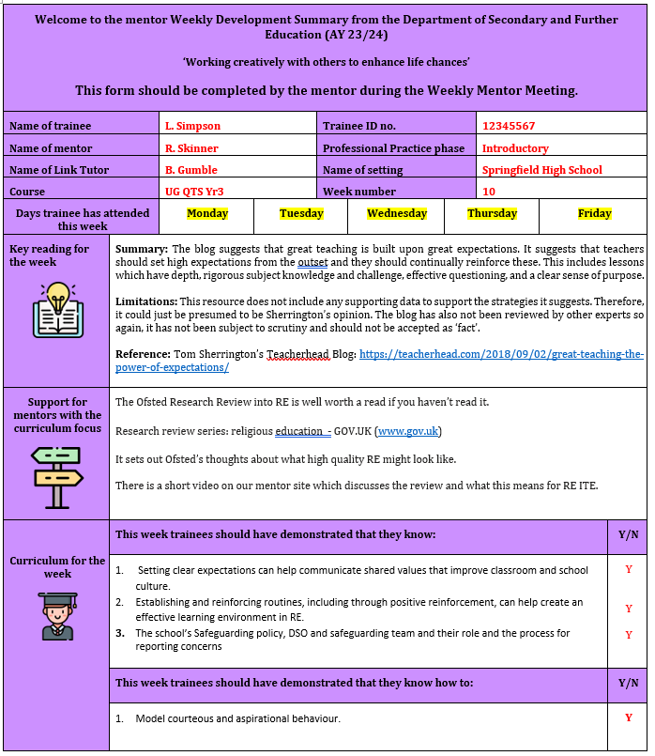

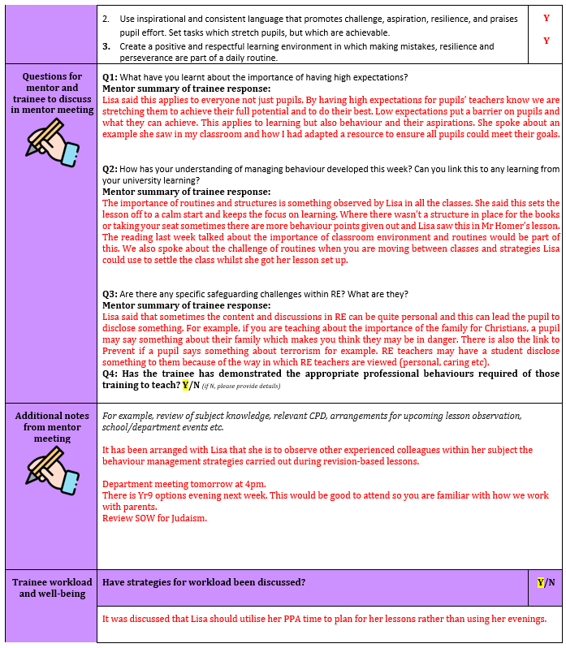
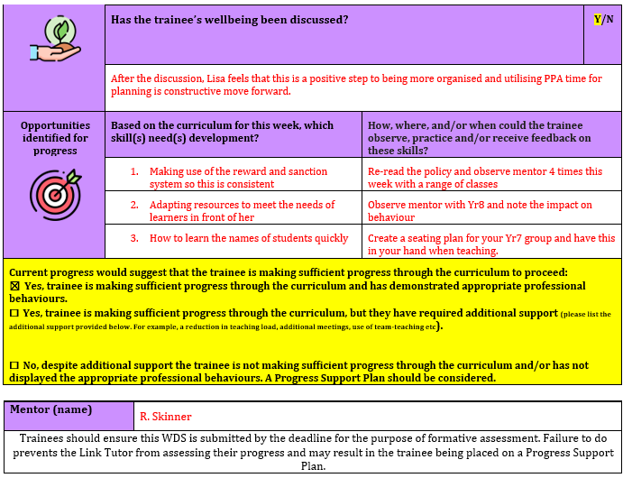

Professional Practice forms: The Lesson Observation form

- The lesson observation form records the one formal lesson observation carried out by the mentor each week. It is subject specific.
- In the weekly mentor meeting, the mentor and trainee should agree the lesson which will be observed in advance and the skill(s) which the trainee will receive feedback on. This should be linked to the ITE curriculum for that week.
- Only mentors and expert colleagues who have undertaken their core Edge Hill mentor training can observe the trainee for their formal lesson observation. Trainees are advised to provide a small notebook (or can have one provided by Edge Hill) for informal lesson observation which can be provided by any expert colleague.
- The observation can focus on a full or part of a lesson, or any intervention work the trainee is doing with a small group.
- The trainee can be seen with the same class/group of learners if the mentor is unable to arrange cover and/or no other colleague is trained and able to observe.
- It is completed on Abaysa by the trainee (before the observation), the mentor (during the observation), and then the trainee and mentor complete the form during the observation feedback (after the observation)
- It is submitted on Abaysa by the mentor at the end of the lesson observation feedback.
- It is a way for the Link Tutor to quality assure the level of mentoring which the trainee is receiving, to triangulate the progress being made as evidenced in the WDS, and to identify any mentor or trainee support needs.

An exemplar lesson observation form with guidance is provided for mentors and trainees to assist with completion of the form accurately.
Exemplar Lesson Observation form
This form is completed on Abyasa, our online platform, and therefore may look slightly different.

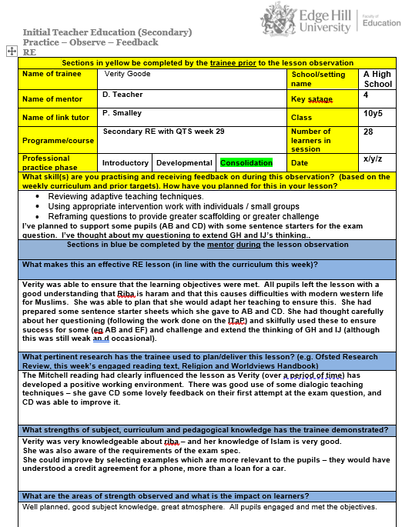
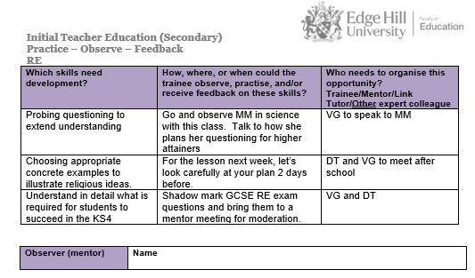
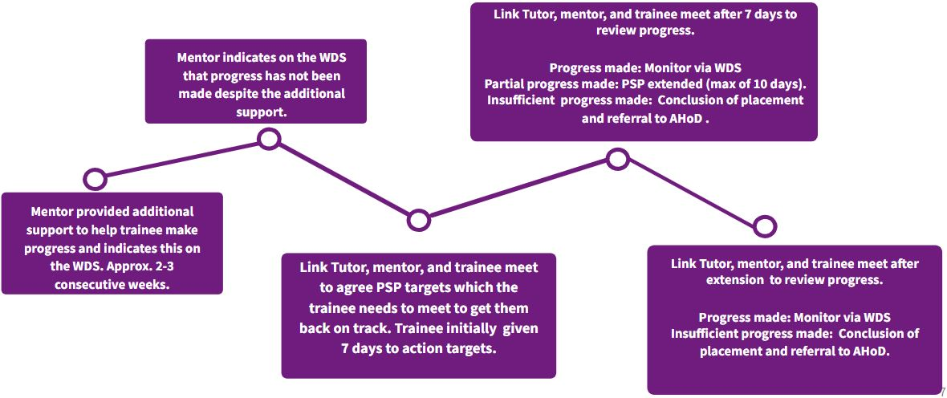
Appendix: Progress Support Plans during Professional Practice
This box may be filled in during the observation or following discussion with the trainee. It should note opportunities the trainee needs and/or has been provided with to make progress based on their feedback from the lesson observation. We suggest no more than 3 opportunities/targets to assist with workload.

Further support, resources, and suggested texts for mentors
ITT Core Content Framework
ITT Core Content Framework Exemplification Resource Materials
ITT Core Content Trainee Teacher Behavioural Toolkit: A Summary
Adaptive Teaching Adaptive teaching: Rethinking the nature of learning in schools: BOLD
Early Career Framework: Learning about adaptive teaching
The Early Career Framework Reforms Overview (ECF)
The Early Career Framework (ECF)
DfE The reading framework: teaching the foundations of literacy
Edge Hill Mentor Space

Each one of our ITE curricula is underpinned by and draws from pertinent research in that subject area such as the Ofsted research review series. We have also compiled a list of suggested texts for mentors for subjects we offer at the Secondary level.
Computing
Developing a Computer Science-specific Learning Taxonomy. Available from: https://www.cs.kent.ac.uk/pubs/2007/2798/content.pdf.

CSE, 2018. Computer Science Education: Perspectives on Teaching and Learning. London: Bloomsbury Academic. https://books.google.co.uk/books?hl=en&lr=&id=MUmlEAAAQBAJ&oi=fnd&pg=PP1&dq=Computer+Science+Education:+Perspectives+on+Teaching+and+Learning.+London:+Bloomsbury+Academic&ots=SpEp0nP1zO&sig=0an1BjkJbk-8KHkZBWp7JNjRMJU
Ofsted (2021) research review series: computing https://www.gov.uk/government/publications/research-review-series-computing

SENTANCE, S., WAITE, J. and KALLIA, M., 2019. Teaching computer programming with PRIMM: a sociocultural perspective. Computer Science Education. 29 (2-3), pp. 136-176. https://www.tandfonline.com/doi/pdf/10.1080/08993408.2019.1608781

The Royal Society, 2012. Shutdown or Restart? The way forward for computing in UK schools. . Available from: https://royalsociety.org/-/media/education/computing-in-schools/2012-01-12-computing-in-schools.pdf.

The White Paper: Practical programming in computing education https://pure.roehampton.ac.uk/ws/portalfiles/portal/7463560/Practical_Work_in_Computing_Apr_22.pdf

English
Cremin, T(2019). Reading communities: Why, what and how? https://www.nate.org.uk/wp-content/uploads/2020/03/4-Reading-Communities-Teresa-Cremin.pdf

Sherrington, T (2020), The hidden lives of learners: Re-reading Nuthall’s Hidden Lives of Learners. Insights from a classic. https://teacherhead.com/2020/02/15/re-reading-nuthalls-hidden-lives-of-learners-insights-from-a-classic/

Education Endowment Foundation (EEF) (2021)., Improving Literacy in Secondary Schools: https://educationendowmentfoundation.org.uk/education-evidence/guidance-reports/literacy-ks3-ks4
Ofsted (2021) research review series: English https://www.gov.uk/government/publications/curriculum-research-review-series-english
Geography
Geographical Association (2022) Geography mentoring. https://www.geography.org.uk/Geography-mentoring

Healy G., Hammond, L., Puttick, S. & Walshe, N. (2022) Mentoring Geography Teachers in the Secondary School: A Practical guide. Routledge.

Jones, M & Lambert D. (2017) Debates in Geography education. Routledge.

Ofsted (2021) research review series: geography https://www.gov.uk/government/publications/research-review-series-geography
History
Chapman, A (ed.) (2021) Knowing History in Schools: Powerful knowledge and the powers of knowledge, London: UCL Press.
https://www.uclpress.co.uk/products/130698

Counsell, K. Burn and A. Chapman, (eds.) (2015) Masterclass in History Education: transforming teaching and learning, London: Bloomsbury.
https://www-bloomsburycollections-com.edgehill.idm.oclc.org/book/masterclass-in-history-education-transforming-teaching-and-learning/

Davies, I. (ed.) (2017) Debates in History Teaching, Oxford: Routledge
https://www-taylorfrancis-com.edgehill.idm.oclc.org/books/edit/10.4324/9781315642864/debates-history-teaching-ian-davies

Harris, R., Burn, K. & Woolley, M. (2014) The Guided Reader to Teaching and Learning History, Abingdon: Routledge.
https://ebookcentral.proquest.com/lib/edgehill/reader.action?docID=1480726

Ofsted (2021) research review series: history https://www.gov.uk/government/publications/research-review-series-history

Reading for practical ideas
Natalie Kesterton’s (2019). ‘Plugging the gaps: using narratives and big pictures’ in Teaching History, 176.

Reading to understand how to structure history lessons
Riley's (2000) article ‘Into the Key Stage 3 history garden: choosing and planting your enquiry questions’, Teaching History, 99.

Reading to develop trainees' understanding about how children learn in history lessons S Wineburg, ‘Unnatural and essential: the nature of historical thinking’, in ‘Teaching History’, Issue 129, September 2007, pages 6 to 11 and Husbands, C. (1996) What is History Teaching? Buckingham: Open University Press, ch 6, pp. 73-87.
Mathematics
Education Endowment Foundation (EEF), ND. Improving mathematics in key stages two and three: guidance report KS2_KS3_Maths_Guidance_2017.pdf (educationendowmentfoundation.org.uk)
Ofsted (2021) research review series: mathematics https://www.gov.uk/government/publications/research-review-series-mathematics
Physical Education

Capel, S, Cliffe, J, & Lawrence, J (eds) 2020, Learning to Teach Physical Education in the Secondary School : A Companion to School Experience, Taylor & Francis Group, Milton. Available from: ProQuest Ebook Central. [17 January 2023].

Deng, A. and Chen, A., 2022. Cognitive Load and Energy Balance Knowledge in High-School Physical Education. Journal of Teaching in Physical Education, 1(aop), pp.1-10. https://www.tandfonline.com/doi/epdf/10.1080/17408989.2020.1849595?needAccess=true&role=button

Vickerman, P., 2007. Teaching physical education to children with special educational needs. Routledge.
Religious Education
Ofsted (2021) research review series: religious education https://www.gov.uk/government/publications/research-review-series-religious-education/research-review-series-religious-education

Sheehan, H. (2023) Mentoring Religious Education Teachers in the Secondary School: A Practical Guide https://www.routledge.com/Mentoring-Religious-Education-Teachers-in-the-Secondary-School-A-Practical/Sheehan/p/book/9781032042442

Pett, S. (2022) Religion and Worldviews in the Classroom: developing a Worldviews Approach Stephen Pett A Draft Resource for curriculum developers https://www.religiouseducationcouncil.org.uk/wp-content/uploads/2022/09/REC-Worldviews-Project-single-pages-Revised-cover-v1.2.pdf

Science
HOLMAN, J. and YEOMANS, E. 2018. Improving Secondary Science Guidance Report. Education Endowment Foundation.

INGLIS, M., 2018. Mentoring New Science Teachers. In: BANNER, I. and HILLIER, J., eds. ASE Guide to Secondary Science Education. 4th ed. Hatfield: Association for Science Education. pp. 276-291

Ofsted (2021) research review series: science https://www.gov.uk/government/publications/research-review-series-science

35

