

Welcome to the Weekly Mentor, Trainee and Link Tutor Briefing from the
Department of Early Years.

Course:  Primary 3-7 PGCE with QTS | Phase:  Developmental | Week:  5

It is almost the half term, keep working hard trainees, you are doing a fantastic job!

Thank you, Mentors, for your expert guidance and support for our trainees!

And thank you Link Tutors for maintaining a positive relationship with schools, trainees and EHU!

Weekly intended curriculum expectations:

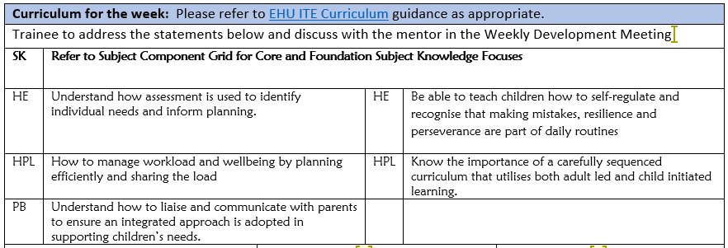

Links to CCF or centre-based training:
As the teaching of Systematic Synthetic Phonic strategies is a Government and National priority, we would ask that before trainees complete this current placement, that they have had opportunities to both observe and teach a sequence of SSP lessons. There is a lesson observation template available on the Mentor Space to support the feedback. Another really important strategy that schools can support trainees with, is to allow them to observe SSP teaching in a range of classes, with opportunities to talk with expert colleagues both before and after the lesson, to ensure there is a robust understanding of how and why SSP is planned so deliberately in each school and class.

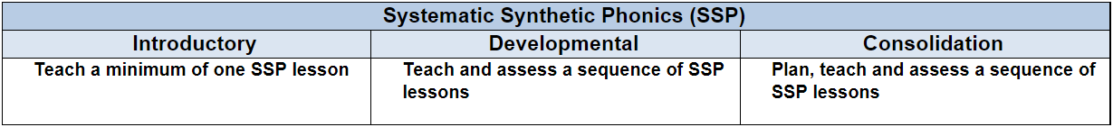

Link Tutors:
Please communicate with trainees and Mentors about when you will undertake an in person visit at school for QA3. Trainees learn so much and gather lots of information regarding their practice and pedagogy following a professional discussion with colleagues after a lesson observation has taken place. Good luck with this trainees and please let
us know how this goes.

Mentor focus:
We would ask that Mentors focus their Weekly Development Meeting (WDM) upon the Intended Curriculum, as identified above. Furthermore, to engage trainees in professional dialogue related to what they have been learning
and how they can use this new knowledge and understanding to help them in planning and delivering effective
learning opportunities for the children. The trainees will be able to clearly articulate the Edge Hill Curriculum
that drives their learning, which also features the Core Content Framework and Edge Hill Pillars, at its core.

In relation to Future Targets within the WDS forms, please could you set targets that relate to the Intended
Curriculum for that week, and be very mindful of how you can support trainees in actioning and completing
these targets within the timeframe they have on Developmental PPP.
If you require further support with target setting, please do contact your trainee’s Link Tutor in the first instance.

Observation of experts to support training suggestions:
How children learn is a focus that trainees will be reflecting more upon, in the next part of their PP Placement.
This is as a direct consequence of their teaching responsibility and expectations increasing over the next 4 weeks.
We would ask that as Mentors and Link Tutors, you hold professional dialogues with trainees focusing on
the following:

Know the role the teacher plays to support learning and memory. Understand strategies including worked examples and modelling.

Know the impact of targeted questioning on pupils’ retrieval and recall.

Know the importance of a carefully sequenced curriculum that uses both adult led and child-initiated learning.

Understand the role of curriculum design with consideration to how children learn utilising both indoor and outdoor environments.

Be able to design provision that supports the needs of all learners and challenges them.

Research and resources:

Allen, S., Whalley, ME., Lee, M. & Scollan, A. (2020) Developing Professional Practice in the Early Years. OUP.

Lindon, J., & Brodie, K. (2016) Understanding Child Development. London: Hodder Education.

Ephgrave, A. (2018). Planning in the Moment with Young Children. Routledge.

If you require any further support or guidance, then please email the Primary 3-7 PGCE Professional Practice Quality Lead – Amanda Casey at Caseya@edgehill.ac.uk

