



Professional Practice Handbook 2024-2025

PGCE Primary Developmental (5-11) with QTS
Contents

Welcome from the Department of Primary Education 1
Mentor Space and Partnership Website 2
Key Contacts 2
Safeguarding 3
Managing a Safeguarding Concern on Professional Practice 4
The Edge Hill University ITE Curriculum Intent 5
What do I need to know about the Core Content Framework (CCF)? 6
Particular points of interest: CCF 6
The Edge Hill University ITE Curriculum Implementation 7
The curriculum as the model of progression 7
How are ITE students assessed? 8
Formative Assessment 8
How is the Weekly Development Summary used as a tool to support formative assessment? 8
Progress Support Plans for trainees not making sufficient progress. 9
Roles, Responsibilities, and Expectations 10
Link Tutor Responsibilities 10
Mentor Role and Responsibilities 12
Inducting the Trainee 12
Monitoring the Trainees’ Progress and Achievement 12
Supporting the Trainee 12
Supporting trainee workload and well-being 13
Trainee responsibilities and professional expectations 14
Edge Hill ITE code of conduct 14
Attendance and punctuality 17
PGCE Primary Education with QTS Developmental Programme Structure 2024/25 18
Teaching expectations on Professional Practice 18
Teaching Progression Across the Placement 21
The Teaching of Systematic Synthetic Phonics (SSP)…………………………………………………………….22

Professional Practice forms: The Weekly Development Summary (WDS) 23
Professional Practice forms: The Lesson Observation form 26
Appendix: Progress Support Plans 28
Further support and resources 29

Welcome from the Department of Primary Education
Edge Hill University has been at the forefront of teacher education for over 135 years, and today it enjoys the enviable position of being one of the country’s most significant providers of education and research for the children’s workforce with a reputation for the highest quality provision, partnership working and delivery.

The Primary Education Department at the Faculty of Education provides a solid foundation and environment for real impact on the quality of primary education across Key Stage One and Key Stage Two. We are very proud of our dedicated Department to support the continued growth of the primary sector.

Our Primary Education team is driven by a commitment to exceptional practice and research, high levels of achievement, ensuring that we provide opportunities for all. We understand that our partnership with our students is crucial in achieving this ambitious vision.

We strive to provide an outstanding student experience as well as support you in your future employment opportunities or further professional development, tailoring our programmes of study to match the demands of the employers.

We very much look forward to working with you and wish you every success in your studies.

Michelle Pearson
Head of Teacher Education

Mentor Space and Partnership Website

All resources for each professional practice including links to the partnership website are available in the Primary Education mentor space.

All documentation and policies are available in full on the Edge Hill Website Partnership pages.

Key Contacts
For the duration of professional practice your Link Tutor is your first point of call for all matters. For all other matters, the table below lists key contacts.

Name | Role | Contact
Department Leadership
Sian Miles | Head of Primary & Childhood Education Department | sian.miles@edgehill.ac.uk
Kelvin Wilkins | Associate Head of Department (ITE) | wilkinsk@edgehill.ac.uk
Primary Colleagues
Shaun Thompson | Strategic Lead for Primary PGCE | Shaun.thompson@edgehill.ac.uk
Virginia Kay | Primary PGCE Professional Practice Quality Lead Ormskirk | virginia.kay@edgehill.ac.uk
Sharon Stelling | Primary PGCE Course Lead Ormskirk | Stellings@edgehill.ac.uk
Emma Dickinson | Primary PGCE Course Lead Holy Cross | Emma.dickinson@edgehill.ac.uk

you

Safeguarding

All ITE trainees are expected to be familiar with and adhere to the statutory guidance set out in ‘Keeping children safe in education 2023: Statutory guidance for schools and colleges’ KCSIE. Trainees have all completed ‘Children’s Safeguarding Assurance Partnership’ training and are also expected to be familiar with the specific safeguarding processes and colleagues in their setting during Professional Practice.

All providers of Initial Teacher Training (ITT) have a responsibility to ensure that trainees have the health and physical capacity to teach and will not put children and young people at risk of harm. In addition, statutory guidance, Keeping children safe in education, requires providers to ensure that entrants on all routes, including salaried schemes, have been subject to an enhanced Disclosure and Barring Service (DBS) criminal records check, including a check of the children’s barred list, a check of the Prohibition List; and, for trainees working with children under the age of 8, the Childcare Disqualification Declaration.

A trainee embarking upon a Professional Practice will carry with them their student ID card (Uni Card) and a letter from the University confirming their suitability to train to teach. The enhanced DBS check lasts the length of a trainee’s programme of study, including where the programme lasts longer than three years. Enhanced DBS apply only to periods of Professional Practice which are organised by Edge Hill for the purpose of completing a named award. They do not cover placement experiences undertaken outside of the structured course, undertaken voluntarily. It is an offence under the 1997 Police Act, and a breach of the DBS Code of Practice, for registered bodies (i.e., Edge Hill University) to share copies of DBS checks or any information contained in a trainee’s disclosure with a third party.

Managing a Safeguarding Concern on Professional Practice

It is the responsibility of everyone to safeguard and protect children, young people, and vulnerable adults and to ensure they are kept free from risk of being harmed or exposed to radicalisation.

Recognising safeguarding issues/concerns through:

- Direct observation.
- Disclosure from child, young person, or vulnerable adult.
- Observation by a third-party.

Reporting incidents or disclosed information requires an immediate and professional response.
Reporting when on Professional Practice | Reporting when at university
- Straight away inform the Designated Safeguarding Lead (DSL) in your setting. Do let leave the premises until you have done so.  - Inform the Senior Safeguarding Lead in the Faculty of Education by completing the form found here -  Safeguarding Report Form | 1. Inform the Senior Safeguarding Lead in the Faculty of Education by completing the form found here - Safeguarding Report Form
Should you wish to contact the Senior Safeguarding Lead for anything other than reporting a disclosure you can email Leon Fraser via foesafeguarding@edgehill.ac.uk.

Remember: You MUST use the Safeguarding Report Form to report a disclosure.

If you need support outside of office hours and the report cannot wait until the next time the office is open, please contact 01695 584227 https://www.edgehill.ac.uk/departments/support/studentservices/critical-incident-support/

Once the information has been reported this will conclude your involvement in the incident. You must not discuss the disclosure or incident with anyone else unless explicitly requested to do so by the DSL or Safeguarding Lead in the setting/Edge Hill.

The Edge Hill University ITE Curriculum Intent

Our EHU ambitious curriculum exceeds the full entitlement described in the ITT Core Content Framework as a baseline and is designed around the three faculty pillars of:

1. Personal and professional attitudes, values, and beliefs.
2. Subject and curriculum knowledge.
3. The craft of teaching and pedagogy.

These faculty pillars are informed by our philosophy of education, created, and enhanced further when our partnership and our students are engaged in an ethos of debate, research and educational curiosity based on reflection and professional enquiry. This ambitious ITE curriculum includes our values of social justice, inclusion, learning outside the classroom and sustainability as key features to support our local and national communities.

Primary (5-11) Vision
Working creatively with others to enhance life chances for all through a curriculum which enables trainees to develop as subject experts in the subject in which they are training to teach.



What do I need to know about the Core Content Framework (CCF)?

- It is not a curriculum nor an assessment document. It is the minimum content all ITE providers must include as part of their curriculum as set out by the Department for Education (DfE) and assured by Ofsted.
- It aligns with our own ambitious ITE curriculum, based on the EHU ITE Pillars (which is a much richer curriculum).
- The EHU ITE pillars together with the CCF have been key documents used to support the design of the sequencing and progression of our own provision, programme by programme (as outlined within our Curriculum Communication documents).
- The CCF has been designed to support trainee development in 5 core areas: behaviour management, pedagogy, curriculum, assessment, and professional behaviours.
- It is presented within 8 key sections: High Expectations, How Pupils Learn, Subject and Curriculum, Classroom Practice, Adaptive Teaching, Assessment, Managing Behaviour and Professional Behaviours.
- Each section of the CCF contains a range of ‘learn that’ and ‘learn how to’ statements or principles, however, this is not an assessment framework and should not be used as such.
- The Introductory/Developmental/Consolidation phases of placements should engage with the EHU ITE curriculum and CCF content with levels of detail and complexity commensurate with the stage of the programme.
- The CCF dovetails with the Early Career Framework (ECF) where Early Career Teachers (ECTs) further develop their skills through a structured programme of support in their first two years of teaching.
- An evidence base is provided within the framework which should be shared with trainees to support their critical engagement with research. Trainees should be engaging with these materials both whilst at school and at centre-based university training.

Particular points of interest: CCF

Trainees should be fully aware of the principles underpinning the CCF. There are some areas of particular interest for current practice, for example:

- Consideration of SEND, disadvantaged backgrounds and mental health.
- The principles of adaptive teaching (as opposed to the use of differentiated tasks).
- The key role of expert colleagues, including experienced and effective teachers and subject specialists in schools.
- Support for Behaviour Management Training.
- The importance of subject specific knowledge and training.
- Working memory, long-term memory – balancing exposition, repetition, practice and retrieval of critical knowledge and skills.
- Trainees themselves need to demonstrate evidence that they know more and remember more of their ITE curriculum and that they can put this into practice.

The Edge Hill University ITE Curriculum Implementation

The curriculum as the model of progression

.
Within the Primary phase, we have put the curriculum at the centre of our understanding of progression. Each distinct course has its own subject specific ITE curriculum which ensures trainees meet the relevant learning milestones over the course of their ITE journey. This ensures that, contingent on meeting the milestones in the curriculum, they can be recommended for the award of Qualified Teacher Status (QTS) at the end of the course. You can download the curriculum handbook for the relevant course by visiting our Mentor Space.


The ITE curriculum for each course is purposefully sequenced on a week-by-week basis over the duration of each course so that Primary trainees cover all aspects of the Core Content Framework (CCF) and meet the necessary competencies for the award of QTS, however it also goes far beyond this. At the Primary phase, each course curriculum breaks down the required component knowledge to address the subject-specific pedagogical content knowledge required within each subject and area, building to the required complex composite understanding at the conclusion of their ITE journey, ready to transition into the Early Career Framework (ECF). The curriculum is sequenced across 3 years for our full-time undergraduate course, 4 years for our part time undergraduate course and one year for our PGCE course.

The week-by-week curriculum for each course states what trainees should be able to know and do each week and ensures the necessary progression is made to enable QTS recommendation via a summative Professional Reflective Viva at the end of their ITE. Progress through the curriculum is monitored on a week-by-week basis via the use of ‘Weekly Development Summaries’ which capture what trainees understand and can do in line with their specific course ITE curriculum.

There is no separate curriculum for school-based experience. Instead, the specific ITE curricula for each course encompass all aspects of school-based experience and ensures trainees have opportunity to purposefully integrate their learning at university with the opportunities afforded on Professional Practice when they are mentored through their ITE curriculum by school-based colleagues who are experts in their practice. The content of the curricula is sequenced in line with the faculty approach to progression on Professional Practice; introductory, developmental, and consolidation and builds in opportunities for trainees to revisit key learning via a spiralised approach. During their Professional Practice, trainees continue to be monitored on a week-by-week basis via the ‘Weekly Development Summaries’. This approach also enables university-based tutors to Quality Assure the mentoring which is taking place during the placement and to provide support/intervention to trainees or school-based mentors as appropriate.

How are ITE students assessed?

Edge Hill University adopts a holistic approach to the monitoring and assessment of trainees through the university-based curriculum. This takes place within a variety of contexts:

- Ongoing formative assessment on a weekly basis through their ITE course curriculum via the Weekly Development Summaries (logged on a tracker in addition to any interventions made). This is done from the outset and for the duration of the ITE journey.

- Trainee reflections and responses to their weekly curriculum during their Weekly Development Meeting (WDM) whilst on Professional Practice.

- Lesson observations during Professional Practice

- Within taught university sessions (online, present in person (PiP), synchronous and asynchronous), through activities and interactions

- Academic submissions related to the level at which the trainee is studying (L4-L7)

- Progress Support Plans for trainees who are not making sufficient progress despite additional support.

Formative Assessment

How is the Weekly Development Summary used as a tool to support formative assessment?

Throughout their time at the centre, trainees complete Weekly Development Summaries (WDS) for each week of their curriculum. The WDS’ capture what trainees know and can do in line with the curriculum for that week in the form of their responses to weekly component knowledge. This is done from the outset of the course. Each week trainees complete their WDS’ and upload this to be reviewed by their link tutor. The tutor reads each WDS and records on a tracker if each trainee has made sufficient progress. Where progress is not made, or where further support is needed, the intervention made is also recorded. When the trainee starts their Professional Practice, the same process is followed however the mentor records the trainee progress based on the discussion had with the trainee in their Weekly Development Meeting (WDM). The mentor also indicates on the form if the trainee has made sufficient progress through the curriculum that week, if sufficient progress has been made but this required additional support, or if despite additional support progress has not been made and if a Progress Support Plan is required. After the meeting the WDS is submitted and reviewed by the Link Tutor. The same process of recording the progress made plus any interventions provided is followed. Thus, we track and monitor progress throughout the ITE curriculum every week for the duration of the ITE course.

Progress Support Plans for trainees not making sufficient progress.

Progress Support Plans (PSPs) are utilised in instances where the WDS process has indicated that a trainee is not making sufficient progress through the weekly curriculum despite additional support being provided. Such support made include (but are not limited to):
- Signposting to additional material or specific content addressed in taught sessions.
- Additional tutorials and/or sessions with a relevant colleague.
- Opportunities such as observation of colleagues, team-teaching, structured support sessions, or additional mentoring (if concern relates to progression through the curriculum whist on Professional Practice).
- A reduction in teaching load and/or an increase in team-teaching or additional support for teaching (if the trainee is on their professional practice)
- Referral to the Student Support Team and the requirement that the trainee engage with their support.
- Department Progress Meetings (DPM)

The process enables the department to formally raise concerns with the trainee about their progression through their ITE curriculum, it puts in place SMART (Specific, Measurable, Realistic and Time) targets which the trainee needs to act on and provides an opportunity for progression towards these targets to be reviewed after one-two weeks. A PSP (Progress Support Plans) can lead to one of three outcomes for the trainee; sufficient progress has been made and the trainee returns to being monitored via the WDS, partial progress has been made but the trainee requires an additional week to make sufficient progress, or the trainee has not made sufficient progress and is referred to the Associate Head of Department (ITE) for consideration of next steps. These next steps can include;
- A delay to the trainee undertaking their placement until such a time as progress has been made (if the PSP has been instigated prior to professional practice).
- A request that the trainee undertakes their professional practice at a second attempt (if the PSP relates to progression through the curriculum whist on professional practice).
- The trainee is transferred to an alternative program which does not enable them to be recommended for QTS

For a comprehensive guide to the PSP process please see the appendix.

Roles, Responsibilities, and Expectations

Link Tutor Responsibilities

Each trainee is assigned a Link Tutor who is a University representative with QTS who supports the mentoring process. The main role of the Link Tutor is to Quality Assure the mentoring that the trainee receives and to provide mentor development opportunities for the mentor. The link tutor has an ongoing QA responsibility but officially supports the mentor and trainee at 4 key points.

Quality Assurance 1 (Meeting)
At the earliest opportunity, before the start of a placement, Link Tutors verify that a mentor has been fully trained through having engaged with the EHU Core Mentor Training Package. They should ensure that any identified training needs are met. Tutors also discuss settling in, confirm induction has taken place and that the trainee has been provided with the necessary documentation such as the safeguarding policy, curriculum and planning resources and timetables etc.
An essential element of the QA 1 visit is to ensure that the schools/settings have a clear understanding of their roles and responsibilities and that mentors;
- are following the correct procedures and documentation
- understand the formative and summative assessment processes
- recording progress through the curriculum using the InPlace system
- completed mentor training
- providing trainees to access experts across the setting signposting mentors to Addressing teacher workload in Initial Teacher Education (ITE) Advice for ITE providers

Quality Assurance 2 (Meeting)
Once the placement had begun, Link Tutors meet with the mentor and trainee (generally via MS teams) to discuss settling in, check the mentor is aware of the curriculum the trainee is following. This meeting is an opportunity to discuss and quality assure the first WDS and provide support for and training for the mentor. The Link tutor will also provide written feedback for mentors at this point on the quality of their mentoring and signpost them to further support or training.

Analysis of InPlace

Using the InPlace Link Tutors/Subject Tutors monitor the weekly progress and lesson feedback forms to check trainees are formatively assessed against our curriculum components outlined in the curriculum map documents.
Link Tutors quality assure the targets set for the trainee. The targets should match the feedback provided and should be at an appropriate level of challenge for the trainees’ stage of development.

Through analysis of the Written and Verbal Feedback on the WDS and Lesson Feedback forms:
The verbal feedback must be consistent with the written feedback that was recorded on the lesson observation forms, weekly development summary forms and final review reports. During the lesson observation feedback, the trainee should be given a chance to reflect on their lesson. The mentor should communicate the strengths of the lesson and discuss the progress made since the previous meeting and the impact on the pupils’/students’ learning. Similarly, during the weekly development meetings, trainees should be provided with focused and clear feedback when discussing how to improve their practice and progress through the curriculum successfully. These discussions must be consistent with the written comments on all forms.

Quality Assurance 3 (Visit)
The mentor, LT and trainee meet for the purposes of discussing the joint or mentor conducted lesson observation, quality assuring assessment, feedback and target setting. This conversation is informed by the WDS’ assessed throughout the placement rather than a separate interim report form. Thus, progression and intervention are tracked on a weekly basis. (Available via links on the ITE Partnership Pages)

Analysis of the Written and Verbal Feedback on the WDS and Lesson Feedback forms:
The verbal feedback must be consistent with the written feedback that was recorded on the lesson observation forms, weekly development summary forms and final review reports. During the lesson observation feedback, the trainee should be given a chance to reflect on their lesson. The mentor should communicate the strengths of the lesson and discuss the progress made since the previous meeting and the impact on the pupils’/students’ learning. Similarly, during the weekly development meetings, trainees should be provided with focused and clear feedback when discussing how to improve their practice and progress through the curriculum successfully. These discussions must be consistent with the written comments on all forms.

This QA visit is a further opportunity for link tutors to provide feedback to mentors on the quality of their mentoring. Where there is a persistent concern LT can refer the mentor for additional support and training with the Lead Mentorship team.

Quality Assurance 4 (Meeting)
At the end of all 3 phases in UG programmes there is a final meeting. The outcome of the meeting determines if the trainees have made appropriate progression through our ITE curriculum and successfully achieved the PP expectations for that phase.

Link Tutors/Subject Leaders and Placement Leads quality assure mentor assessment of trainee progress through the curriculum. Link Tutors consider the evidence provided and moderate the mentors’ assessment outcome on InPlace trainees’ development needs are met in a timely and supportive manner. The verbal feedback must be consistent with the written feedback that was recorded on the lesson observation forms, weekly development summary forms and final progress reports.

Mentor Role and Responsibilities

ITE Partnership Mentors provide high-quality mentoring to our trainees during the professional practice. Working closely with the LTs, our mentors support and guide our trainees effectively throughout their training process. Our partnership trainers and mentors are consistently skilful at drawing on the taught curriculum evidence base during their interactions with trainees, particularly during mentoring sessions and feedback following observations.

There are three main aspects of the role of the mentor: 1- Inducting the trainees, 2- Monitoring the trainees’ progress and achievement through the curriculum, 3- Supporting the trainee.

Inducting the Trainee
The mentors carry out meetings/sessions with the trainees to introduce them into their school’s/setting’s life/day. The expectations should be made clear at the start and the timetable should be shared with the trainees in a timely manner. Mentors should provide the trainees with access to all key documents such as the safeguarding policy, behaviour policy and teachers’ code of conduct. Additionally, mentors should provide access to teaching resources such as the curriculum plans and online materials.

Monitoring the Trainees’ Progress and Achievement

Mentors play a crucial role in developing trainees’ knowledge, understanding and skills to become teachers. They monitor the progress continuously through the weekly lesson observations and WD meetings, where they provide the necessary support and guidance as to how to consolidate what has been learnt and move onto further progress.

Formative Assessment: Mentors assess the progress of the trainees formatively throughout the introductory, developmental, and consolidation phases. They refer to the key official documents on a weekly basis, when judging if the trainee is making appropriate progress, such as; the EHU ITE Curriculum (which covers the ITT Core Content Framework and more) and The trainee teacher behavioural toolkit: a summary.

A week-by-week sequential curriculum enables mentors to know what progression looks like on a weekly basis. Trainee progress through the curriculum is captured in the weekly mentor meeting in which the mentor records progress on the WDS. In addition, the form asks that mentors indicate each week if the trainee has made sufficient progress through the curriculum or if despite additional support, progress has not been made. Where the mentor has identified the trainee needs additional support, they contact the Link Tutor to discuss next steps and the necessary support is put in place such as a Progress Support Plan.

Feedback is provided in the form of a weekly lesson observation and a weekly development summary. The lesson observation reflects on the subject specific skills related to the lesson being taught. A feedback form is completed which identifies strengths and areas for development alongside a commentary of subject knowledge and subject specific pedagogy.

Supporting the Trainee: This is a vital part of the mentoring role. It provides effective support for achieving the targets to address the identified development areas. It is important that the trainees receive focused feedback and guidance at their weekly review meetings.

Using our ITE curriculum mentors;

- Provide opportunities to discuss and analyse with expert colleagues how to sequence lessons and identify possible misconceptions
- Arrange lessons trainees can observe delivered by expert colleagues and discuss and analyse with expert colleagues how they balance exposition, repetition, practice of critical skills and knowledge.
- Provide opportunities to discuss / experience the teaching of learners with EAL and SEND. Provide opportunities to discuss / experience in action about how to incorporate diversity, inclusion, race, equality and discrimination matters into their teaching.

Referring to ‘The trainee teacher behavioural toolkit: a summary’, mentors support trainees in developing effective behaviour management strategies.

Supporting trainee workload and well-being
As a department we are actively working to support trainee workload and we ask our mentors to support us in this endeavour. We ask mentors to:
- Model a healthy work-life balance including appropriate timings of emails, communications, and work requests.
- Provide a timetable which focuses on opportunities to develop through the curriculum, rather than working to a specific teaching load/number of hours.
- Model to trainees how to manage the workload of a teacher. For example, by making use of a marking timetable to deal with busy periods of marking activity.
- Deliver and support with our curriculum in line with where the trainee is at in their ITE journey noting their status as novice teachers and the support they will be offered as an ECT.
- Implement the guidance Ofsted by not requiring trainees to produce onerous lesson plans (once a level of competence is reached) and discouraging trainees from artificially creating distinct tasks for different groups of pupils (instead the focus is on adapting their teaching accordingly).
- Discuss workload and well-being strategies each week in the mentor meeting and record the discussion on the WDS.
- Discuss any concerns about workload and well-being with the trainee and their Link Tutor. This enables the Link Tutor to provide an appropriate support.
- Signpost trainees to the support available via the Edge Hill Well-being team https://www.edgehill.ac.uk/departments/support/studentservices/wellbeing/

Trainee responsibilities and professional expectations

Edge Hill ITE code of conduct

All Initial Teacher Education (ITE) programmes leading to a recommendation for the award of Qualified Teacher Status (QTS), or eligibility for the relevant Post 14 qualification such as QTLS, are programmes of professional training and education.

As a trainee studying on an ITE programme you are expected to demonstrate consistently high standards of personal and professional conduct and be expected to maintain and model the highest standards of ethics and behaviour.

You are entitled to expect that your placement settings mirror the professional experience of a teacher, and settings are entitled to expect that you will present and conduct yourself in a way that is consistent with the professional expectations of a teacher in that phase.

This Code of Conduct is additional and complementary to the Edge Hill University Student Disciplinary Regulations: https://www.edgehill.ac.uk/wp-content/uploads/documents/student-disciplinary-regulations-2021-22.pdf and the Student Charter 2023 Student Charter 2023/24 - Edge Hill University

You are therefore both bound by, and protected by, the entitlements included in the Academic Student Regulations in force at the time of your enrolment and study. These were issued to you at the point of enrolment and subsequent updates are accessible via the EHU website. Academic Regulations 2023/24 - Edge Hill University

Behaviours and attitude

As a trainee following an ITE programme at Edge Hill University, you will exhibit high standards of personal and professional conduct, honesty, and integrity, in keeping with those expected in the teaching profession. At all times you should:

- Demonstrate professional behaviours to all pupils/learners in all settings, and others, including fellow trainees and all staff in the Edge Hill University Partnership.

- Not engage in any conduct, poor or irresponsible behaviour outside of your studies that could bring the profession or the university into disrepute.

- Use language appropriate to the situation and the people involved. Communicate professionally in all contexts including your online and electronic communications such as email.

- Show respect and due regard for the ethos and values, processes, and procedures of the university both in the setting where the programme is delivered and at any other setting in which you are placed.

- Embrace the principles of equality, diversity and inclusion and bring them to life in all you do each day to work with children, staff, and parents. Equality, Diversity and Inclusion (EDI) Strategy - Edge Hill University

- Acquire an understanding of working with diversity, including gender, race and culture and ensure that any personal prejudices and stereotypical views do not influence your judgements or actions.

- Be aware of the requirement to promote equal opportunities and to provide reasonable adjustments for learners with disabilities, as provided for in current Equalities legislation.

- Take responsibility for adhering to all key policies and procedures: this includes, but is not restricted to, child protection and safeguarding policies, staff conduct, SEND code of practice, children missing in education, Health and Safety and fire evacuation procedures.

- Demonstrate professional behaviour and relationships in both formal and informal contexts. You will observe boundaries in line with a teacher’s professional position and responsibilities.

- For those on programmes of QTS, trainees must adhere to expectations as outlined within Part Two of the Teachers’ Standards: Personal and professional conduct which may be accessed at :https://www.gov.uk/government/publications/teachers-standards

- For those training to teach in the FE sector, you should have due regard for the ETF Professional Standards (2022) https://www.et-foundation.co.uk/professional-standards/teachers/

- Take care with confidential personal information that you will have access to.

Training responsibilities

In addition to the behaviours and attitudes above, as a trainee teacher you are required to:

- Take responsibility to engage professionally and positively in all aspect your course. This means engaging with, listening to, and acting on feedback and advice from Mentors and Link Tutors across the Edge Hill University Partnership.

- Commit to attending all university based and practice-based training opportunities and contribute fully to the life of the setting when on professional practice. You will notify the relevant staff members of any absence in advance noting that in some instances this may affect any bursary which you may receive. Academic Programme Engagement Policy (APEP) details the faculties expectations of you https://www.edgehill.ac.uk/documents/academic-programme-engagement-policy-faculty-of-education/

- Take responsibility for your own learning and development, ensuring a professional and accountable approach to all aspects of the programme adhering to high standards of academic integrity.

- Take responsibility for managing the demands of the profession by looking after your personal health, wellbeing as well as actively developing resilience strategies. Self-help resources and ideas and support to help your wellbeing can be found in Student Services

- Ensure the welfare and safeguarding of all children, young people, and vulnerable adults, by reporting all safeguarding concerns to your setting DSL and foesafeguarding@edgehill.ac.uk as instructed in your training and our guidance documents.

- Keep your personal academic tutor aware of all relevant matters likely to impact on you making good progress.

- Inform the university should you become subject to a criminal conviction or caution after your application for DBS enhanced disclosure has been submitted.

- Commit to actively reflect on your learning and teaching experiences to set targets, plan actions, improve, achieve and attain highly.

- Participate and actively engage in all learning and teaching experiences, and activities; and engage with the full range of feedback mechanisms, such as trainee surveys, trainee consultation and focus groups.

- Maintain an appropriate standard of dress and appearance as required by your setting and university guidance.

- Adhere to all Data Protection and data handling rules including the use of mobile devices when travelling to and from settings, ensure that any digital images are acquired under the terms of the location they are taken at.

- Ensure that if social media sites are used, details are not shared with learners and young people and privacy settings are set at maximum and that conduct is professional at all times. A professional approach should be taken at all times, with no detrimental mention of any educational settings (including EHU), colleagues, peers, pupils/learners, parents/carers. Trainees should not engage with any learners/parents/carers through social media channels.

- Maintain positive, appropriate professional relationships with learners, parents and staff which always adhere to child protection and safeguarding legislation. In addition to whilst in settings this includes after school clubs, sports days and residential activities.

Breaches of Conduct

Breaches of conduct, may occur if you are unable to meet the professional and personal standards expected, this may include poor attendance and engagement, inappropriate behaviours, or attitude and dishonestly in the assessment process (malpractice) and may result in one or more of the following actions:

- The requirement for a Progress Support Plan.

- A placement being temporarily suspended by a setting pending an investigation

- A placement being concluded early by a setting

- A recommendation to attend a Fitness to Practice Panel

- A referral to a University Malpractice Panel

- A referral to the University Fitness to Study process

- A referral to Student Disciplinary Regulations

Attendance and punctuality

As trainees seeking to work in the professional education sector, attendance is compulsory across all aspects of our Initial Teacher Education provision, and this includes Professional Practice. Poor attendance on Professional Practice has an impact on progression through the ITE curriculum and thus can hinder the progression of the trainee.

Reporting an absence
We recognise that on rare occasions, trainees may feel too unwell to attend their Professional Practice. These instances should be rare, infrequent, and it will be expected that the trainee has sought advice from their GP. Trainees should always let their mentor and Link Tutor know at the earliest opportunity if they cannot attend their Professional Practice (for example, the evening before). For every day that the trainee is absent they are expected to:
- Report their absence to their mentor, Course Leader, and Link Tutor before 8am that day. This should via email addressed to all three colleagues.
- Follow the process in place for reporting an absence in their setting.

Absences of longer than 5 consecutive days
Trainees can self-certify their absence from Professional Practice for a maximum of 5 working days. On the 6th day they are expected to return to Professional Practice or to gain a medical certificate from their GP for a longer period of absence. Support will be provided to assist trainees in transitioning back into their Professional Practice following extended periods of absence.

Setting cover work during an absence
Where an absence has not been agreed in advance, trainees are not expected to set cover work however they should do all they can to send their mentor the lessons they were intending to deliver that day (plus any related resources) unless the nature of their absence means this is not possible.

Where an absence has been agreed in advance, mentors and trainees should agree the work which the trainee will set for their classes in their absence and mentors are asked to support trainees with this task.

Making up days absent
There is no requirement for trainees to make up the days they are absent if such absences have been rare, infrequent, and have not impacted on the progression of the trainee through their ITE as evidenced via their WDS. Where absences have impacted on the progress of the trainee, this should be noted in the WDS, and the trainee should expect to have additional interventions put in place to enable their progression. This may include an extension to the placement, the use of a Progress Support Plan, or additional opportunities being made available to them.

School closure days, strikes, INSET days etc.
Trainees are expected to attend their setting in line with the guidance given to colleagues in that setting. This includes days when the setting may be closed, open only to colleagues (such as INSET days), or open to specific groups of learners (such as on strike days). If the setting is open, trainees should attend unless their mentor informs them otherwise. Trainees who are members of a union should seek advice from their union about attendance during periods of strike action and should attend Professional Practice unless their union has informed them differently.

Days for religious observance
It is anticipated that trainee teachers will require no more than two days religious observance during a professional placement. It is the responsibility of the trainee teacher to inform the school and their Link Tutor as far in advance as possible of the need to be absent from placement due to religious observance and to provide appropriate cover work (see guidance above).

PGCE Primary Education with QTS Developmental Programme Structure 2024/25

Teaching expectations on Professional Practice

Within the Primary phase, we have put the curriculum at the centre of our understanding of progression. Each distinct course has its own subject specific ITE curriculum which ensures each trainee meet the relevant learning milestones over the course of their ITE journey. This is shared with the mentor and the trainee periodically through the Weekly Development Summary and the mentor is asked to assess the trainee against this progression.
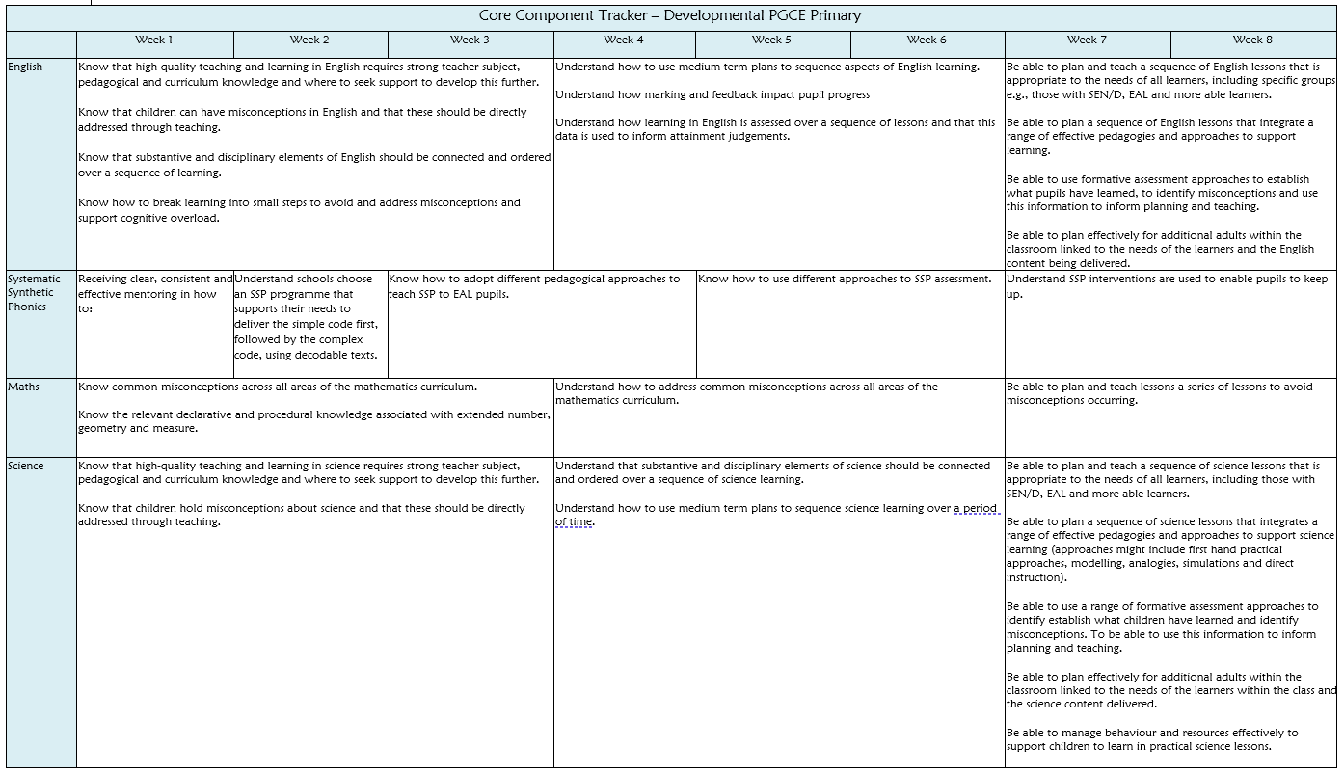

Postgraduate Developmental – Strand Component Tracker

 | Week 1 | Week 2 | Week 3 | Week 4 | Week 5 | Week 6 | Week 7 | Week 8
High Expectations  - EDI  - Behaviour  - EAL | Understand the legal and moral responsibilities of teachers to provide a high quality education and to make reasonable adjustments as required.  Be able to support children to be productive and feel safe in the classroom  Understand the importance of effective and focused observations of professionals and pupils. | Instil belief and promote the academic potential of all pupils including disadvantaged learners  Develop strategies to manage challenging behaviours | Know that there are attainment gaps between different groups of children and their peers, and what can be done to address inequalities  Be able to establish and reinforce routines, including positive reinforcement, to help create safe and effective learning environments.  Know and recognise specific adaptive teaching strategies to meet the needs of all learners. | Support pupils with a range of additional needs through adaptations to content, teaching strategies, approaches to recording and the environment, with support from expert practitioners.  Be able to apply the ‘PACE’ model as a supportive tool for individuals | To know the socially constructed and contested nature of the categories of gender, race, and socio-economic status, and the historic and current impact of these on children’s education;  Be able to teach children how to self-regulate and recognise that making mistakes, resilience and perseverance are part of daily routines | Augment their practice with strategies to support the education of children regardless of their gender, ethnicity and socio-economic status | To understand the evidence which suggests that disadvantaged pupils face additional challenges in reaching their potential in school  Understand that self-perception and self-belief supports behaviour  Recognise and develop an understanding of the importance of assessment and assessment tools. | Know how school staff assess their pupils’ needs and use Pupil Premium funding to improve attainment by drawing on evidence of effective practice  Be able to understand and be consider different approaches when planning to meet the needs of all learners.
How Pupils Learn, Classroom Practice and Adaptive Teaching  - Adaptive Teaching  - Planning  - How Children Learn | Be able to provide targeted support to increase pupil success using well designed resources.  Understand that adaptive teaching is less likely to be valuable if it causes the teacher to artificially create distinct tasks for different groups of pupils or to set lower expectations for particular groups. | Understand the need to work with SENDCO, and other expert colleagues and the designated safeguarding lead to understand the needs and provision for all pupils.  Know that learning is progressive, and plans should be flexible and adapted on the basis of pupil progress. | Know and understand the how to build effective relationships and partnerships with parents and carers to better understand pupils needs.  Know the role the teacher plays to support learning and memory. Understand strategies including worked examples and modelling | Know that pupils learn at different rates and require different levels of support to ensure their success. To understand there is a misconception that pupil shave distinct learning style and to tailor lessons to learning styles is unlikely to be beneficial.  Know how to effectively deploy support assistants and other adults to the benefit and progression of learners with SEND | Know how expert colleagues balance new input with the knowledge of prior learning so that pupils master important concepts.  Know and understand how to intentionally group in relation to specific learning outcomes and review these groupings, monitoring the impact and avoiding the perception that groups are fixed. | Be able to incorporate the use of technology, including educational software and assistive technology to support teaching and learning for pupils with SEND.  Be able to group pupils effectively and apply high expectations to all groups ensuring all pupils have access to a rich curriculum. | Be able to use formative assessments and 1 page profiles to adapt delivery and support to ensure success for all pupils.  Understand how to design a sequence of learning (MTP).  Understand the impact of targeted questioning on pupils’ retrieval and recall | Know how to apply high expectations to all groups and ensuring all pupils have access to a rich curriculum  Be able to incorporate the use of technology, including educational software and assistive technology to support teaching and learning for pupils with SEND.  Be able to write effective sequences of learning (MTP).
Professional Behaviours  - Safeguarding  - Professionalism  - Mental Health, Wellbeing and Workload | Understand it is important to keep up to date with current safeguarding legislation, such as: Keeping Children Safe in Education 2024 | Know how to deploy support staff effectively so they have a positive impact on pupil progress. | Know that wellbeing within the workplace requires supportive school environments with systems and structures in place that support staff mental health | Know how to identify of indicators of abuse and neglect. | Understand: how to liaise and communicate with parents to ensure an integrated approach is adopted in supporting children’s needs.  Understand the importance of seeking appropriate advice and support when dealing with specific issues (behaviour, workload, safeguarding concerns). | Be able to identify staff members who have overall responsibility for mental health and wellbeing in school | Be able to identify children who may need help or protection. | Be able to demonstrate professionalism by understanding the wider roles and responsibilities of a teacher.
Assessment |  | Know feedback must be high-quality and can be in unwritten or verbal form. |  | Understand teachers use information from assessments to inform the decisions they make; in turn, pupils must be able to act on feedback for it to have an effect. |  | With expert colleagues, can plan formative assessment tasks linked to lesson objectives and think ahead about what would indicate understanding.

Professional Practice Expectations – Primary 5-11
Mentors should ensure that trainees have regular opportunities to observe and collaborate with experts, practice pedagogical approaches, receive regular purposeful feedback, observe, and be observed.

The table below sets out guidance for the number of hours trainees should be engage in teaching activity per week on each of the three phases to ensure they have sufficient opportunity to practise, be observed, and receive feedback. When not engaged in teaching or support activities within their base classroom it is expected that trainees have opportunities to observe or support other experts across the setting and work within their component grids. Time for planning preparation and assessment equivalent to 20% should be built in across the week but should be school based.

Phase | Developmental
Minimum hours in classrooms (including observing, teaching, co-teaching each week.) | A minimum of 15 hours (on average 3 per day)
Mentoring - Minimum hours of mentoring each week | 1.5 hours. (This includes your weekly observation and weekly development meeting) |  | PPA Time  (School based) |  | 20%
Subject coverage  All trainees must have an opportunity to plan, teach and assess | Systematic synthetic phonics:  Plan, teach and assess a sequence of 3 SSP sessions |  | Core subjects:  Plan, teach and assess a sequence of English and maths lessons  Teach a sequence of science lessons |  | Foundation subjects:  Plan, teach and assess 5 foundation subjects  - where possible teach a sequence of lessons
Wider opportunities  (based on opportunity) | Co-deliver an extra-curricular club | Co-deliver an assembly or collective worship. |  | Attend pupil progress meetings |  | Attend school trip
Wider opportunities  (based on opportunity) | Attend parents evening or event and contribute to report writing | Supervise play times |  | Contribute to the setting of homework |  | Meet/greet/dismiss children
Wider opportunities  (based on opportunity) | Register children | Attend staff meetings/INSET

The Teaching of Systematic Synthetic Phonics (SSP)

There is an expectation to teach SSP across all placements with progression and development across the phases. Below sets out the expectation for this.

In placements where SSP isn’t taught regularly in the base class, we ask trainees to be given the opportunity to teach within a different class/key stage for these sessions, or to engage in daily SSP intervention.

There is an expectation for a minimum of one formal lesson observation within SSP and there is a lesson observation template available on the Mentor Space to support the feedback.

Systematic Synthetic Phonics (SSP)
Introductory | Developmental | Consolidation
Teach a minimum of one SSP lesson | Teach and assess a sequence of SSP lessons | Plan, teach and assess a sequence of SSP lessons

Professional Practice forms: The Weekly Development Summary (WDS)

- The Weekly Development Summary (WDS) is a record of the weekly meeting between trainee and mentor which captures the progress the trainee has made that week in reference to their ITE curriculum.
- It is completed by the mentor each week in the weekly mentor meeting.
- The mentor indicates if the trainee has been able to demonstrate what they know and can do that week in reference to the ITE curriculum set out that week. This may draw from a wide variety of evidence sources, including, but not limited to:

- Discussion with mentor
- Discussion with trainee
- Discussion with learners
- Discussion with TA / other professionals
- Learners’ responses within the lesson and in their books/work
- Observation of teaching and learning
- The trainees’ assessment and planning records in their files
- Informal notes and reflections

- The mentor questions the trainee and records the trainee’s responses on the WDS. The mentor makes use of the reading and additional support which has been provided to them for that week to ascertain if the trainee is able to link theory to practice, to make use of current pedagogical research, and to critically reflect on their practice.
- The mentor and trainee also discuss any other matters which have arisen that week such as subject knowledge, additional CPD, and workload.
- The mentor and trainee agree targets which the trainee needs to meet to make progress through the curriculum and note the opportunities which have provided for the trainee to meet this target.
- Finally, the mentor identifies whether sufficient progress has been made that week:
- Yes.
- Yes, but this required additional support (which the mentor then lists).
- No, progress has not been made despite additional support and the trainee may require a Progress Support Plan.
- By the end of each week the trainee should upload their WDS to the Placement Management System as per the guidance so the Link Tutor can QA and provide any necessary support/intervention.

Once the WDS has been completed in the weekly review meeting, this is uploaded by the trainee by the agreed deadline for their Link Tutor to review.

Each week, the Link Tutor will review the WDS from the previous week and note if the trainee is making sufficient progress, if further support is being provided, or if sufficient progress is not being made.

Failing to upload their WDS by the agreed deadlines hinders the Link Tutor in assessing the progress of the trainee and can trigger a Progress Support Plan. Moreover, it hinders the Link Tutor’s ability to QA the mentoring which the trainee is receiving.

A template of the WDS with guidance is provided for mentors to assist with completion of the form accurately.
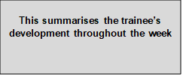
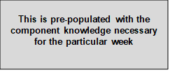
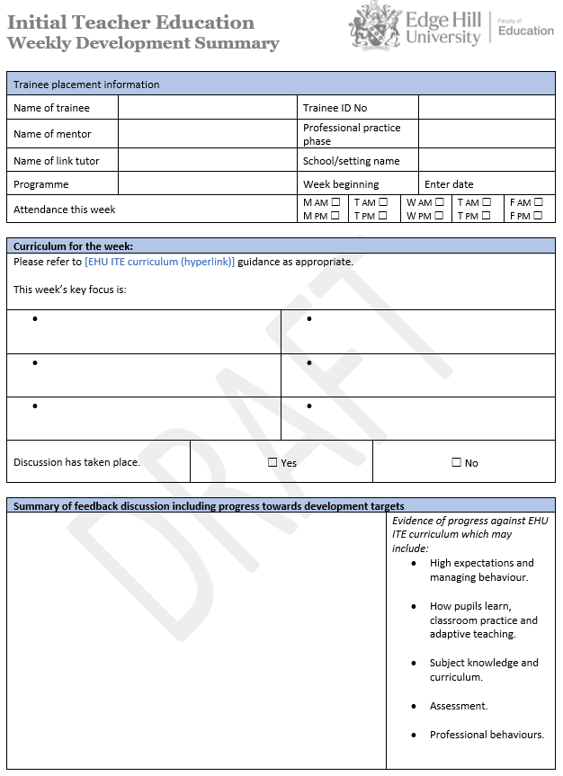

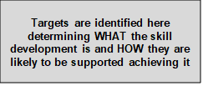
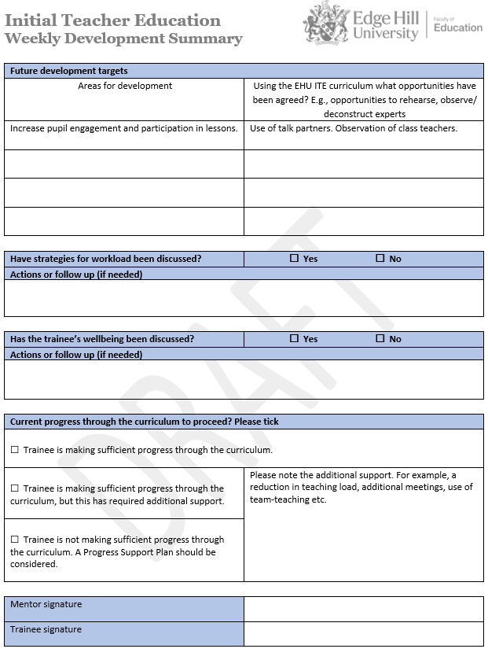

Professional Practice forms: The Lesson Observation form

- The lesson observation form records the one formal lesson observation carried out by the mentor each week.
- Mentor and trainee should agree the teaching which will be observed in advance and in the weekly review meeting.
- Only mentors and expert colleagues who have undertaken their core Edge Hill mentor training can observe the trainee for their formal lesson observation. Trainees are advised to provide a small notebook (or have one provided by Edge Hill) for informal lesson observation which can be provided by any expert colleague.
- The observation can focus on a full or part of a lesson, or any intervention work the trainee is doing with a small group.
- The focus of the lesson observation is derived from the curriculum for that week but also assess’ the trainee subject and pedagogical content knowledge.
- The trainee can be seen with the same class/group of learners if the mentor is unable to arrange cover and/or no other colleague is trained and able to observe.
- By the end of each week the trainee should upload their lesson observation form as per the guidance so the Link Tutor can undertake the necessary quality assurance checks and triangulate with the WDS that sufficient progress is being made.

A template of the lesson observation form with guidance is provided for mentors to assist with completion of the form accurately.
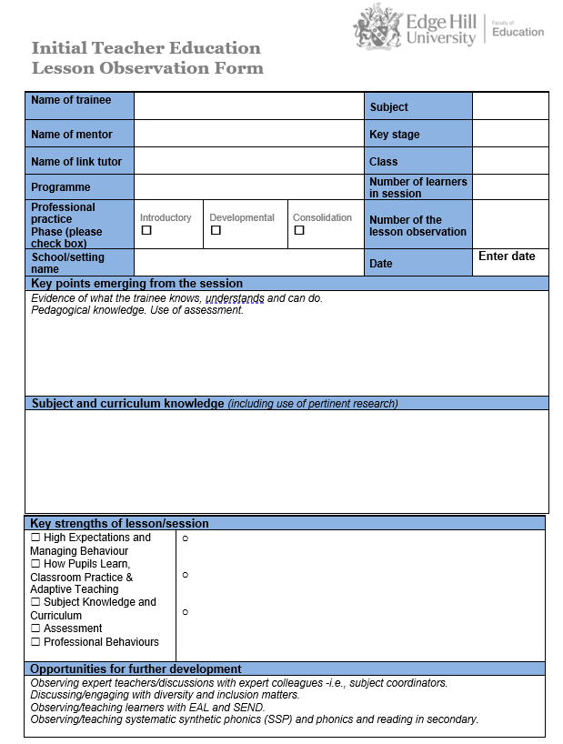
Mentor to indicate key strengths of the lesson and use the space provided to expand on any of these.
Mentor to comment on trainee’s subject and curriculum knowledge. This may include addressing misconceptions, linking to prior subject knowledge, building on foundational concepts, use of subject specific terminology and pedagogical approaches.
This will often be the last box the mentor completes as this will summarise the key points for follow up discussion and feedback with the trainee. This feedback should be in relation to the ITE curriculum for that week.

Mentor should complete these boxes with the relevant details.
This box may be filled in during the observation or following discussion with the trainee. It should note opportunities the trainee needs and/or has been provided with to make progress based on their feedback from the lesson observation. We suggest no more than 3 opportunities/targets to assist with workload.

Appendix: Progress Support Plans

This is designed to support trainees with additional needs, where informal additional support has not proven sufficient.

A Progress Support Plan is put in place between mentor, link tutor and trainee to identify specific development needs and reviewed at an agreed time.

The purpose of the Progress Support Plan is to support the trainee on getting back on track with the ITE Curriculum

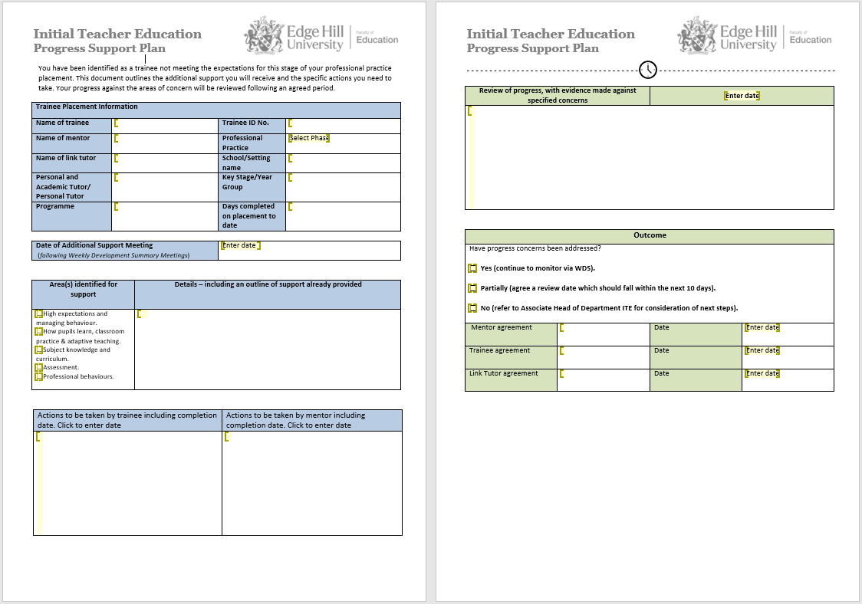

Further support and resources
- ITT Core Content Framework
- ITT Core Content Framework Exemplification Resource Materials
- ITT Core Content Trainee Teacher Behavioural Toolkit: A Summary
- Adaptive Teaching Adaptive teaching: Rethinking the nature of learning in schools: BOLD
- Early Career Framework: Learning about adaptive teaching
- The Early Career Framework Reforms Overview (ECF)
- The Early Career Framework (ECF)
- DfE The reading framework: teaching the foundations of literacy

