InPlace Guidance

How to add and remove mentors on trainees placement records

How to change/update a mentor’s email address or name

Contents
Add a mentor to a placement record 2
How to add a mentor if not listed 5
Remove a mentor from a placement record 8
Change/update a mentor’s email address 9

Add a mentor to a placement record

Navigate to InPlace and find the trainees placement record that you would like to add a mentor to.

- Once on the placement record, scroll to the bottom of the page to the Supervisors area.

- Press ‘Add Supervisors’

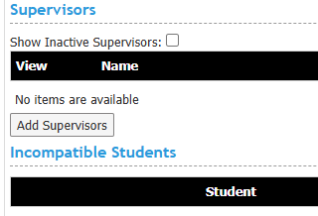

- A list of mentors and school contacts will appear under the Placement Supervisor Full Name column.

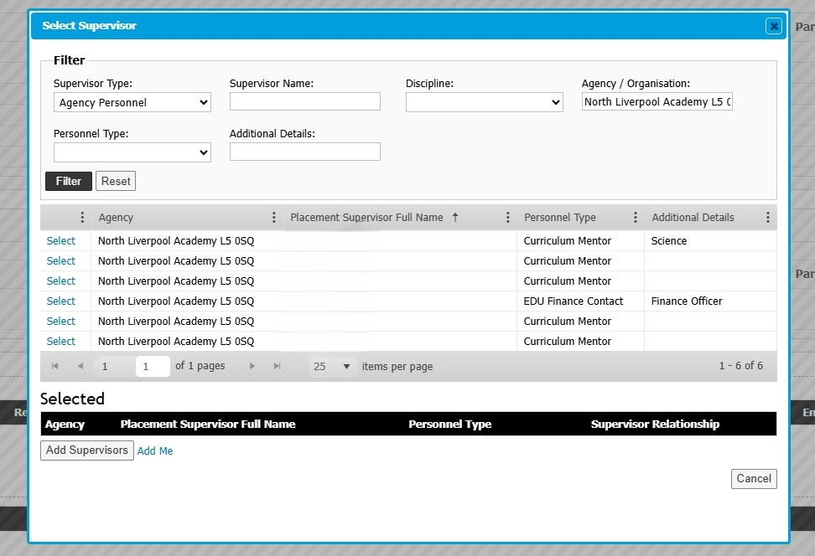
Names will be listed here

- Press Select on the mentor you would like to add.
If the mentor is not listed, follow steps under ‘How to add a mentor if not listed’
Name of mentor to add

- The mentor will appear under selected.
Choose Classroom Mentor for Primary/Early Years. Choose Curriculum Mentor for Secondary/FE under supervisor relationship and press Add Supervisors.
Name of mentor to add
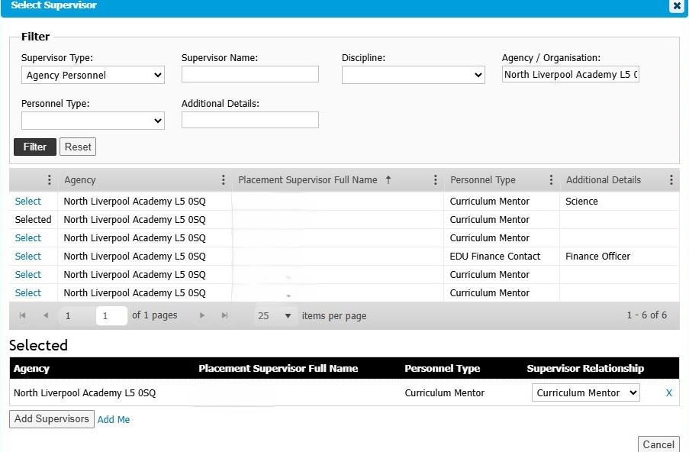

The mentor will now be added to the trainee’s placement record. If the mentor you’ve added is replacing another mentor, please also follow the steps in ‘Remove a mentor’

How to add a mentor if not listed

If a mentor is not listed when following the steps in the section above, then an InPlace record may need to be created for the mentor.
A record only needs to be created once. If a mentor’s record has errors, then follow the steps in Change/update a mentor’s email address or name instead of creating a new record.
Navigate to InPlace and find the trainees placement record that you would like to add a mentor to.

- At the top of the placement record, press the agency link. This will take you to the school’s placement record.
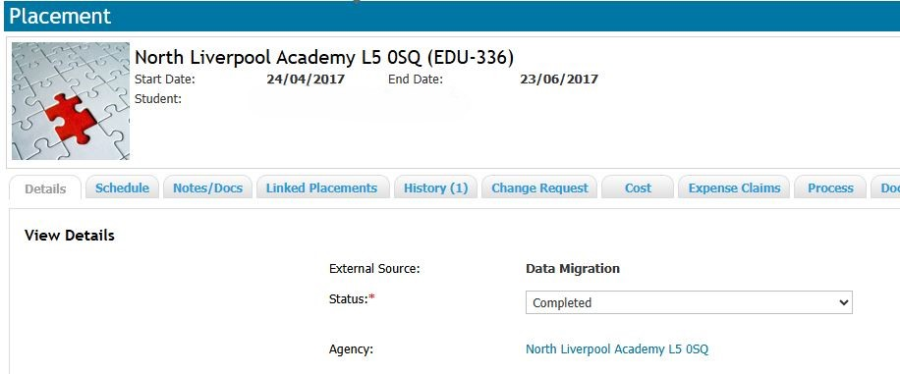

- Navigate to Personnel
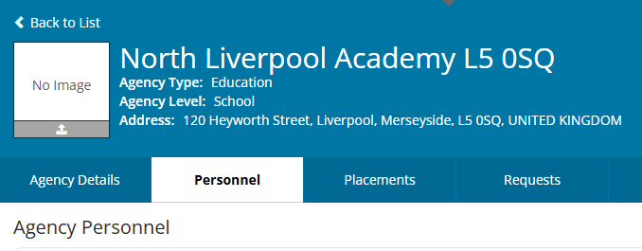

- Check the list of personnel to ensure the mentor does not already exist before adding a new record.
For example, they may be recorded as Tom rather than Thomas/their name may be misspelt. If you find an existing record and want to change the mentors’ name/email, follow steps in Change/update a mentor’s email address or name and do not create a new record.

If you cannot find any record for the mentor, please proceed to step 4.

- Press +Add Personnel on the right-hand side
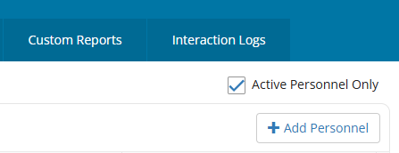

- Type the full name of the mentor you want to add

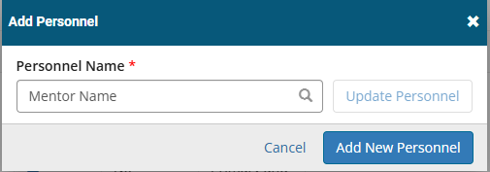
6) Press Add New Personnel

7) Enter the mentors email address

Choose a Type from the dropdown –
Choose Classroom Mentor for Primary/Early Years.
Choose Curriculum Mentor for Secondary/FE.
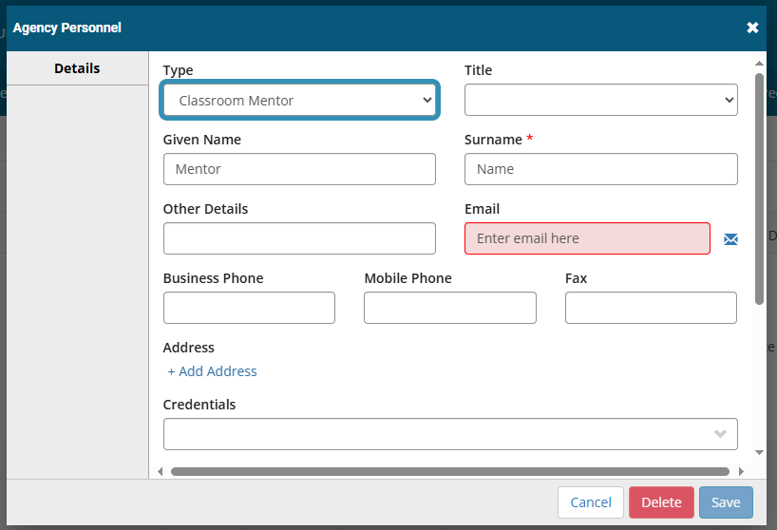

- Tick all 4 boxes under Permit View and press Save

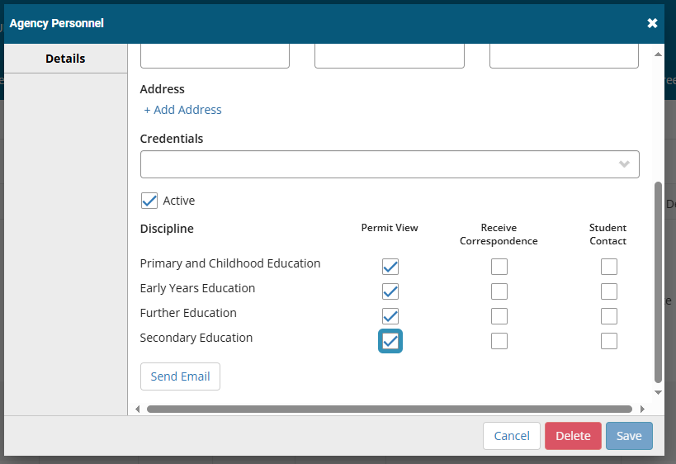

The mentor is now added to this school’s record. This mentor will now be listed when following steps 1-5 under Add a mentor to a placement record.

Remove a mentor from a placement record

If a mentor is replacing another then the mentor/s already attached will need to be removed from the trainees placement record.

Navigate to InPlace and find the trainees placement record that you would like to remove a mentor from.

- Once on the placement record, scroll to the bottom of the page to the Supervisors area.

- Press Detail on the mentor you would like to remove

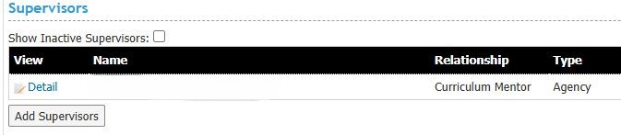
Name of mentor to remove

- Press Delete
Name of mentor to remove
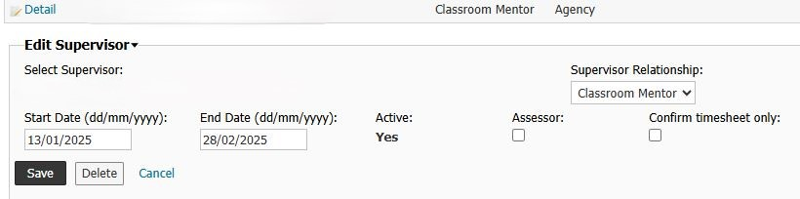
Name of mentor to remove

The mentor will now be removed from the trainee’s placement record.

Change/update a mentor’s email address or name

A mentor’s email/name may have changed or be inputted incorrectly on InPlace so will require updating.

Navigate to InPlace

1) Navigate to Manage > Agency Personnel

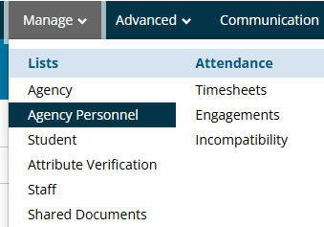

2) Search for the School of your mentor under Agency Name

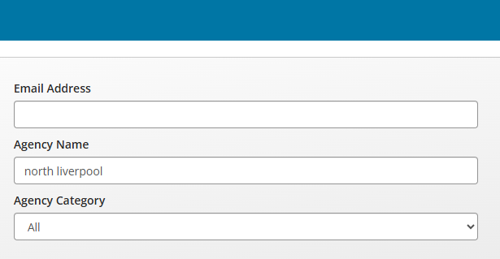

- Press Apply Filter and a list of mentors that match your search will appear.



- Press the Agency name

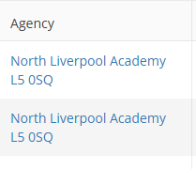

- Navigate to Personnel

- A list of mentor names will appear. Press on the name of the mentors record you want to amend.

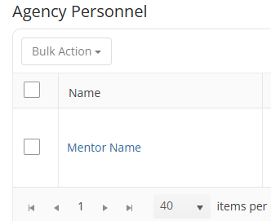

- Enter the new/amended email address and press Save
Here you can also amend the mentors name if this is misspelt or changed.

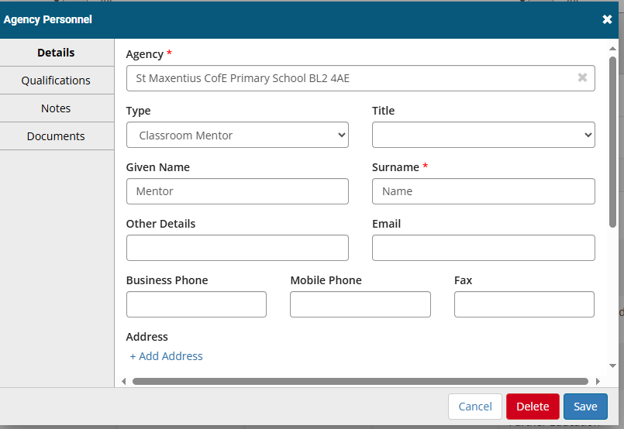

These updates will now be changed automatically on any trainee placements that this mentor is attached as a supervisor to.

