
Welcome to the weekly mentor, trainee and link tutor briefing from the Department of Early Years.
Course: | UG Primary 3-7 with QTS
Phase: | Consolidation | Week: |  | 17th March 2025
Weekly intended curriculum expectations linked to CCF:
SK - Refer to Subject Component Grid for Core and Foundation Subject Knowledge Focuses

HE - Implement effective strategies to manage behaviour for learning which are developed based on developing positive relationships with children.

HPL - Plan a sequence of lessons in school across a range of areas of learning or subjects (scaffolded to progress from group to whole with support initially) in the NC.

PB - Know teachers are required to support other agencies and professionals in child protection.

PB - The importance of working with external colleagues

Mentor Focus: Primary 3-7 UG Consolidation (Y3) - Mentor Space ITAP SCAFFOLDIN
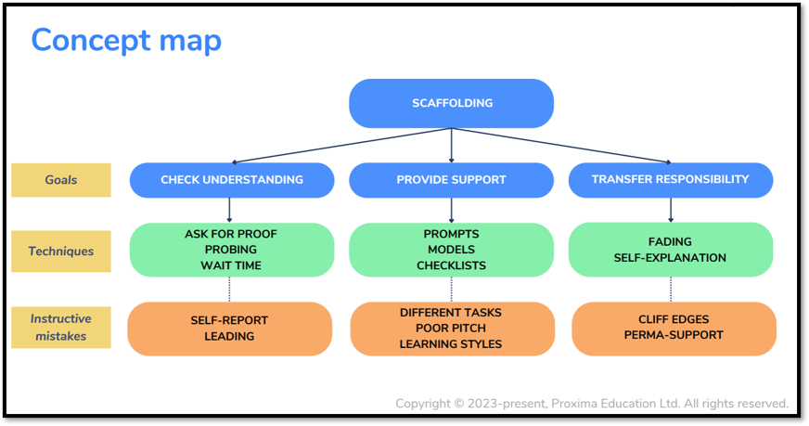
The Year 3 ITaP focus was on ’scaffolding’ and the key components are outlined in the concept map. This week we would ask if you can discuss with the trainee their knowledge and understanding of scaffolding for example asking them to talk through the techniques and instructive mistakes above. Also, as a mentor you could emphasise the scaffolding techniques that you use effectively to impact on learning. Then on their WDS or a lesson observation if you can give feedback based on their scaffolding techniques within their teaching.

Mentor Training:
Please ensure that you have accessed and completed the core and phase-specific mentor training that is signposted in your email from FoEMentoring, following completion of the Mentor Audit.
· Core Mentor Training (Access online training which can be completed at any time here: https://omnis.edgehill.ac.uk/webapps/consulting-central/app/launch/TDMv2
· Phase Specific Mentor Training (Watch this recording Mentor Training - Primary 3-7 UG Consolidation (Y3) - Mentor Space and email your link tutor to let them know you have managed to complete the training)
QA2: Your link tutor will be in touch, if they have not already done so, to arrange a brief meeting on Teams. This is a three-way meeting between you, the trainee and the link tutor.
If you have any issues, queries or concerns, please do not hesitate to contact your assigned link tutor at the earliest opportunity. They will be able to offer guidance, support and answer many of your questions.
If your query is about your link tutor, please email the Professional Practice and Quality Lead, Jamie Allman allmanj@edgehill.ac.uk.
Mentor Drop-in Sessions:
We have sessions available to support you with any questions, queries, feedback or concerns that you have as a mentor. These sessions are in addition to the phase/subject mentor training webinars. These sessions will be facilitated by our Lead Mentors who are active in partnership schools so will be able to answer any questions you have. You do not need to stay for the full 30 minutes, drop in as needed.
Thursday 13th March 12:00-12:30
Join the meeting now
Meeting ID: 388 389 625 752
Passcode: ti6se3GU
Observation of experts to support training suggestions: |  |  | Research and Resources:
Please ensure that trainees are observed regularly each week, both informally and formally. Formal observations are intended to provide the trainee with subject specific feedback on the areas of learning. Discussing the observed lesson can form part of your weekly discussion meeting. Please remember that observations can take place during continuous provision and may be unplanned as this will enable you to support the trainee with their interactions. Observation forms can be added by following the guidance on page 16 |  |  | DEPARTMENT FOR EDUCATON. 2024. Statutory framework for the early years foundation stage.  ALLEN, S., WHALLEY, ME., LEE, M. & SCOLLAN, A. 2020. Developing Professional Practice in the Early Years. OUP.  SHERRINGTON, T., & CAVIGLIOLI, O., 2020. Teaching walkthrus:five-step guides to instructional coaching.  John Catt Educational. Available from: https://edgehill.on.worldcat.org/oclc/1202298997
Link Tutor: |  |  | Trainee:
Please remind trainees to engage with their EYE3010 module and continue collating evidence for their scrapbooks. Finally, please contact me if you have any questions or if you have any concerns. |  |  | Continue to develop positive relationships with children, parents and other professionals in the school. Make yourself visible around school and engage in conversation as much as possible. If you haven’t already, begin engaging yourself in the wider school community by taking part in after school clubs and attending staff meetings. Finally, ensure you are fully prepared to take greater responsibility of the class.

