Abyasa Pro Report – Mentor Training Progress
Link Tutors, PPQL/Course Leads and Programme Tutors will be able to run reports on their attached mentors mentor training progress via Abyasa’s Pro Report
Contents
How to run the mentor training progress report on Abyasa 1
Which training should my mentor do? 2
Do I need to put these completions onto InPlace? 2

How to run the mentor training progress report on Abyasa
1) Navigate to Pro Report > Mentor Training Progress > Please Select Participant Group
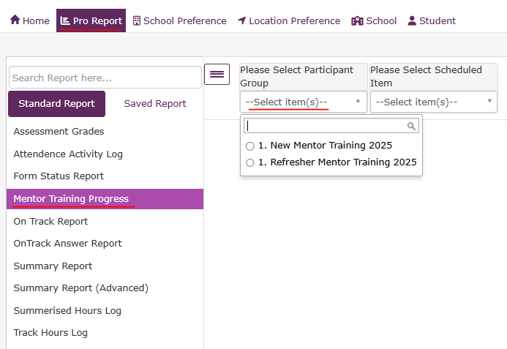

2) Choose a group: New Mentor Training 2025 or Refresher Mentor Training 2025 and press Show
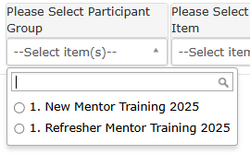

You will be shown a list of all your attached mentors who are in each group with their completions.
Ignore the percentage complete column and use Complete/Draft in the Completion Phase column as the signifier that the training is completed. Example below where percentage is 95 but training is completed.
If you have a large number of mentors, you can also Export to Excel.

Which training should my mentor do?
Mentors are allocated to the New Mentor Training 2025 or Refresher Mentor Training 2025 group based on if they mentored with us last year.
The table below outlines the training requirements for mentors for 25-26:
Type of mentor | Required mentor training for 2025-26
In New Mentor Training 2025 group – has not mentored with another ITT provider in 2024-25** | New to Mentoring at EHU: The Principles and Models of Mentoring 2025/26
In New Mentor Training 2025 group - has mentored with another ITT provider in 2024-25** | Refresher: Principles and Models of Mentoring 25/26
In Refresher Mentor Training 2025 group | Refresher: Principles and Models of Mentoring 25/26

** We rely on self-reporting from “New to EHU” mentors regarding any prior mentoring experience with another ITT provider. As long as they have completed either the New to Mentoring or Refresher training, this is considered acceptable.

Do I need to put these completions onto InPlace?
No – the mentoring team will put these completions onto InPlace under the mentors credentials.

