Department of Primary & Childhood Education

Principles of Planning

Introduction
This document outlines planning expectations for Edge Hill ITE trainees across our three professional phases. It is designed to support mentors in guiding trainees toward purposeful, learner-informed teaching. Edge Hill regards planning as a professional commitment to knowing the learners, sequencing learning effectively, and adapting pedagogy to context.
We require lesson planning not as a formality, but as evidence that trainees:
- Understand the learners they are teaching
- Can articulate clear learning intentions and outcomes
- Are able to adapt teaching to promote progress
- Are developing autonomy in sequencing and evaluating learning
- Are accountable for inclusive, responsive pedagogy

While we recognise and respect that experienced teachers often develop their own planning styles, shaped by subject expertise, teaching context, and personal preferences, it is essential that all trainees use the designated planning format provided by our programme. This ensures consistency across professional practices and supports mentors in offering focused, developmental feedback.
Crucially, it means that when a trainee transitions between professional practices, any mentor can be confident that the trainee is familiar with a shared planning structure, rather than arriving with one of many potential formats.
Our approach is not designed to limit professional autonomy, but to scaffold reflective practice and ensure that planning remains purposeful, inclusive, and aligned with curriculum intent and learner needs across training phases.
To this end, there are clear expectations for planning across the three Professional Practice phases: Introductory, Developmental and Consolidation.

Placement Phase | Trainee Planning Requirement | Focus | Mentor Role
Introductory | Full lesson plan using the Edge Hill planning document for every taught lesson. | Trainees must demonstrate detailed planning that includes learning outcomes, success criteria, adaptive teaching, and formative assessment.  By the end of Professional Practice: Trainees should demonstrate an awareness of the needs of the class as a whole and seating groups. | Review and provide feedback on each plan.  Ensure trainees understand the class context and are planning with learner needs in mind.
Developmental | A minimum of one individual lesson plan per week for observed lessons.  Sequence plans for sequences of three lessons or more. | Trainees begin to sequence learning across multiple lessons. Planning should show progression, adaptation, and responsiveness to prior learning.  By the end of Professional Practice: Trainees should demonstrate an understanding and consideration of the needs for groups and individuals. | Support trainees in sequencing learning and identifying links between lessons.  Encourage use of school data and formative assessment to inform planning.  Support trainees with additional individual lesson plans where further support is needed.
Consolidation | A minimum of one individual lesson plan per week for observed lessons.  Sequence plans for sequences of three lessons or more. | Trainees should demonstrate autonomy in planning, including adapting schemes of work and designing units. Planning must reflect learner diversity and curriculum intent.  By the end of Professional Practice: Trainees should demonstrate a developed understanding and consideration of the needs of groups and individuals. | Guide trainees in refining sequence plans. Ensure planning is responsive to pupil progress and includes evaluation of learning. Provide feedback on strategic decisions.  Support trainees with additional individual lesson plans where further support is needed

The Role of AI
We acknowledge the growing role of AI tools in supporting lesson planning and reducing workload, particularly in helping structure ideas or generate initial prompts. However, these tools must not replace the trainee’s own professional judgement, pedagogical reasoning, or creative input. Trainees are required to ensure that no pupil-specific or school-identifiable information is entered into any large language model or AI system, in line with data protection and safeguarding expectations. Should you have concerns around a trainee’s use of AI systems with lesson planning, please contact your Link Tutor in the first instance.
Below are some suitable example prompts that can support lesson planning:
Planning Structure & Sequencing
- Can you suggest a logical sequence for teaching geography to Year 4 pupils?
- What are some effective starter activities to activate prior knowledge about the Great Fire of London?”
- How can I scaffold learning for mixed-ability groups when teaching fractions?
Learning Objectives & Outcomes
- What might be appropriate learning objectives for a lesson on algorithms at KS2?
- Can you help me phrase success criteria for a Design and Technology task involving creating and designing a biscuit brand?
Adaptive Teaching & Inclusion
- What are some inclusive strategies for supporting EAL learners during a lesson on programming?
- How can I adapt this activity for pupils with SEND while maintaining challenge?
Questioning & Assessment
- Can you suggest some open-ended questions to assess understanding of punctuating direct speech?
- What formative assessment strategies could I use in a lesson on singing as part of a group?
Creativity & Engagement
- What are some creative ways to introduce Extreme Earth to engage Year 3 pupils?
- Can you suggest a role-play or simulation activity to explore peer pressure in a PSHE lesson?

We expect trainees to be open and honest about any use of AI in their planning, so that mentors can provide informed guidance and support their professional development effectively.

Schemes of Work
Published schemes of work can provide valuable starting points, especially in terms of curriculum coverage and resource efficiency. However, it is essential that trainees engage critically with these materials rather than relying on them unadapted. Our expectation is that trainees demonstrate ownership of their planning by tailoring content to meet the specific needs of their learners, aligning activities with the ITTECF standards, and embedding inclusive pedagogy.
We also recognise the importance of maintaining fidelity to the core objectives of published schemes—particularly in areas such as systematic phonics instruction—where consistency and progression are crucial. Trainees should therefore strike a balance between adapting materials to reflect their developing understanding of curriculum intent, sequencing, and adaptive teaching, while ensuring that essential pedagogical principles are preserved.
This approach supports professional growth and encourages trainees to become reflective and creative practitioners who can respond flexibly to learner needs without compromising the integrity of key curriculum components.

The Individual Lesson Plan
The individual lesson plan is a vital tool for structuring purposeful and inclusive teaching. Within this format, trainees are guided to articulate clear learning objectives, identify substantive and disciplinary knowledge, and sequence teaching to build on prior learning. The plan encourages consideration of adaptive teaching strategies, ensuring that all pupils—including those with SEND, EAL, or from disadvantaged backgrounds—are appropriately supported and challenged. By anticipating misconceptions, planning key questions, and embedding opportunities for assessment, trainees develop a responsive approach to teaching that prioritises pupil progress. The lesson plan also prompts reflection on the role of the teacher and support staff, promoting effective collaboration and classroom management.
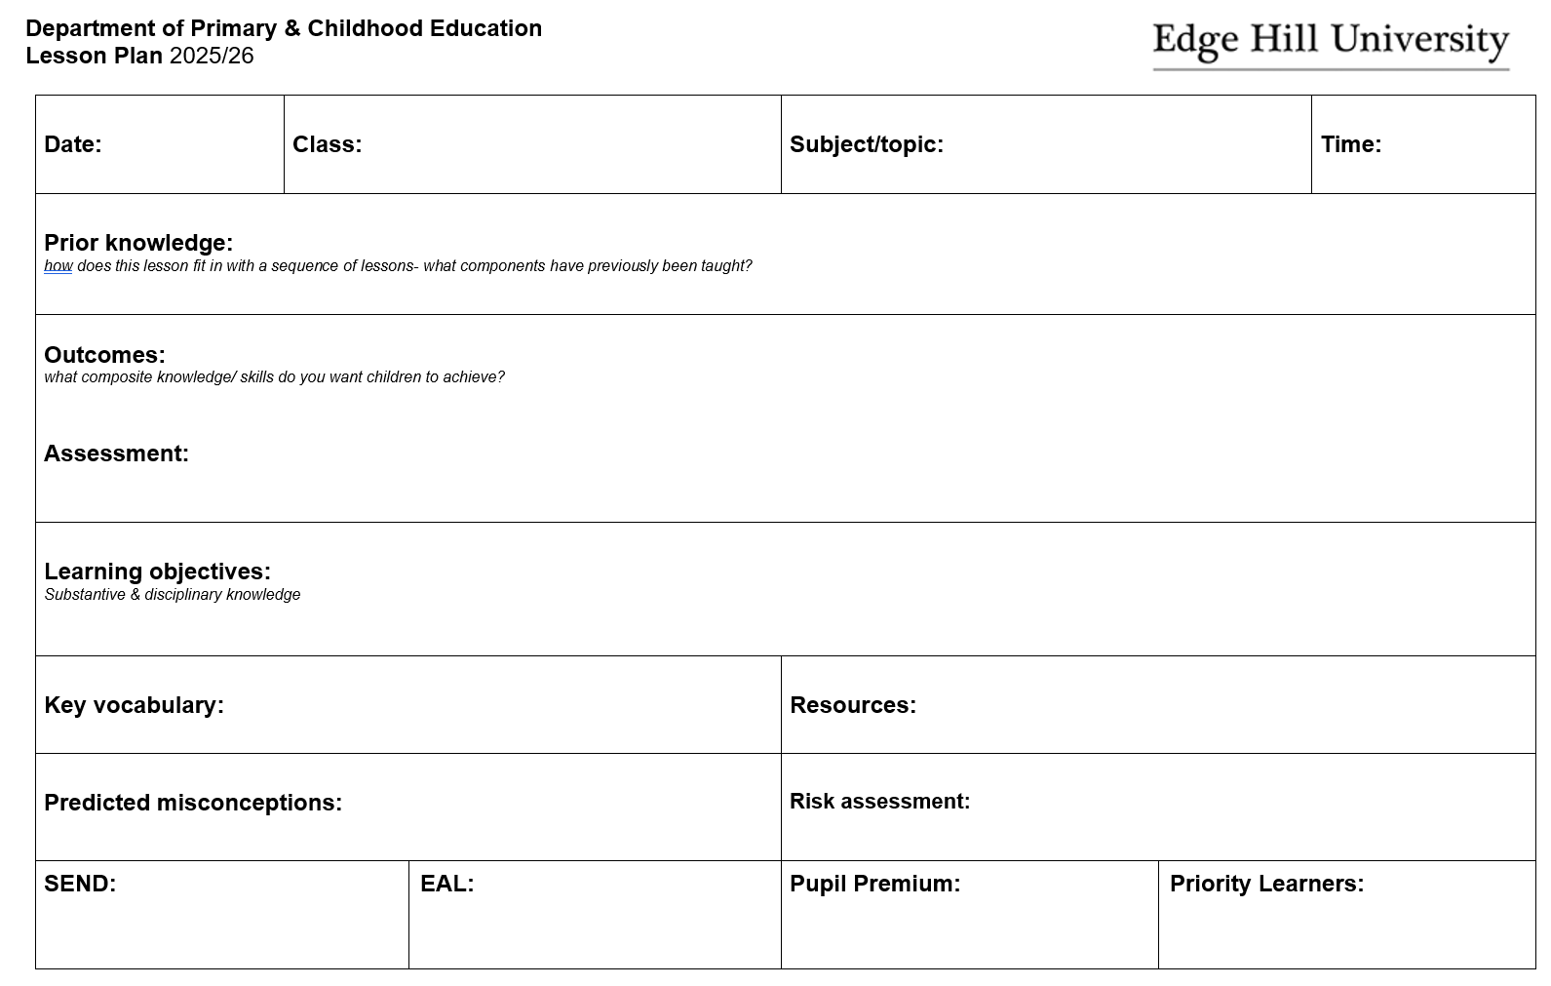

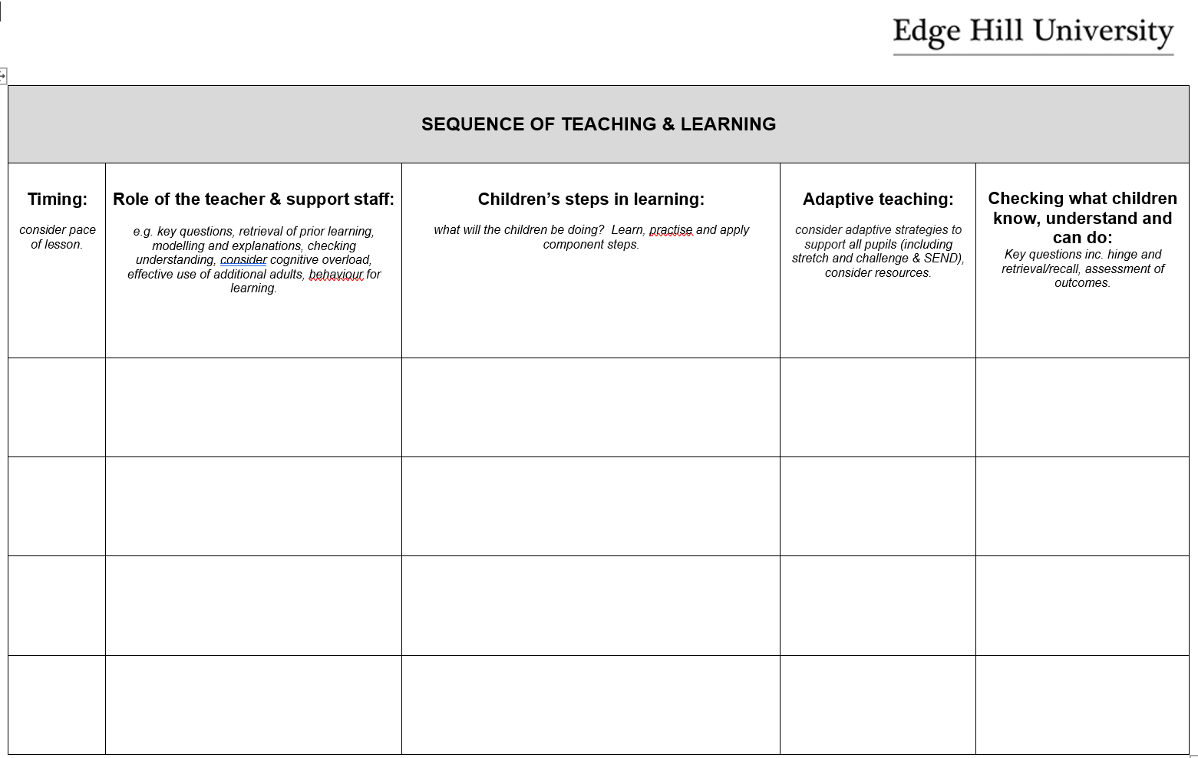

The Sequence Plan
From the Developmental Professional Practice placement onwards, trainees are expected to begin designing and delivering sequences of lessons, typically comprising three or more sessions, within a coherent unit of learning. This marks a shift from planning standalone lessons to structuring sustained, purposeful teaching over time. Whether planning a half-term of history or a focused week of maths, sequence planning enables trainees to build learning progressively, ensuring pupils revisit, deepen, and apply key concepts and skills.
Engaging with sequence planning helps trainees identify composite outcomes and break them into component steps, aligning each lesson with broader curriculum aims. It supports cognitive development through spaced retrieval, cumulative knowledge-building, and adaptive teaching strategies that respond to pupil progress. It also encourages professional reflection, prompting trainees to consider how prior learning informs future teaching and how assessment can be used diagnostically across a sequence. Introducing this expectation during the Developmental Professional Practice provides a scaffolded opportunity for trainees to develop curriculum fluency, pedagogical coherence, and a strategic understanding of progression in learning.
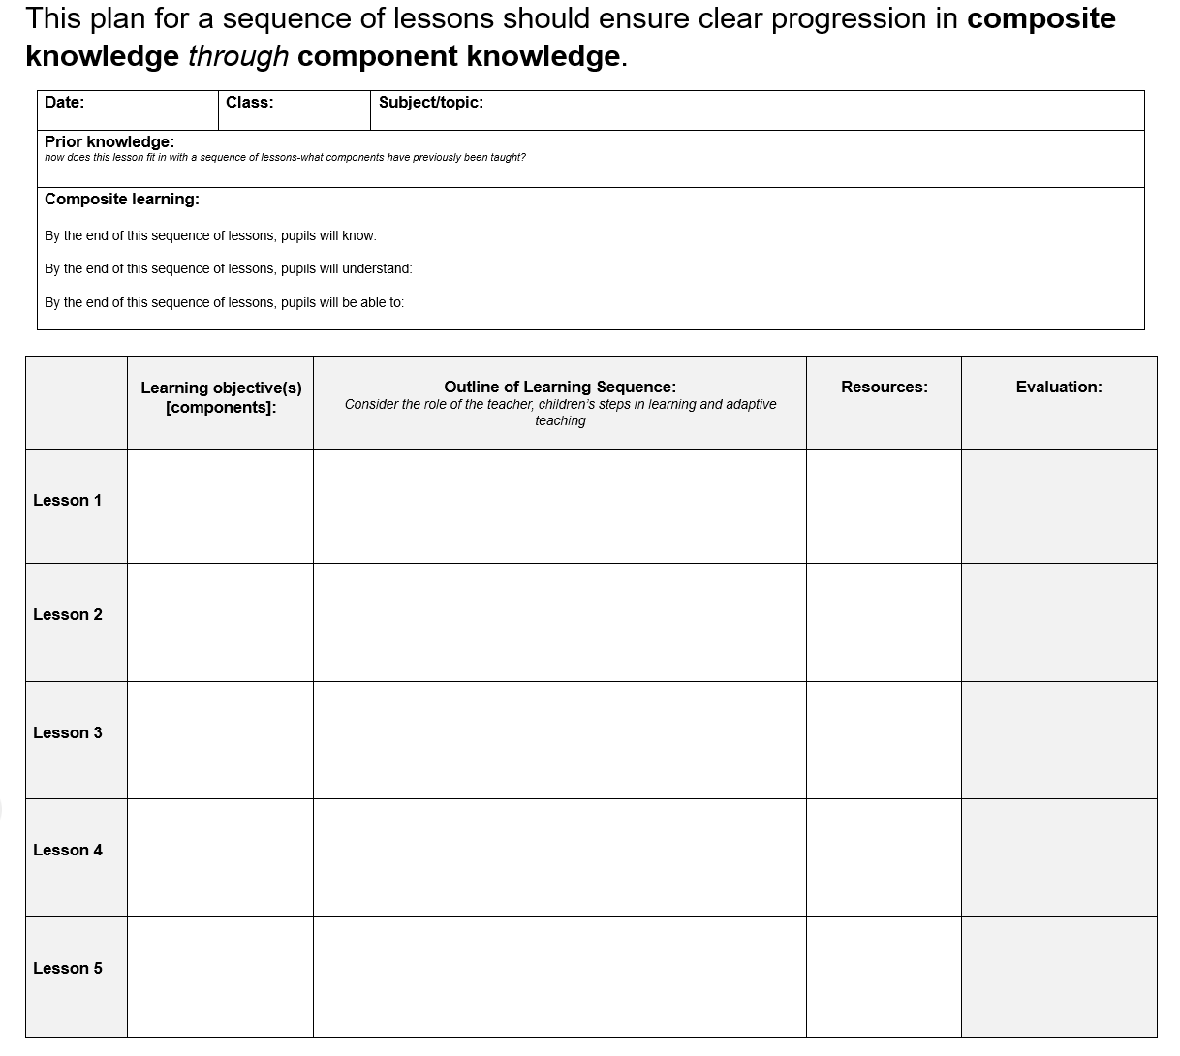

Professional Boundaries and Planning Dialogue
We encourage trainees and mentors to maintain regular, professional dialogue around planning throughout each placement. These conversations are vital for supporting curriculum thinking, adaptive teaching, and responsive pedagogy. However, we also recognise the importance of work-life balance and the right of both trainees and mentors to switch off from work outside of contracted hours.
Trainees should not be expected to email planning documents to mentors during evenings or weekends, unless this has been explicitly agreed in advance and is necessary for a specific purpose (e.g. preparing for an observed lesson or because a trainee is requiring extra planning support). Planning should be shared and discussed within agreed working hours wherever possible, ensuring that professional expectations do not compromise wellbeing.
This approach reflects our commitment to sustainable professional practice and respectful collaboration across the training partnership.

